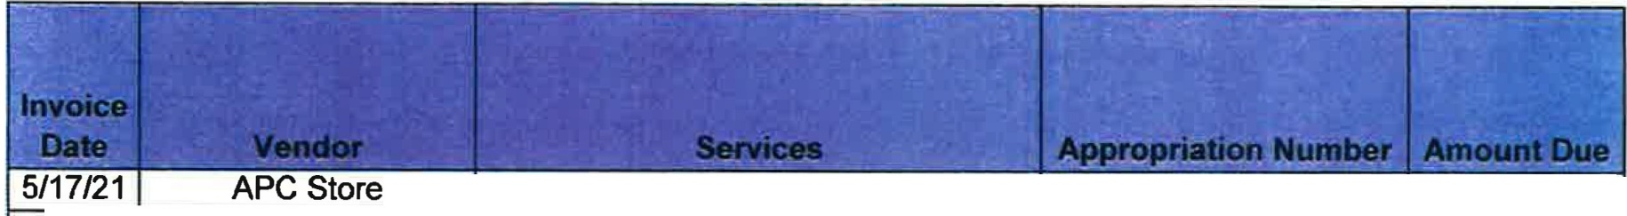
MUNSTER FIRE DEPARTMENT DISBURSEMENTS COVERING PERIOD FROM May 17 - June 17, 2021

Boat Batteries 101-23001-62302 $ 193.98

5/6/21 APC Store Batteries for #2223 101-23001-62302 $ 935.94

5/4/21 Gus Bock LED Bulbs, Batteries 101-23001-62900 $ 50.96

4/30/21 Forsensic Mappling Drone Training-Zeman & Zgobica 101-23201-63991 $ 1,590.00 4/26/21 Hasting Air Energy Plymovent repair @ Station1 101-2301-63602 $ 393.53

5/4/21 Paul Heuring Replace battery on #2203 101-23001-63602 $ 339.80

Safety Training

4/20/21 Services Sensit Gold Multigas Monitor 402-23201-62900 $ 2,444.00 4/21/21 10-8 Technology Repair lights & radio on #2203 101-23001-63602 $ 275.00

5/6/21 Terpstras Carburetor for #2226 101-23001-62302 $ 89.93

5/12/21 Terpstras Chainsaw & Bars 101-23001-62302 $ 1,177.04 Third District Fire

5/3/21 I Chiefs IBox alarm dispatch fee -8005 Schreiber! 101-23201-63903 I $ 125.00

Software License for Lightning

4130121 I Thor Guard I Detectors 247-11402-63611 $ 1,000.00

5114/21 I APC Store · I Battery for #2201 101-23001-62302 $ 152.99

5/18/21 APC Store
 | Battery Tender and Battery for Trailer |  | 101-23001-62302 |  | $ 264.95
 | Oil and Filter for Polaris |  | 101-23001-62900 |  | $ 69.74
 | Trufuel |  | 101-23001-62900 |  | $ 352.68
 | Radio Maintenance June |  | 101-23202-63601 |  | $ 65.00
 | Starter for #2224 |  | 101-23201-62302 |  | $ 365.00
I |  | I |  | 1 | $ 9,885.54

5/12/21 APC Store
5/25/21 APC Store 5/17/21 Miner Electronics
5/20/21 Sluiter Auto Electric -
GRAND TOTAL

