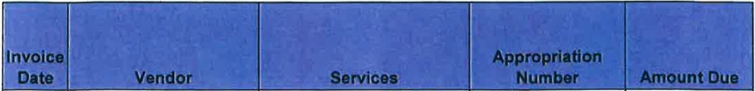
MUNSTER FIRE DEPARTMENT DISBURSEMENTS COVERING PERIOD FROM March 14 - April 15, 2021

3/1121 | Fire Service | LED lights on Engine 2223 | 402-23201-62900 | $ | 3,967.00
3/2/21 | Star Uniform | Collar pins, Badge for Chief | 402-23201-62900 | $ | 197.00
3/11121 | Menards | Materials for remodel office | 414-9152117-  64202 | $ | 317.71
3/17/21 | 10-8 Technology | Reprogram radios/3 vehicles | 101-23001-63602 | $ | 335.00
3/17121 | 10-8 Technology | Warning lights/siren pedal  #2226 | 101-23001-63602 | $ | 440.25
3/17/21 | Strypes Plus More | Replace striping on #2200 | 101-23001-63602 | $ | 85.00
 |  | 414-9152117-
3/20/21 | Menards Schererville | Drywall for office remodel | 64202 | $ | 89.80
3/26/21 | Polar Ice Systems | Repair ice machine St. 1 | 101-23001-63602 | $ | 195.00
3/29121 | APC/Auto Value | Fuel Filters #2221 | 101-23001-62302 | $ | 42.05
3/24/21 | J.Michael Harrigan | Material for picture rails | 402-23201-62900 | $ | 227.00
3/31/21 | Andrew Giordano | CPST Recertification | 101-23201-63991 | $ | 55.00
3/30/21 | Randy Fischer | Spray Paint | 402-23201-62600 | $ | 10.77
GRAND TOTAL $ 5,961.58

