**Administrative Special Order #** 22-07

Date: November 29, 2022 Regarding: Assignment

By order of the Chief of Police, the following personnel are assigned accordingly :

|  |  |  |  |
| --- | --- | --- | --- |
| **NAME** | **RANK** | **ASSIGNMENT** | EFFECTIVE DATE |
| Ryan Vassar | Sergeant | Tac Sergeant | November 29, 2022 |

*/ 1 - ?*

I *:£*• •

*'>-. .*

/ Stephen F. Scheckel

Chief of Police

cc: Dustin Anderson

Board of Safety Bulletin Board Personnel File Sergeant Vassar

Munster Police Department

1001 Ridge Road • Munster, IN 46321 • (219) 836-6650 • Fax (219) 836-8134 • Police *I* Fire Emergencies 911 [www.munster.org](http://www.munster.org/)

## Administrative Special Order # 22-08

Date: November 30, 2022 Regarding: Assignment

By order of the Chief of Police, the following personnel are assigned accordingly:

NAME RANK ASSIGNMENT EFFECTIVE DATE

Daniel Balich Luke Tambrini

Officer Officer

Tac Officer Tac Officer

November 30, 2022

November 30, 2022

Chief of Police

cc: Dustin Anderson

Board of Safety Bulletin Board Personnel File Officer Balich Officer Tambrini

Munster Police Department

1001 Ridge Road • Munster, IN 46321 • (219) 836-6650 • Fax (219) 836-8134 • Police *I* Fire Emergencies 911 [www.munster.org](http://www.munster.org/)

r

TO\tVN OF

Mt'N1TER

- .

**Administrat ive Special Order # 23-01**

Date: January 5, 2023 Regarding: Assignment

By order of the Chief of Police, the following personnel are assigned accordingly:

|  |  |  |  |
| --- | --- | --- | --- |
| **NAME** | **RANK** | **ASSIGNMENT** | **EFFECTIVE DATE** |
| Justin Palas | Officer | Investigations | November 30, 2022 |

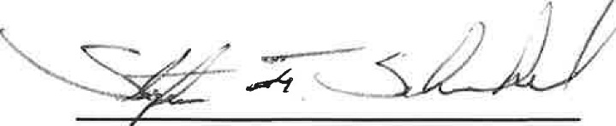Per General Order #16.2.3 (1.) Officers assigned to detective (temporary duty) shall serve for a period not to exceed 18 months unless removed sooner or assigned to the full-time position by the Chief of Police. Persons selected may not serve consecutive terms. The Chief of Police has the discretion to extend or reassign an officer to a consecutive term to this temporary duty detective position at his discretion to fulfill the department's needs. This position will become a full-time position in Investigations and adding a Temporary or Rotating position will be readdressed when we are fully staffed.

Stephen F. Scheckel Chief of Police

cc: Dustin Anderson

Board of Safety

Bulletin Board .

I · Munster Pohce Department

/8@rt<?JWofcJ Munster.IN 46321 • (219) 836-6650 • Fax (219) 836-8134 • Police *I* Fire Emergencies 911

Justin-l'alas [www.munster.org](http://www.munster.org/)

**0**