**Me1110**

**To:** Munster Board of Safety **From:** Lt. Daymon Johnston cc: File

**Date:** March 3, 2022

Re: Tow Service Provider List for 2022 and 2023

The Chief of Police and the Town of Munster Board of Safety Commissioners will designate towing services to tow for the Munster Police Department per Municipal Code 54-71(d) authorized towing contactors and garage keepers. This Tow Service Provider list will be active for 2 years. The last Tow Service Provider List expired 12/31/2021 and this new list will expire on 12/31/2023. After review of the calls for tows, it is clear the number of tows has sharply declined during this last time period (2019 and 2020). It is unclear at this time what caused this drastic decline, but it could be attributed to the procedures and policies enacted during the pandemic . I do not recommend increasing the current Tow Service Provider List from the current 4 providers to the maximum of 5 until our numbers have returned to their previous levels .

Recommended Action: By motion and voice vote, retain the current list of Tow Service Providers (Bert's Towing, Double T Towing, Ray & Son's Towing, and Stan's Towing) for 2022

& 2023.

#### Logo, company name Description automatically generatedMunster Police Department

**Tow Service Provider Inspection Report**

The following procedures will be followed when adding or removing towing service providers from the Munster Police Department authorized roster. The Chief of Police and the Town of Munster Board of Safety Commissioners will designate towing services to tow for the Munster Police Department per Municipal Code 54-71(d) Authorized towing contactors and garage keepers. If more than one service is authorized to tow for the Town of Munster, a rotation schedule will be implemented. The Town of Munster will have a maximum of five (5) Tow Service Providers on the rotation list determined by the Safety Board. The safety board will determine the top five (5) Tow Service Providers by taking into consideration history with the department, years of service, any negative interactions or suspensions from the list, and business reputation. This Tow Service Provider list will be active for 2 years.

Recommended Action: By motion and voice vote, retain the current list of Tow Service Providers (Bert's Towing, Double T Towing, Ray & Son's Towing, and Stan's Towing) for 2022 & 2023.

The Tow Service Provider list delivered prompt and professional services for the Munster Police Department, Town of Munster, and citizens. There were no outstanding issues or problems. I did request for applications this year again and performed the inspections of the four current companies as well as 2 other companies. There is no cause to remove any of the current companies on the list nor a need to increase the list as the companies are each sufficiently handled the roughly 224 tow requests per company over the two-year span. Adding another

company would not add to the services in my opinion and greatly reduce the number of tows (by 20%) for each company.

###### Top 4 Recommended Tow Service Providers

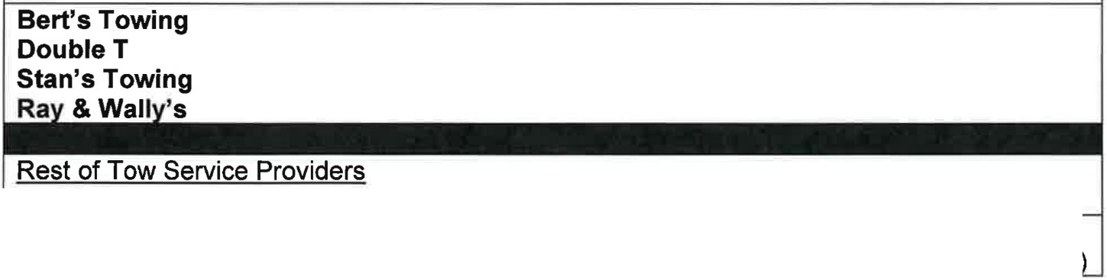

McCoy & Sons (Lot security concerns and low number of medium or heavy-duty tows)

Tom & Eds ve small onl 3 flatbeds, no semi tows, onl 5 drivers with ve little ex erience

1

|  |  |  |  |  |  |  |  |  |  |  |
| --- | --- | --- | --- | --- | --- | --- | --- | --- | --- | --- |
| Company | Miles from Town Hall | #'s of Locations | #  Outside Storage | # Inside Storage | # Small or Flatbed | #  Medium or Heavy Duty | Total # Vehicles | Semi Towing? | Rent/Own | Location |
| Bert's | 4.2/2.7/  4.8 | 3 | 40 | 2 | 9 | 8 | 17 | YES | Own | Griffith/Ha mmond/Hig hland |
| Double T | 4.2 | 1 | 80 | 8 | 4 | 5 | 9 | YES | Own | Griffith |
| McCoy &  Sons | 4.0 | 1 | numero  us | 8 | 7 | 1 | 8 | YES | Rent lot | Hammond |
| Ray &  Wally | 3.8 | 1 | 1acre | 5-6 | 4 | 4 | 8 | YES | Rent to own | Hammond |
| Stan's | 7.3 | 1 | 2 acres | numero us | 5 | 3 | 8 | YES | Own | St. John |
| Tom & Eds | 5 | 1 | 100 | 10 | 3 | 0 | 3 | NO | Own | Schererville |

This table is a quick overview of the tow service providers wanting to be on our list. This should provide a quick snapshot of the resources available for each company .

|  |  |  |  |  |
| --- | --- | --- | --- | --- |
|  | | | | |
| **Bert's (Current)** | **223** | **24.89%** | **4003** | **29.84%** |
| **Double T (Current)** | **220** | **25.56%** | **3623** | **27.00%** |
| **Ray & Wally (current)** | **224** | **25.00%** | **1631** | **12.16%** |
| **Stans (Current)** | **229** | **25.56%** | **3252** | **24.24%** |
| Tom & Eds (new) | 0 | 0.00% | 908 | 6.77% |
| McCoy and Sons  (new) | 0 | 0.00% | 0 | 0.00% |
| **TOTALS** | **896** | **100.00%** | **13417** | **100.00%** |
| Expected Ave Tows = 224 25%  Ave Tows if we go to 5 Companies = 179  20% | | | | |

The table above is taken from a report off our RMS system that gives us all the tows done by these towing companies between a set period (1/1/20 to 1/1/22 in the Munster Tows 2020-2021 Column and all Munster Tows for the All Documented Munster Tows Column). I also figured out the percentage of tows each company performed during these times. All things being equal

they would have percentages of 25% each for 2020-2021 since we only had 4 tow companies for that time period. Tom & Eds and McCoy & Son do not currently tow for us and we do not have Munster data for them . I did locate historical data from Tom & Eds for Munster. A check of McCoy & Son towing in the system did not produce any evidence of not being available for towing.

2

Bert's Towing

Have lots of resources and types of vehicles. Only downside is that the storage lot is at different location than office but isjust down the street. Expanding to provide more storage outside and inside and they will have a new office next to Double T. Great reputation. No known issues with this company. It is near town.

Double T Towing

Large location, lots of resources and types of vehicles, beautiful newer storage location. Very professional looking. Great reputation. No known issues with this company. It is near town.

Ray & Wally's

They are in Hammond on Summer in the lot with State Auto Body. Good reputation. No known issues. It is near town.

Stan's Towing

Large location, lots of resources and types of vehicles. Great reputation. No known issues with this company other than they are at the 7-mile radius south of us. The inside storage has been recently updated.

Tom & Eds Towing

This company has not requested to be on our list in quite some years and they state that they are trying to restart their police tow business. They currently only have three flatbeds for service and do not have capability to tow medium or heavy duty or any semi-trucks. Their drivers are very low in experience.

McCoy & Sons

McCoy and Son's Towing was the other location that presented a problem while I was investigating. On the west side of the storage lot, they do not have a fence. The entire property including the lot next them is enclosed in a fence. McCoy and Son's rents this property and stated that they have a "good relationship" with the neighbor. They stated that they put cars on the west side of the storage area bordering the non-fenced in property to help secure the location. When I spoke with the neighboring business, they stated that they have no verbal or written agreement with McCoy and Sons to help provide security or use their property. They stated that they have been trying to get a fence put in for over a year now. They have built a new office shed on the property to improve the customer experience and keep customers out of the shop.

##### 3