MONTHY ACTIVITY REPORT - MONTH OF MARCH

MAR, 2021 MAR, 2020 YEAR TO DATE YEAR TO DATE

2020 2021

HOMICIDE 0 0 0 0

RAPE 0 0 0 0

ASSAULT 4 4 17 1

FORCIBLE FONDLING 0 - - 9

ROBBERY 1 1 2 2

BURGLARY 0 2 2 1

LARCENY 14 8 38 32

MTR VEHICLE THEFT 2 1 4 5

ADULT ARREST 14 20 54 42

JUVENILE ARREST 4 4 10 5

TOTAL ARREST 18 24 64 47

ACCIDENTS 37 38 157 123

INJURIES 6 6 25 27

FATALITY 0 0 0 0

TOTAL ACCIDENTS 37 38 157 123

VANDALISM 5 3 9 10

**TRAFFIC ARRESTS**

STATE VIOLATIONS 78 82 299 190

LOCAL VIOLATIONS 82 58 199 158

TOTAL TRAFFIC ARRESTS 160 140 498 348

WARNINGS 242 247 1023 641

ALARMS 67 47 163 145

NO MILES PATROLED 25,030 21,266 64,146

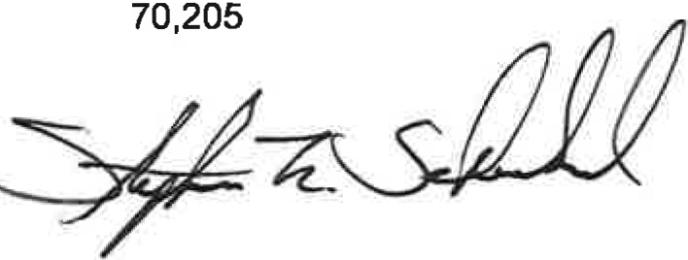

Stephen F. Scheckel

Chief of Police

UCR/YEARLY ACTIVITY REPORT - 2021

|  |  |  |  |  |  |  |  |  |  |  |  |  |  |
| --- | --- | --- | --- | --- | --- | --- | --- | --- | --- | --- | --- | --- | --- |
| JAN | | FEB | MAR | APRIL | MAY | JUNE | JULY | AUG | SEPT | OCT | NOV | DEC | TOTAL |
| HOMICIDE | 0 | 0 | 0 |  |  |  |  |  |  |  |  |  | 0 |
| RAPE | 0 | 0 | 0 |  |  |  |  |  |  |  |  |  | 0 |
| FORCIBLE FONDLING | 1 | 0 | 0 |  |  |  |  |  |  |  |  |  | 1 |
| ASSAULT | 3 | 2 | 4 |  |  |  |  |  |  |  |  |  | 9 |
| ROBBERY | 1 | 0 | 1 |  |  |  |  |  |  |  |  |  | 2 |
| BURGLARY | 0 | 1 | 0 |  |  |  |  |  |  |  |  |  | 1 |
| LARCENY | 12 | 6 | 14 |  |  |  |  |  |  |  |  |  | 32 |
| MTR VEHICLE THEFT | 1 | 2 | 2 |  |  |  |  |  |  |  |  |  | 5 |
| ADULT ARREST | 16 | 12 | 14 |  |  |  |  |  |  |  |  |  | 42 |
| JUVENILE ARREST | 0 | 1 | 4 |  |  |  |  |  |  |  |  |  | 5 |
| TOTAL ARREST | 16 | 13 | 18 |  |  |  |  |  |  |  |  |  | 47 |
| ACCIDENTS | 48 | 38 | 37 |  |  |  |  |  |  |  |  |  | 123 |
| INJURIES | 18 | 3 | 6 |  |  |  |  |  |  |  |  |  | 27 |
| FATALITIES | 0 | 0 | 0 |  |  |  |  |  |  |  |  |  | 0 |
| TOTAL ACCIDENTS | 48 | 38 | 37 |  |  |  |  |  |  |  |  |  | 123 |
| VANDALISM | 2 | 3 | 5 |  |  |  |  |  |  |  |  |  | 10 |
| **TRAFFIC** |  |  |  |  |  |  |  |  |  |  |  |  |  |
| STATE VIOLATIONS | 70 | 42 | 78 |  |  |  |  |  |  |  |  |  | 190 |
| LOCAL VIOLATIONS | 36 | 40 | 82 |  |  |  |  |  |  |  |  |  | 158 |
| TOTAL TRAFFIC | 106 | 82 | 160 |  |  |  |  |  |  |  |  |  | 348 |
| WARNINGS | 204 | 195 | 242 |  |  |  |  |  |  |  |  |  | 641 |
| TOT*AU*ALARMS | 33 | 45 | 67 |  |  |  |  |  |  |  |  |  | 145 |
| FIELD CONTACTS | 0 | 0 | 0 |  |  |  |  |  |  |  |  |  | 0 |
| NO. MILES PATROLED | 22,750 | 22,425 | 25,030 |  |  |  |  |  |  |  |  |  | 70,205 |