**SUBMISSION FORM**

Town of Munster / Munster Civic Foundation

**Beauty & the Box Utility Box Art Designs**

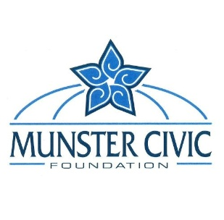

***NOTE: to be considered, this completed form must accompany your submission. All submissions are to be emailed to the Munster Civic Foundation by 5pm CST, Friday, June 20, 2025 (***[***CivicFoundation@munster.org***](mailto:CivicFoundation@munster.org)***).***

Your Name Click or tap here to enter text.

Business Name (if applicable) Click or tap here to enter text.

Your Street Address Click or tap here to enter text.

City / Town Click or tap here to enter text. State Click or tap here to enter text.

Telephone Number Click or tap here to enter text.

Email Address Click or tap here to enter text.

Your Website and/or Social Media Address(s)

Click or tap here to enter text.

**How Many Designs Are You Submitting?** Click or tap here to enter text.

***NOTE:*** *please do not submit more than 3*

**How Will You Be Submitting Your Designs?** (please check from the options below)

Supplying the MCF with URL link(s) to the design(s) or folder

(see next page for where to place links)

As an attachment to the email you are submitting this completed submission form

Inserting a design concept in the designated area(s) on the following pages

Other (please indicate): Click or tap here to enter text.



**URL link(s) for your submissions**

Click or tap here to enter text.

**Design Concept 1**





**Design Concept 2**





**Design Concept 3**

