UCR /MONTHLY ACTIVITY REPORT - MONTH | OF JUNE | June, 2022 | June,2021 | Year to Date | Year to Date
 |  | No of | No Of | 2021 | 2022
HOMICIDE |  | 0 | 0 | 0 | 0
RAPE |  | 2 | 0 | 2 | 3
FORCIBLE FONDLING |  | 0 | 0 | 4 | 12
ASSAULT |  | 4 | 5 | 19 | 10
ROBBERY |  | 1 | 2 | 4 | 2
BURGLARY |  | 1 | 4 | 7 | 6
LARCENY |  | 19 | 19 | 83 | 106
MTR VEHICLE THEFT |  | 0 | 1 | 7 | 6
ADULT ARREST |  | 22 | 22 | 94 | 127
JUVENILE ARREST |  | 4 | 2 | 12 | 28
TOTAL ARREST |  | 26 | 24 | 106 | 155
ACCIDENT/PUBLIC |  | 51 | 81 | 315 | 305
INJURIES/PUBLIC |  | 8 | 15 | 61 | 65
FATALITIES |  | 0 | 0 | 0 | 1
TOTAUACCIDENTS |  | 51 | 81 | 315 | 305
VANDALISM |  | 13 | 12 | 34 | 32
TRAFFIC ARREST
STATE VIOLATIONS |  | 85 | 89 | 436 | 681
LOCAL VIOLATIONS |  | 125 | 73 | 394 | 492
TOTAL TRAFFIC |  | 210 | 162 | 830 | 1173
WARNINGS |  | 272 | 209 | 1318 | 1697
TOTAL ALARMS  NO MILES PATROLED |  | 51  20,553 | 75  23,660 | 352  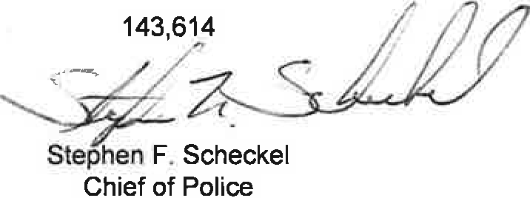  146,054 | 330

UCRNEARLY ACTIVITY REPORT - 2022

 | JAN | FEB | MAR | APRIL | MAY | JUNE | JULY | AUG | SEPT | OCT | NOV | DEC | TOTAL
HOMICIDE | 0 | 0 | 0 | 0 | 0 | 0 |  |  |  |  |  |  | 0
RAPE | 0 | 1 | 0 | 0 | 0 | 2 |  |  |  |  |  |  | 3
ASSAULT | 2 | 2 | 6 | 0 | 2 | 0 |  |  |  |  |  |  | 12
FORCIBLE FONDLING | 1 | 0 | 0 | 4 | 1 | 4 |  |  |  |  |  |  | 10
ROBBERY | 0 | 0 | 0 | 1 | 0 | 1 |  |  |  |  |  |  | 2
BURGLARY | 2 | 1 | 1 | 1 | 0 | 1 |  |  |  |  |  |  | 6
LARCENY | 15 | 16 | 24 | 12 | 20 | 19 |  |  |  |  |  |  | 106
MTR VEHICLE THEFT | 1 | 1 | 0 | 2 | 2 | 0 |  |  |  |  |  |  | 6
ADULT ARREST | 19 | 18 | 27 | 18 | 23 | 22 |  |  |  |  |  |  | 127
JUVENILE ARREST | 2 | 3 | 6 | 2 | 11 | 4 |  |  |  |  |  |  | 28
TOTAL ARREST | 21 | 21 | 33 | 20 | 34 | 26 |  |  |  |  |  |  | 155
ACCIDENTS | 64 | 46 | 44 | 52 | 48 | 51 |  |  |  |  |  |  | 305
INJURIES | 8 | 8 | 21 | 9 | 11 | 8 |  |  |  |  |  |  | 65
FATALITIES | 0 | 0 | 0 | 1 | 0 | 0 |  |  |  |  |  |  | 1
TOTAL ACCIDENTS | 64 | 46 | 44 | 52 | 48 | 51 |  |  |  |  |  |  | 305
VANDALISM | 3 | 2 | 4 | 4 | 6 | 13 |  |  |  |  |  |  | 32
TRAFFIC
STATE VIOLATIONS | 112 | 127 | 138 | 103 | 116 | 85 |  |  |  |  |  |  | 681
LOCAL VIOLATIONS | 72 | 81 | 53 | 42 | 119 | 125 |  |  |  |  |  |  | 492
TOTAL TRAFFIC | 184 | 208 | 191 | 145 | 235 | 210 |  |  |  |  |  |  | 1173
WARNINGS | 215 | 295 | 317 | 288 | 310 | 272 |  |  |  |  |  |  | 1697
TOTAL/ALARMS | 55 | 60 | 57 | 45 | 62 | 51 |  |  |  |  |  |  | 330
FIELD CONTACTS | 0 | 0 | 0 | 0 | 0 | 0 |  |  |  |  |  |  | 0
NO. MILES PATROLED | 21,181 | 25,334 | 26,224 | 26,200 | 24,122 | 20,553 |  |  |  |  |  |  | 143,614

