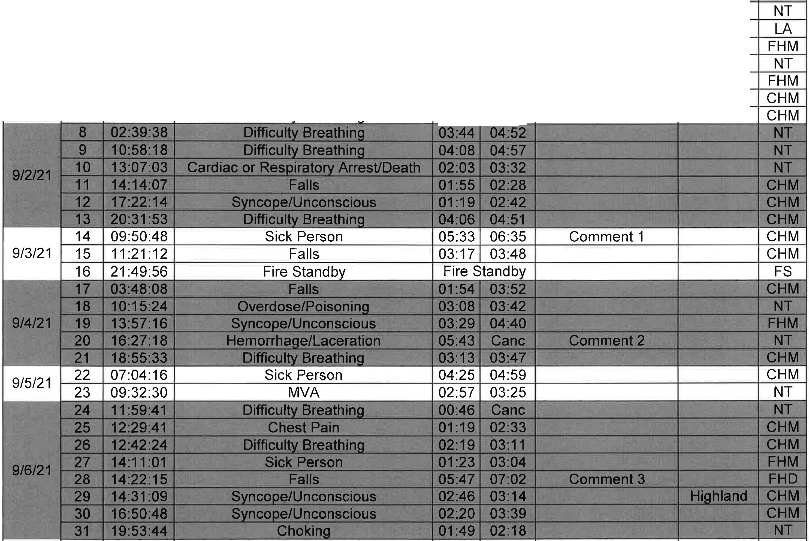
D t I Trip Call Time Nature Resp Time Response Delay Mutual I Dest
a e ID
Time To PT Aide City

1 09:28 :35 MVA 03:13 Cane
- 10:40:56 Lift Assist Lift Assist
- 11:14:39 Sick Person 02:48 04:00 I Railroad Crossin 911121 I 4 14:54:19 Syncope/Unconscious 01 :26 02:30
5 16:52:48 Sick Person 01:51 02:12
6 17:30:16 Falls 01:20 02:01
7 22:13:07 Difficultv Breathina 03:38 04:12
5

Page 1 of 12 '
32  33  34 | 06:42:48 | Sick Person | 03:36 | 04:12 |  |  | CHM
 | 08:25:07 | Falls | 02:36 | 02:53 |  |  | CHM
 | 09:19:23 | Sick Person | 02:08 | 03:08 |  |  | CHM
35 | 10:45:51 | Seizure/Convulsions | 03:52 | Cane |  |  | NT

Date | Trip  ID | Call Time | Nature | Resp Time | Time To PT | Response Delay | Mutual Aide City | Dest
9/7/21 | 36 | 11:10:44 | Falls | 02:25 | 03:56 |  |  | CHM
 | 37 | 12:04:33 | Sick Person | 03:26 | 04:27 |  |  | CHM
 | 38 | 12:11:10 | Difficulty Breathing | 13:21 | 16:33 | Mutual Aid/  Comment 4 | Dyer | FHM
 | 39 | 12:11:00 | Sick Person | 08:03 | 09:00 | Mutual Aid | HiQhland | CHM
 | 40 | 12:54:02 | Diabetic Problems | 01:20 | 01:58 |  |  | CHM
 | 41 | 13:09:09 | Cardiac or Respiratory Arrest/Death | 04:17 | 04:57 |  |  | NT
 | 42 | 16:46:47 | Lift Assist | Lift Assist |  |  |  | LA

Page 2 of 12

Date Trip ICall Time
Nature
ID

43 I 17:40:17 Sick Person
!"'"".-::... 'Lo
Resp I Time

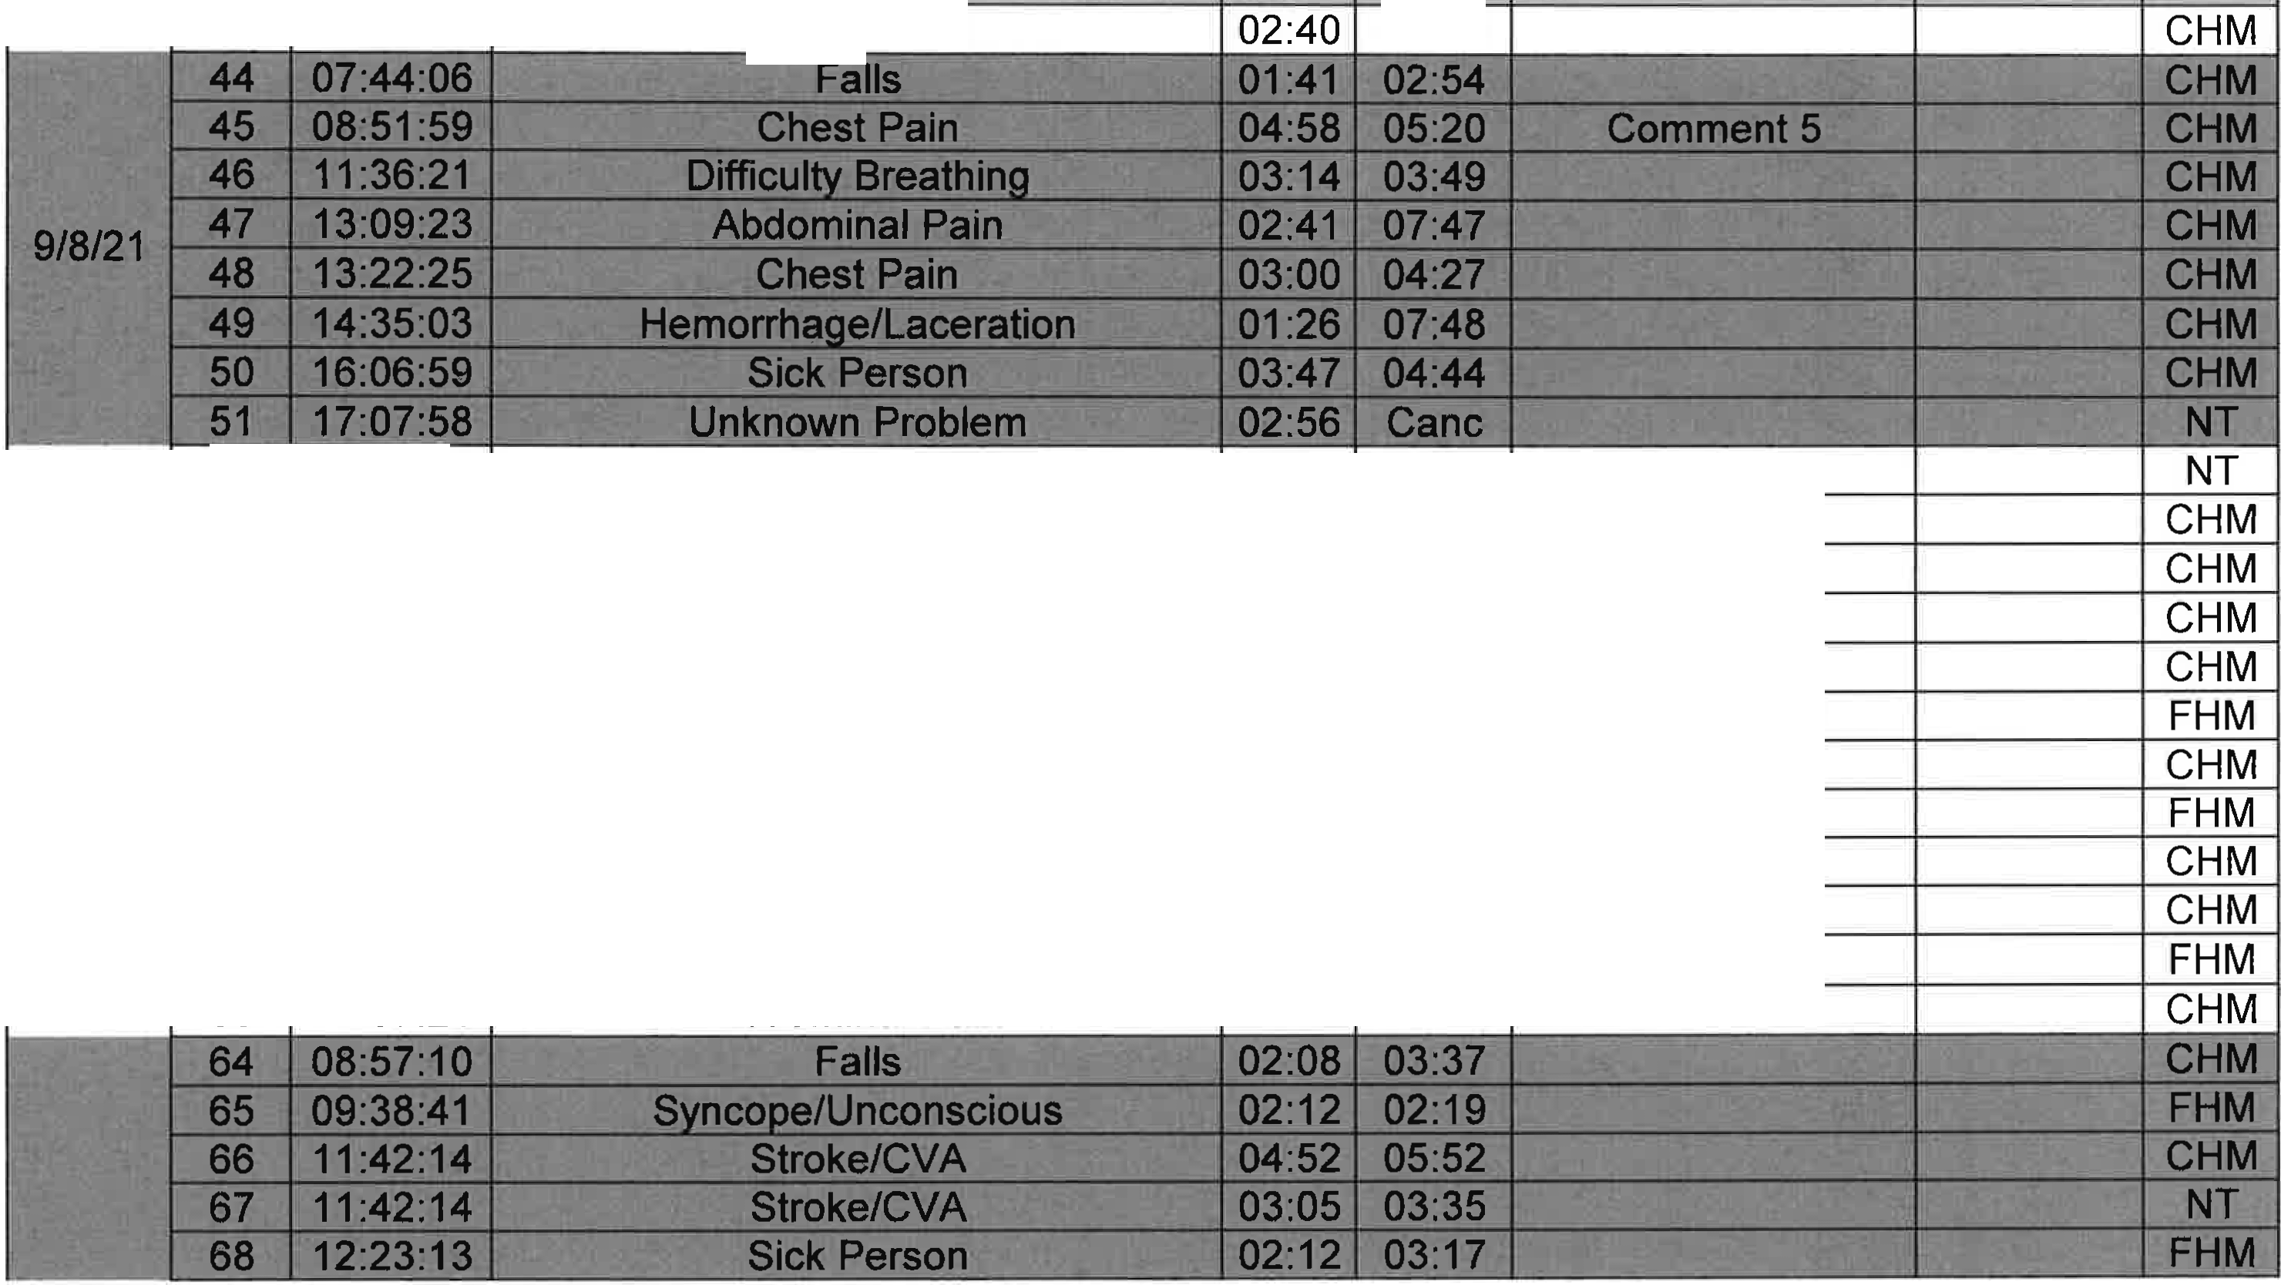
Time To PT Response Delay

03:43
Mutual I Dest Aide City

o _ -

9/9/21 I
52 | 02:52:02 | Pregnancy/Child birth | 01:24 | Cane
53 | 07:26:14 | Hemorrhage/Laceration | 03:40 | 03:49
54 | 08:25:46 | Syncope/Li nconscious | 02:45 | 04:05
55 | 09:13:06 | Syncope/Li nconscious | 02:14 | 03:50
56 | 11:21:47 | Diabetic Problems | 03:12 | 03:30
57 | 11:40:37 | Falls | 04:31 | 05:49 | I | Comment 6
58 | 15:27:51 | Sick Person | 03:20 | 04:09
59 | 15:56:18 | Chest Pain | 02:37 | 03:39
60 | 16:39:20 | MVA | 01:42 | 01:50
61 | 16:58:05 | Sick Person | 03:45 | 03:50
62 | 17:27:25 | Sick Person | 01 :36 | 03:35
63 | 17:57:21 | Abdominal Pain | 01 :28 | 02:34

I

Page 3 of 12

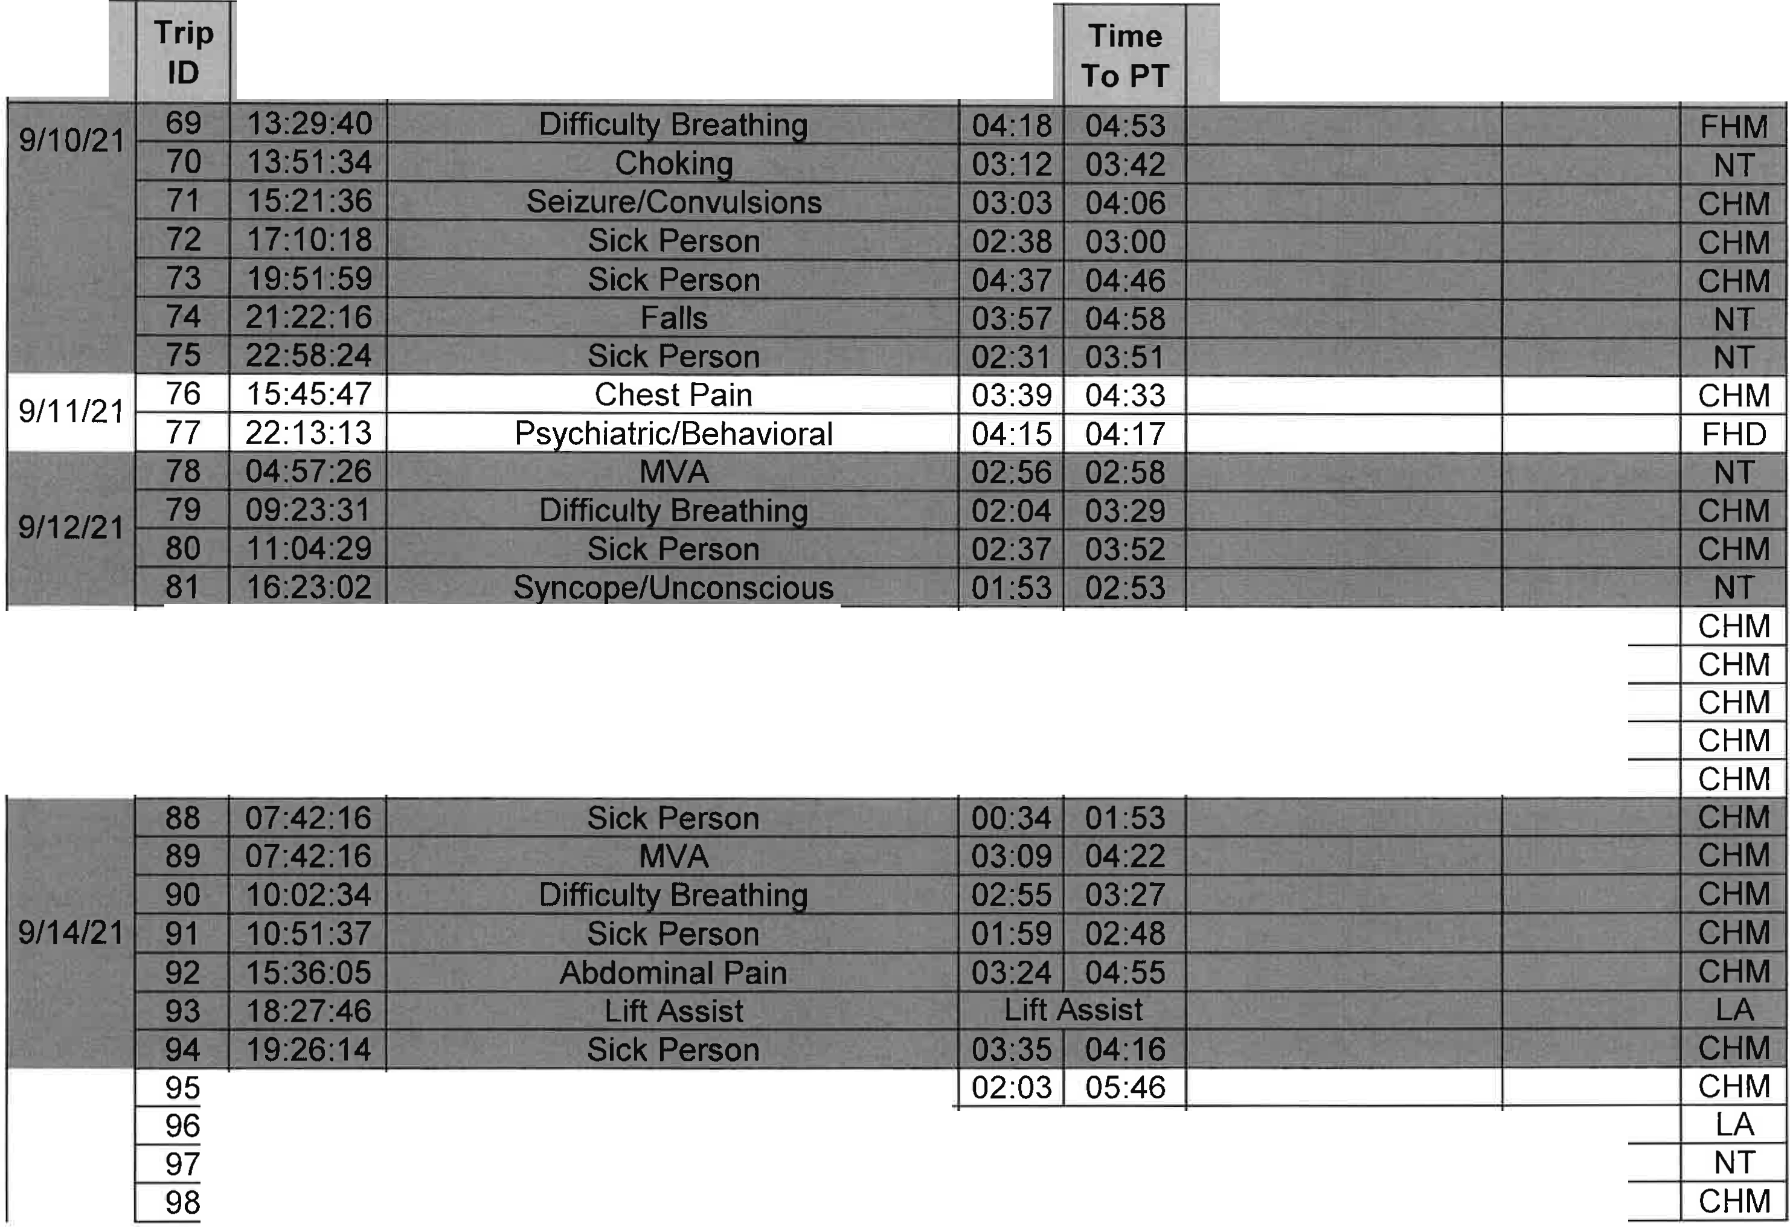
Date Call Time Nature Resp Time
Response Delay Mutual
Aide City

Dest

rs:,
12:02:12 | Heart Problems/AICD | 00:54 | 01:54
12:04:43 | Syncope/Unconscious | 03:37 | 04:37
12:12:10 | Syncope/Unconscious | 09:52 | 11:50 | I | Mutual Aid | I Over
14:13:35 | Difficulty Breathing | 03:54 | 04:16
17:47:41 | Falls | 03:14 | 04:19

 | 83
 | 84
9/13/21 I | 85
 | 86
 | 87

 | 03:39:13 | Hemorrhaae/Laceration
 | 04:24 :01 | Lift Assist | Lift Assist
 | 05:55:29 | Diabetic Problems | 03:53 | I 04:52
 | 08:58:17 | Difficultv Breathin | 03:28 | I 04:23

Page 4 of 12

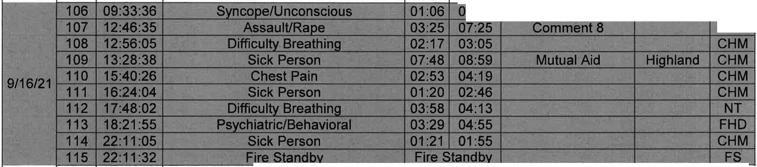
D t I Trip Call Time Nature Resp Time Response Delay Mutual I Dest
a e ID
Time To PT Aide City

99 09:06:14 Chest Pain 05:31 07:27 Comment 7 NT
9/15/21 I 1oo 09:11 :08 Chest Pain 03:14 04:32 HiQhland CHM
101 10:49:57 Sick Person 02:57 04:26 CHM
- 12:09:37 Syncope/Li nconscious 03:31 04:39 CHM
- 13:37:42 Syncope/Li nconscious 03:22 04:08 NT
- 13:31:59 Diabetic Problems 03:56 04:51 FHM
105 18:27:59 Falls 01:00 01:36 CHM

nt:5.5 '!,!-'- . ·'.\-:,.1,.l J•T/r.::. ·-: c
' ·-...&..:.

'\· •
CHM

. -_I. _ .. .;,-
<
CHM

 |  |  | II .
 | 116 | 00:23:01 | Chest Pain | 02:29 | 02:59 |  |  | CHM
 | 117 | 01:18:58 | Difficulty BreathinQ | 02:16 | 02:19 |  |  | CHM
 | 118 | 09:15:38 | Overdose/PoisoninQ | 03:32 | 04:44 |  |  | NT
 | 119 | 13:12:37 | Falls | 04:00 | 04:34 |  |  | CHM
9/17/21 I | 120 | 14:47:30 | Syncope/Linconscious | 03:41 | 04:24 |  |  | CHM
 | 121 | 17:33:31 | Sick Person | 03:27 | 04:21 |  |  | CHM
 | 122 | 19:36:29 | Bite/Sting (Non-Life Threatening) | 04:26 | 04:51 |  |  | NT
 | 123 | 21 :12:52 | llergic Reaction (Non-Life Threatening | 05:25 | Cane | Comment | 9 | NT
 | 124 | 21:37:17 | Falls | 05:46 | 05:49 | Comment | 10 | CHM

Page 5 of 12

Date
Trip 1 Call Time
ID

Nature
Resp Time

Response Delay
Mutual I Dest Aide City

9/19/21
02:24:15
04:40:28 Lift Assist
09:01:35 Back Pain 02:33 I 03:25
12:07:34 Back Pain 01:16 1 02:17

15:02:26 Seizure/Convulsions
J 03:0 04:34

"+= ·-- %" - - - - · ---- - i--:---:... - - .

149 09:03:39 Lift Assist Lift Assist LA
- 11:35:27 Seizure/Convulsions 00:38 01:58 CHM
- 11:55:32 Falls Cane NT
 | 153 | 12:41:57 | Chest Pain | 02:14 | 03:13 | CHM
 | 154 | 13:26:58 | Falls | 01:07 | 02:02 | CHM
9/21121 I | 155 | 13:49:32 | MVA | 01:36 | 03:03 | NT
 | 156 | 14:04:12 | Assaul URape | 02:35 | 03:29 | NT
157 14:41:44 Lift Assist Lift Assist LA

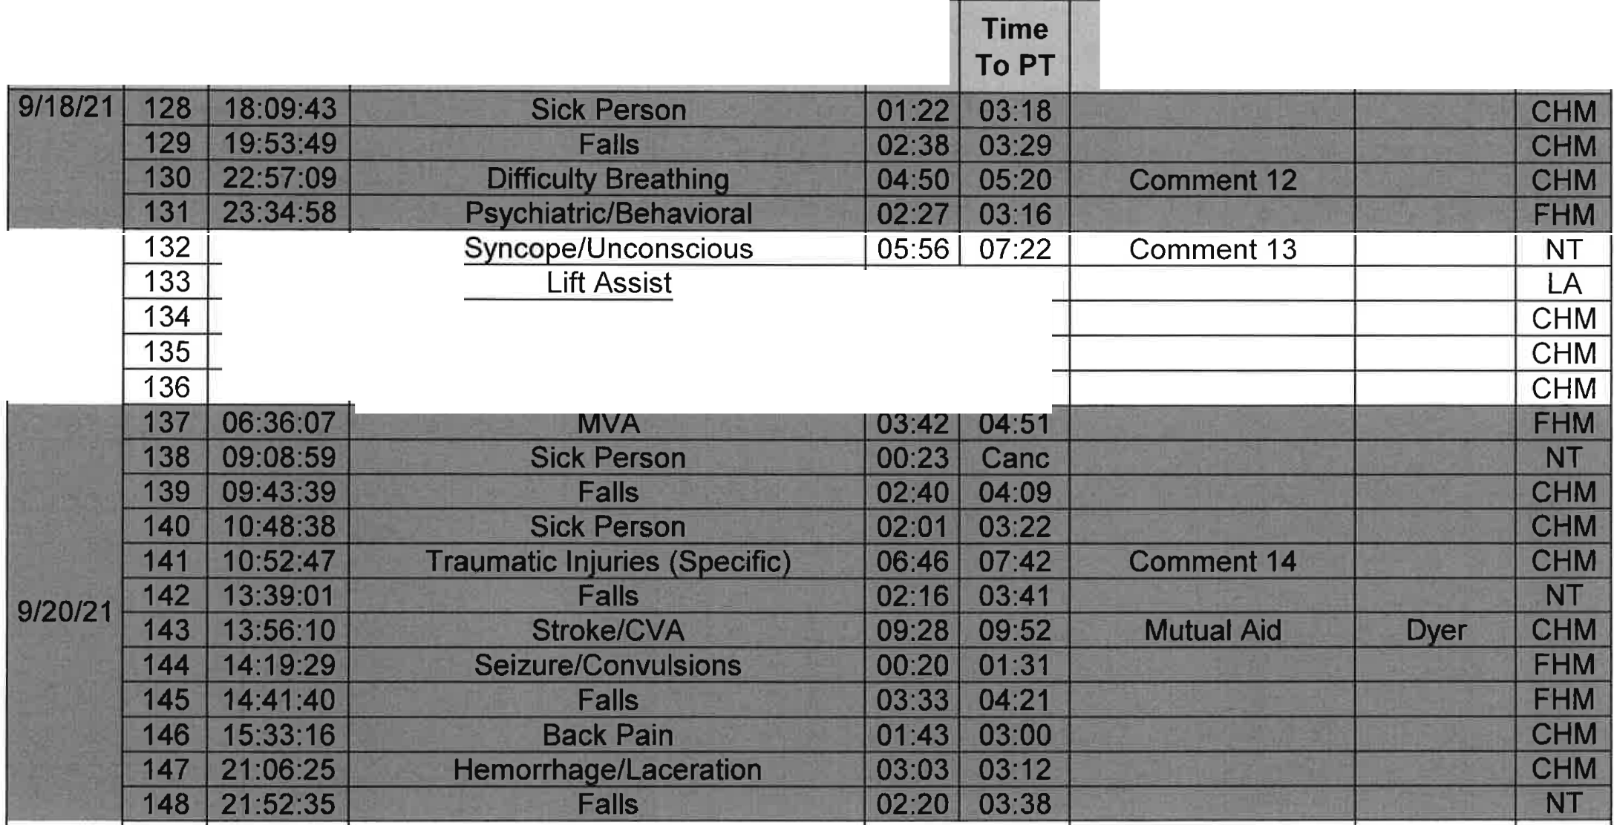
Page 6 of 12

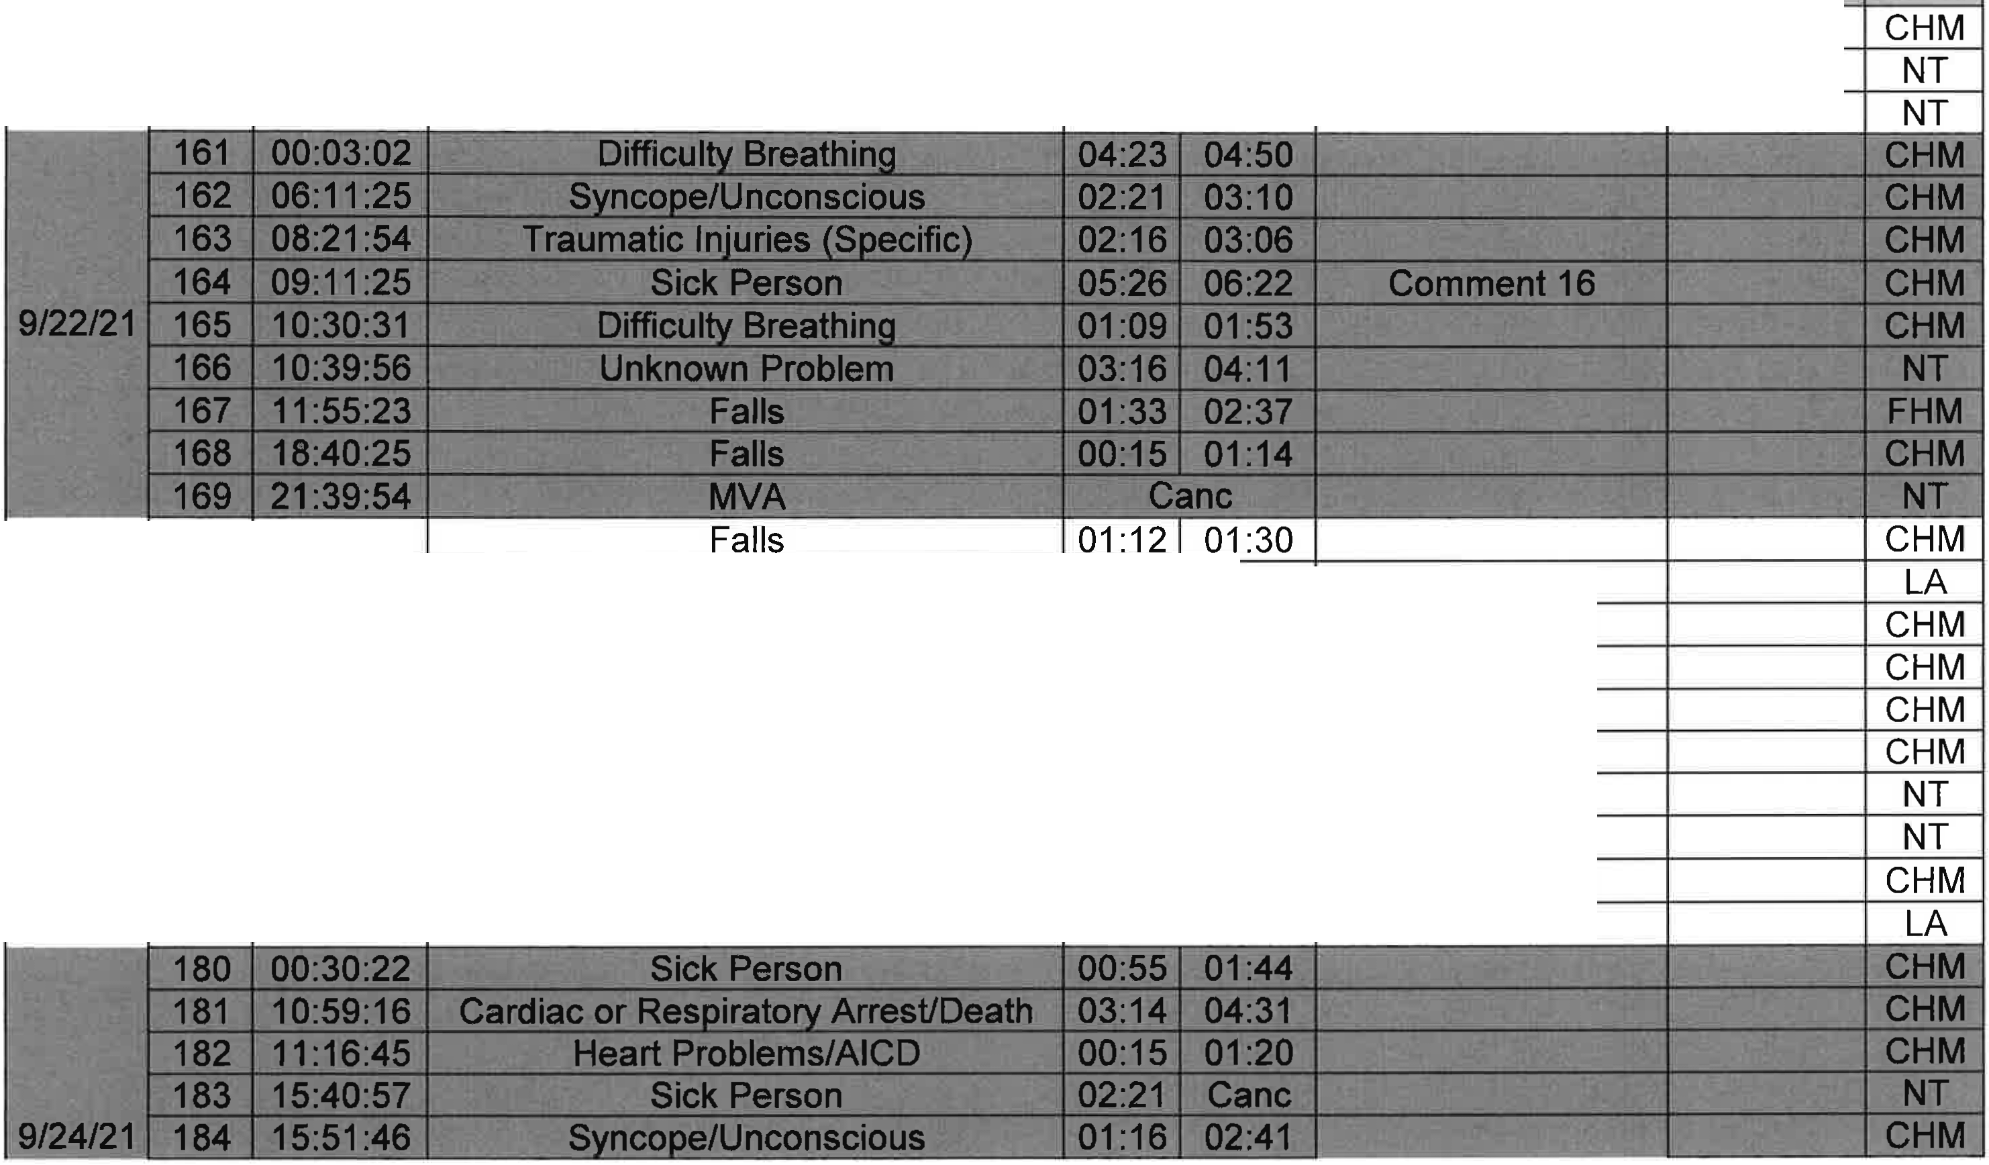
D t I Trip Call Time Nature Resp Time Response Delay Mutual I Dest
a e ID
Time To PT Aide City

158 | 15:19:10 | Psychiatric/Behavioral | 03:03 | 04:24
159 | 17:53:08 | Psychiatric/Behavioral | 05:30 | Cane | I | Comment | 15

160 18:52:41 Falls Cane

170 06:53:34
171 09:01 :49 Lift Assist Lift Assist

9/23/21 :
172  173  ; 176  177  178 | 09:06:51 | Sick Person | 04:45 | 05:40 | I | Comment | 17
 | 09:44:37 | Sick Person | 01:27 | 02:16
 | 11:41:16 | Psychiatric/Behavioral | 02:06 | 03:44
 | 15:03:13 | Chest Pain | 03:46 | 04:43
 | 15:05:54 | MVA | 04:10 | 04:46
 | 16:35:09  18:22:47 | Sick Person Sick Person | 02:11  09:28 | 03:33  10:24 | I | Comment | 18

179 23:34:51 Lift Assist Lift Assist

Page 7 of 12

Date Trip ICall Time
Nature
ID
Resp I Time
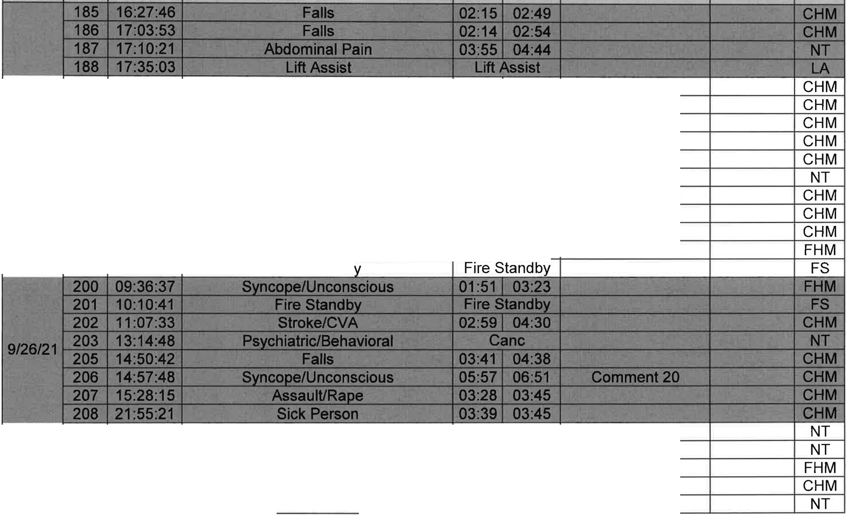
Time To PT Response Delay
Mutual
Aide City Dest

9/25/21 I
189 | 00:50:43 | Difficulty Breathing | 03:24 | 04:27
190 | 02:03:31 | Heart Problems/AICD | 01:41 | 02:56
191 | 08:05:04 | Syncope/Li nconscious | 02:24 | 03:56
192 | 10:40:26 | Sick Person | 03:40 | 04:44
193 | 10:49:22 | Difficulty BreathinQ | 03:41 | 04:38
194 | 13:52:32 | Sick Person | 00:45 | 02:04
195 | 13:58:17 | Sick Person | 05:13 | 06:13 I | Comment | 19
196 | 15:45:40 | Hemorrhage/Laceration | 01:23 | 02:11
197 | 16:20:03 | Stroke/CVA | 00:08 | 00:57
198 | 20:03:41 | Psychiatric/Behavioral | 01 :45 | 01:49
199 | 23:23:26 | Fire Standb

209 03:29:57 Falls Cane
210 03:31:46 MVA 00:00 00:09
211 03:29:23 Falls 11:23 11:37 I Comment 21
- 06:24:11 Cardiac or Respiratory Arrest/Death 01:33 01:36
- 08:44:09 Sick Person 03:03 Cane

Page 8 of 12

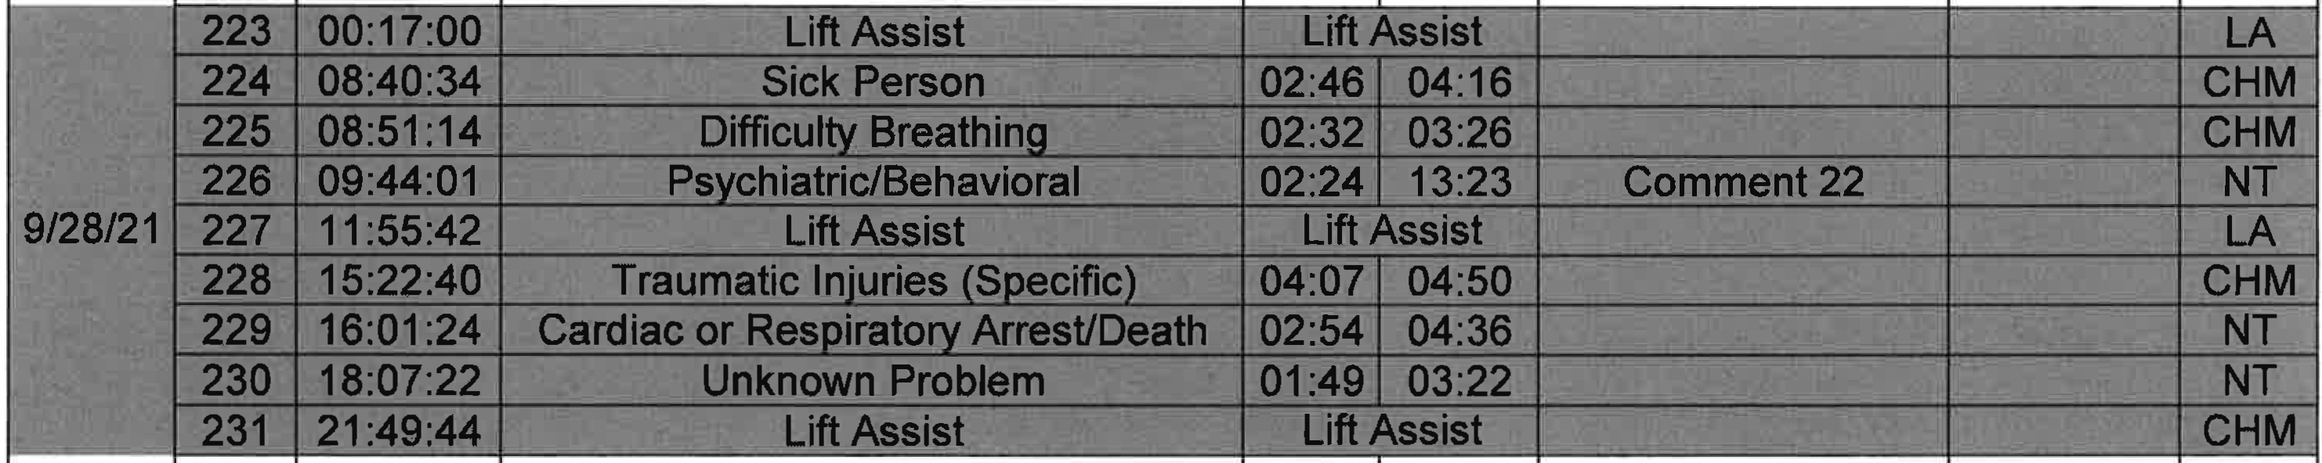
D t I Trip Call Time Nature Resp Time Response Delay Mutual I Dest
a e ID
Time To PT Aide City

214 10:02:31 Sick Person 01:35 02:31 CHM
9/27/21 1 215 11:08:13 Fire Standby Fire Standby FS
I 216 13:02:54 Syncope/Li nconscious 02:38 03:33 CHM
- 13:15:32 Cardiac or Respiratory ArresUDeath 02:44 Cane NT
- 13:28:18 Seizure/Convulsions 07:19 07:41 Mutual Aid HiQhland CHM 219 14:07:33 Stroke/CVA 02:57 03:59 NT
220 15:07:59 Falls 02:11 03:01 CHM
221 17:35:02 ShootinQ/StabbinQ 00:43 01:06 NT
222 18:28:41 Sick Person 02:19 02:37 CHM

232 01:24:09 MVA 02:23 03:07 CHM
233 04:52:02 Sick Person 00:06 00:54 FHM
234 07:23:47 Difficulty Breathing 05:22 06:41 Comment 23 CHM 9/29/21 I 236 13:23:27 Unknown Problem 02:14 Cane NT
I 237 14:36:14 Abdominal Pain 03:43 04:10 FHM
238 15:43:11 MVA 03:06 Cane NT
240 19:34:06 MVA 00:02 00:08 NT
241 22 :06:48 Chest Pain 02:27 04:06 CHM

Page 9 of 12

Date | Trip ID | Call Time | Nature | Resp Time | Time- To PT | Response Delay | Mutual Aide City | Dest
9/30/21 | 243 | 08:27:18 | Syncope/Unconscious | 02:14 | 02:17 |  |  | FHM
 | 244 | 10:22:02 | Sick Person | 01:49 | 02:58 |  |  | CHM
 | 245 | 10:29:06 | Stroke/CVA | 07:55 | 08:00 | Comment 24 |  | CHM
 | 246 | 10:55:38 | Sick Person | 07:06 | 07:42 | Mutual Aid | Hiahland | CHM
 | 247 | 11:42:45 | Svncope/Unconscious | 01:42 | 01:49 |  |  | CHM
 | 248 | 13:40:03 | MVA | 01:53 | 03:38 |  |  | NT
 | 250 | 10:55:38 | Sick Person | 04:00 | 04:06 |  |  | NT
 | 251 | 20:51:45 | Assault/Raoe | ' 03:18 | 03:21 | Comment 25 |  | FHM
Average Response Times 04:11 04: 22
l

Page 10 of 12

Date
Trip
ID
Call Time
Nature
Resp Time Response Delay Time To PT
Mutual Dest Aide City

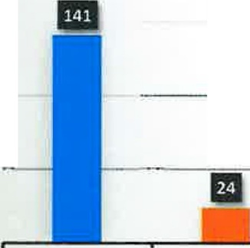
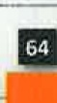
150
Destination Hospital Breakdown
-
I II
m

100

so

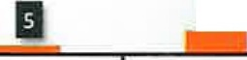
0
l"H M FH M F.HO <;Ql E I A NT

. -
Destination Hospital | Abbr | #Trans | Total Transports | 169
Community Hospital Munster | CHM | 141 | Non-Transports | 82
Franciscan Health Munster | FHM | 24 | Grand Total | 251
Franciscan Health Dyer | FHD | 3 | M.A Citv | #RESP
St Catherine Hospital | SCH | 1 | Over | 3
- Fire Stand Bv | FS | 5 | Highland | 6
Lift Assists | LA | 13 | Grand Total | 9
NO TRANSPORT | NT | 64
Grand Total |  | 251

- - - - ------ - = -
Comment 1- Call dispatched out quickly and was a 2.5 mile response from the ERV's posted Comment 2- PD needed to ensure scene safety due to call notes.
Comment 3- ERV respondingfrom prior call. Ambulane respondingfrom Base. Nursing Home Delay. Comment 4- Mutual aid was on a prior call when call came in. Responding from Dyer Hospital.
Comment 5- Call dispatched within 30 seconds. 2 mile response. ERV respondingfrom posted position. Comment 6- ERV was on Prior call. Ambulance responding from base.
Comment 7- ERV respondingfrom prior call on north side of town. Ambulance respondingfrom Base. Comment 8- Waiting for PD to ensure scene safety
Comment 9- No light and sirens due to request of person calling 911.
Comment 10- 2.6 mile response from ERV's posted position. Ambulance respondingfrom Base.
Comment 11- ERV was responding from having completed shift change early due to a change in an employee's schedule.
- Comment 12- Distance due to 2.2 mile response from ERV posted position. Was on scene before 5 minutes.
, Comment 13- ERV initially mapped the address incorrectly which caused a delay to scene.

Page 11 of 12

Comment 14- ERV responding from prior cal[Ambulance respondingfrom Base.
Date |  | Trip  ID | ICall Time | Nature | Resp Time | I Time To PT | Response Delay | Mutual Aide City | Dest

Comment 15- ERV was respondingfrom having completed shift change early due to a change in an employee's schedule Comment 16- ERV was assisting ambulance on prior call due to severity of patient. Ambulance respondingfrom Base.
Comment 17- ERV was on prior call. To patient delay due to being at an urgent care. Comment 18- ERV on shift change. Both ambulance and ERV respondingfrom base.
Comment 19- ERV on prior call. Ambulance responding from base.
I Comment 20- ERV on prior call. Ambulance respondingfrom base.
Comment 21- While Enroute to call,ERV and Ambulance rolled up on an accident. They initiated care and the second ambulance was dispatched 2.5 min into the call.
Comment 22- Awaiting PD to ensure scene safety for the crew.
Comment 23- ERV was using the facilites when the call came in which resulted in a delay. Comment 24- ERV on Prior Call. Ambulance respondingfrom base.

Page 12 of 12

Date T
rip ID  1  2  3  4  5  6  7  8 | Call Time | Nature | Resp Time Time To PT | Response Delay | Mutual Dest Aide City
 | 10:05:32 | Chest Pain | 01:32 03:20 |  | CHM
 | 10:58:55 | Stroke/CVA | 02:50 04:05 |  | CHM
 | 12:13:03 | Difficulty Breathing | 00:46 01:44 |  | CHM
 | 15:05:25 | Falls | 03:40 04:35 |  | CHM
 | 15:17:08 | Hemorrhage/Laceration | 05:39 06:07 | Comment 1 | CHM
 | 16:52:02 | Seizure/Convulsions | 01:27 03:58 |  | CHM
 | 18:52:52  19:58:12 | Stroke/CVA Psychiatric/Behavioral | 03:26 Cane  04:50 09:16 | PD Stage | NT  CHM
9 | 00:07:11 | Fire Standby | Fire Standby |  | FS

10/1/21

--

 | 10 | 10:13:53 | Unknown Problem | 02:57 | 03:07 | NT
 | 11 | 11:52:21 | Sick Person | 02:03 | 02:49 |  | NT
10/2/21 | 12 | 11:58:08 | Falls | 07:02 | 08:12 | Comment 2 | NT
 | 13 | 19:21:30 | Difficulty Breathing | 00:56 | 02:36 |  | CHM
 | 14 | 19:37:56 | Abdominal Pain | 03:49 | 04:48 |  | CHM
 | 15 | 21:07:16 | Falls | 01:09 | 02:28 |  | NT
 | 16 | 06:32:30 | Sick Person | 02:19 | 02:57 |  | CHM
 | 17 | 08:00:06 | Sick Person | 01:51 | 03:13 |  | FHM
 | 18 | 11:27:23 | Chest Pain | 02:01 | 02:48 |  | CHM
10/3/21 | 19 | 13:53:36 | Other/Medical | 03:30 | 04:07 |  | NT
 | 20 | 15:28:48 | Sick Person | 02:40 | 04:19 |  | CHM
 | 21 | 16:05:34 | Difficulty Breathing | 02:52 | 03:05 |  | CHM
 | 22 | 18:07:36 | Falls | 00:50 | 02:14 |  | NT
 | 23 | 07:09:36 | Sick Person | 02:08 | 02:24 |  | FHM
 | 24 | 07:48:28 | Sick Person | 00:45 | 01:30 |  | CHM
 | 25 | 09:45:23 | Difficulty Breathing | 01:55 | 03:37 |  | CHM
10/4/21 | 26 | 10:40:35 | Psychiatric/Behavioral | 02:26 | 11:25 | PD Stage | CHM
27 14:20:56 Lift Assist Lift Assist LA
-- | 28 | 22:19:01 | Overdose/Poisoning | 02:59 | Cane NT
 | 29 | 23:07:35 | Falls | 02:18 | 04:04 CHM

Page 1 of 11

Date | Trip ID | Call Time | Nature | Resp Time | Time To PT | Response Delay | Mutual Aide City | Dest
10/5/21 | 30 | 10:07:04 | Falls | 00:57 | 02:20 |  |  | CHM
 | 31 | 10:56:20 | Syncope/Linconscious | 02:05 | 02:45 |  |  | CHM
 | 32 | 11:20:36 | Lift Assist | Lift Assist |  |  |  | LA
 | 33 | 11:39:24 | Psychiatric/Behavioral | 02:27 | 03:54 |  |  | CHM
 | 34 | 11:39:48 | Psychiatric/Behavioral | 02:00 | 04:06 |  |  | SCH
 | 35 | 12:54:11 | Svncope/U nconscious | 02:41 | 03:37 |  |  | CHM
 | 36 | 13:13:38 | Falls | 02:33 | Cane |  |  | NT
 | 37 | 20:44:31 | Syncope/Unconscious | 02:24 | 02:27 |  |  | CHM
10/6/21 | 38 | 07:24:44 | Syncope/Unconscious | 03:51 | 04:57 |  |  | CHM
 | 39 | 08:21:14 | Sick Person | 04:08 | 04:56 |  |  | CHM
 | 40 | 09:09:00 | Sick Person | 03:56 | 04:42 |  |  | CHM
 | 41 | 10:02:29 | Stroke/CVA | 03:09 | 04:02 |  |  | CHM
 | 42 | 10:02:29 | Svncope/Unconscious | 03:09 | 03:52 |  |  | CHM
 | 43 | 10:51:51 | Heart Problems/AICD | 01:48 | 02:10 |  |  | FHM
 | 44 | 12:37:04 | Sick Person | 01:24 | 03:08 |  |  | FHM
 | 45 | 13:11:58 | Difficulty Breathing | 03:13 | 04:30 |  |  | CHM
 | 46 | 13:52:46 | Difficulty Breathing | 03:07 | 03:48 |  |  | CHM
 | 47 | 14:07:16 | Sick Person | 04:18 | 04:58 |  |  | CHM
 | 48 | 14:33:47 | Difficulty Breathing | 01:32 | 02:38 |  |  | CHM
 | 49 | 18:26:47 | Sick Person | 00:48 | 00:51 |  |  | CHM
 | 50 | 23:45:50 | Falls | 03:11 | 03:20 |  |  | NT
10/7/21 | 51 | 06:37:07 | Sick Person | 03:10 | 04:41 |  |  | CHM
 | 52 | 09:27:57 | Sick Person | 02:44 | 03:44 |  |  | CHM
 | 53 | 12:00:01 | Diabetic Problems | 00:52 | 02:28 |  |  | CHM
 | 54 | 17:06:32 | Traumatic Injuries (Specific) | 02:37 | 02:58 |  |  | CHM
 | 55 | 19:28:05 | Psychiatric/Behavioral | 03:16 | 04:40 |  |  | FHD
 | 56 | 22:11:35 | Lift Assist | Lift Assist |  |  |  | LA
 | 57 | 23:08:54 | Syncope/Linconscious | 01:01 | 02:06 |  |  | FHM

Page 2 of 11

Date Trip Call Time Nature Resp Time Response Delay Mutual Dest ID Time To PT Aide City

58 06:00:39 Falls 01:45 02:21 CHM
59 07:25:11 Falls 06:18 08:21 Comment 3 CHM
60 08:00:25 Falls 05:53 06:17 Comment 4 NT
61 09:23:22 Sick Person 02:45 04:27 CHM
10/8/21 62 10:42:36 Falls 02:19 04:29 CHM
- 11:43:19 Psychiatric/Behavioral 01:57 02:41 CHM
- 13:30:44 Heart Problems/AICD 03:05 03:31 SCH
65 15:12:01 MVA 03:36 04:42 CHM
66 16:08:25 MVA 03:23 04:38 NT
67 17:13:33 Falls 02:06 Cane NT
68 04:17:59 Cardiac or Respiratory Arrest/Death 03:05 04:23 FHM
69 10:51:20 Falls 03:49 04:57 NT
70 11:12:37 Lift Assist Lift Assist LA
71 11:34:06 Sick Person 01:20 03:54 CHM
- 11:56:34 Difficulty Breathing 02:42 03:42 CHM
- 13:11:04 Lift Assist Lift Assist CHM
10/9/21 74 13:18:31 Diabetic Problems 03:59 04:59 NT
- 14:42:42 Heart Problems/AICD 02:56 03:49 CHM
- 16:31:28 Cardiac or Respiratory Arrest/Death 03:08 04:32 NT
- 16:46:19 Psychiatric/Behavioral 02:08 03:43 CHM
78 18:03:03 Unknown Problem 00:21 01:05 NT
79 18:47:32 MVA 00:16 Cane NT
80 20:04:59 MVA 03:26 03:51 CHM
81 23:58:11 Sick Person 01:00 01:19 NT
82 08:48:27 Sick Person 01:29 01:33 CHM
- 09:56:31 llerQic Reaction (Non-Life ThreateninQ 02:52 03:37 CHM
- 10:25:08 Difficulty Breathing 02:15 03:52 CHM
10/10/21 85 11:20:18 Stroke/CVA 03:31 03:42 CHM
86 15:52:42 Difficulty Breathing 02:42 04:18 NT
87 16:44 :50 Falls 07:09 08:05 Comment 5 CHM
- 16:46:00 Syncope/Unconscious 06:40 07:00 Comment 6 CHM
- 16:54:31 Sick Person 14:43 15:49 Mutual Aid Dyer NT

Page 3 of 11

10/11/21
10/12/21
10/13/21

Date | Trip ID | Call Time | Nature | Resp Time | Time To PT | Response Delay | Mutual Aide City | Dest
 | 90 | 08:51 :03 | Lift Assist | Lift Assist |  |  |  | CHM
 | 91 | 09:30:20 | Fire Standby | Fire Standby |  |  |  | FS
 | 92 | 13:02:29 | Difficulty Breathing | 03:15 | 04:00 |  |  | CHM
 | 93 | 13:11:05 | Falls | Lift Assist |  |  |  | NT
 | 94 | 13:47:51 | Psychiatric/Behavioral | 02:15 | 03:15 |  |  | CHM
 | 95 | 17:37:02 | Hemorrhage/Laceration | 01:29 | 03:50 |  |  | CHM
 | 96 | 07:50:21 | MVA | 00:51 | 01:44 |  |  | NT
 | 97 | 08:25:39 | Stroke/CVA | 04:16 | 04:56 |  |  | CHM
 | 98 | 07:50:21 | MVA | 00:51 | 01:41 |  |  | NT
 | 99 | 08:47 :18 | Difficulty Breathing | 02:13 | 03:36 |  |  | CHM
 | 100 | 10:36:29 | Sick Person | 01:36 | 02:31 |  |  | FHM
 | 101 | 12:16:37 | Falls | 02:28 | 04:55 |  |  | CHM
 | 102 | 12:21:22 | Sick Person | 06:33 | 07:15 | Comment 7 |  | CHM
 | 103 | 14:43:03 | MVA | 04:05 | 04:58 |  |  | CHM
 | 104 | 16:17:02 | Stroke/CVA | 03:05 | 03:58 |  |  | CHM
 | 105 | 18:03:11 | Falls | 02:59 | 04:22 |  |  | NT
 | 106 | 20:08:25 | Fire Standby | Fire Standby |  |  |  | FS
 | 107 | 22:58:43 | Sick Person | 02:45 | 03:41 |  |  | CHM
 | 108 | 00:28:34 | MVA | 00:25 | 01:05 |  |  | CHM
 | 109 | 05:31 :44 | Difficulty Breathing | 04:40 | 05:16 | Apartment Access |  | CHM
 | 110 | 07:56:58 | Falls | 03:59 | 06:07 | Apartment Access |  | NT
 | 111 | 09:08:35 | Difficulty Breathing | 00:55 | 01:27 |  |  | NT
 | 112 | 12:35 :42 | Unknown Problem | 03:42 | 04:55 |  |  | NT
 | 113 | 15:42:52 | Sick Person | 02:58 | 03:58 |  |  | CHM
 | 114 | 18:16:03 | Chest Pain | 02:36 | 03:57 |  |  | CHM
 | 115 | 18:58:59 | Chest Pain | 00:50 | 03:56 |  |  | CHM
 | 116 | 21:36:39 | Falls | 02:05 | 03:21 |  |  | CHM

Page 4 of 11

Date Trip ID  117  118  119  120  121  122  123  124  10/14/21 125  126  127  128  129  130  131  132  133  134  135  136  10/15/21 137  138  139  140  141 |  | Call Time | Nature | Resp Time Time To PT | Response Delay Mutual  Aide City | Dest
 |  | 04:51 :39  05:09:04  06:32:08  08:17:53  11:26:54 | Unknown Problem Falls  Cardiac or Respiratory ArresUDeath Sick Person  Sick Person | 02:58 Cane  04:00 04:56  01:18 02:52  02:49 04:07  01 :31 03:48 |  | NT FHM NT FHD CHM
 |  | 11:34:48 | Falls | 03:31 04:31 |  | CHM
 |  | 11:38:57 | Sick Person | 04:27 05:26 | Mutual Aid Dver | CHM
 |  | 13:15:59 | Sick Person | 02:42 03:36 |  | CHM
 |  | 13:38:37 | Unknown Problem | 03:09 04:10 |  | CHM
 |  | 14:58:13 | Sick Person | 02:41 Cane |  | NT
 |  | 15:17:04 | Sick Person | 03:15 04:16 |  | CHM
 |  | 15:55:26 | Falls | 08:59 10:26 | Mutual Aid Dver | NT
 |  | 15:43:48 | Sick Person | 03:27 04:12 |  | CHM
 |  | 15:54:15 | Falls | 09:20 Cane | Mutual Aid Over | NT
 |  | 16:34:02 | Difficulty Breathing | 02:12 03:13 |  | CHM
 |  | 18:58:35 | Sick Person | 01:14 01:20 |  | CHM
 |  | 19:09:17 | Unknown Problem | 03:15 03:36 |  | NT
 |  | 21 :59:25 | AssaulURape | 01:21 02:11 |  | CHM
 |  | 01 :51 :24 | Difficulty Breathino | 03:22 03:26 |  | CHM
 |  | 09:46:58 | Sick Person | 03:14 04:51 |  | CHM
 |  | 13:00:24 | Sick Person | 02:36 04:10 |  | CHM
 |  | 13:50:13 | Syncope/Unconscious | 02:01 02:47 |  | CHM
 |  | 20:01 :42 | Difficulty Breathing | 02:00 03:28 |  | CHM
 |  | 01 :01:23 | Sick Person | 01:17 02:47 |  | CHM
 |  | 11:48:14 | Heart Problems/AICD | 02:20 03:13 |  | FHM
 | 142 | 11:49:42 | Fire Standby | Fire Standby |  | FS
10/16/21 | 143 | 13:29:01 | Unresponsive | 02:43 03:29 |  | CHM
 | 144 | 17:27:10 | Lift Assist | Lift Assist |  | LA
 | 145 | 21 :15:51 | Falls | 03:18 04:51 |  | CHM
 | 146 | 23:13:32 | Chest Pain | 01:39 03:28 |  | CHM

Page 5 of 11

Page 6 of 11
Date Trip ID  147  148  10/17/21 149  150  -- 151  152  153  154  10/18/21 155  156  157  158 |  | Call Time | Nature | Resp Time Time To PT | Response Delay Mutual  Aide City | Dest
 |  | 03:29:52 | Assault/Rape | 02:43 04:04 |  | CHM
 |  | 12:09:58 | Falls | 02:36 03:45 |  | FHM
 |  | 12:30:05 | Chest Pain | 06:19 07:01 | Comment 8 | CHM
 |  | 16:00:23 | Sick Person | 02:28 03:16 |  | CHM
 |  | 19:45:04 | Seizure/Convulsions | 03:59 04:59 |  | CHM
 |  | 06:11 :46  07:41:56 | Cardiac or Respiratory Arrest/Death MVA | 03:22 04:47  04:05 04:55 |  | NT NT
 |  | 08:20:33 | Sick Person | 03:07 03:54 |  | CHM
 |  | 09:28:11 | Heart Problems/AICD | 07:36 09:33 | Comment 9 | CHM
 |  | 13:00:15 | Sick Person | 03:30 04:19 |  | SCH
 |  | 13:14:52  13:40:57 | MVA  Sick Person | 03:59 04:53  04:08 Cane |  | NT NT
 | 159 | 14:23:16 | Lift Assist | Lift Assist |  | LA
 | 160 | 00:31 :31 | Chest Pain | 01:35 02:29 |  | CHM
 | 161 | 00:55:54 | Chest Pain | 02:38 04:46 |  | CHM
 | 162 | 04:12:32 | Lift Assist | Lift Assist |  | LA
 | 163 | 09:16:45 | Sick Person | 01:15 02:39 |  | CHM
10/19/21 | 164 | 11:36:12 | Sick Person | 03:58 04:48 |  | CHM
 | 165 | 11:36:18 | Falls | 02:09 02:50 |  | CHM
 | 166 | 12:30:40 | Falls | 00:11 00:54 |  | CHM
 | 167 | 17:56:50 | Sick Person | 01 :11 03:10 |  | CHM
 | 168 | 19:06:29 | Difficulty Breathinq | 03:44 04:36 |  | CHM
 | 169 | 08:52:13 | Sick Person | 03:35 04:21 |  | CHM
 | 170 | 09:11:53 | Unknown Problem | 01:16 02:07 |  | CHM
 | 171 | 16:01:02 | Difficulty Breathing | 02:49 03:53 |  | CHM
10/20/21 | 172 | 16:59:41 | MVA | 03:18 03:29 |  | FHM
 | 173 | 18:04:57 | Syncope/LInconscious | 00:32 00:37 |  | CHM
 | 174 | 21:30:55 | Stroke/CVA | 01:57 02:00 |  | NT
 | 175 | 21:30:55 | Stroke/CVA | 04:07 04:54 |  | CHM

Date | Trip ID | Call Time | Nature | Resp Time | Time To PT | Response Delay |  | Mutual Aide City | Dest
10/21/21 | 176 | 02:32:03 | Falls | 02:01 | 02:44 |  |  |  | NT
 | 177 | 03:37:32 | Lift Assist | Lift Assist |  |  |  |  | LA
 | 178 | 09:22:31 | Syncope/Unconscious | 03:35 | 04:17 |  |  |  | CHM
 | 179 | 10:13:21 | Difficulty BreathinQ | 03:04 | 04:01 |  |  |  | FHM
 | 180 | 13:43:30 | Syncope/Unconscious | 01:03 | 02:13 |  |  |  | CHM
 | 181 | 19:22:34 | Difficulty Breathing | 02:52 | 04:52 |  |  |  | FHM
10/22/21 | 182 | 06:04:56 | Falls | 05:36 | 07:04 | Comment 10 |  |  | CHM
 | 183 | 11:10:44 | Falls | 03:08 | 04:10 |  |  |  | NT
 | 184 | 12:16:30 | Lift Assist | Lift Assist |  |  |  |  | LA
 | 185 | 12:48:55 | Stroke/CVA | 01:42 | 03:03 |  |  |  | CHM
 | 186 | 13:25:08 | Difficulty Breathing | 02:37 | 03:08 |  |  |  | CHM
 | 187 | 23:28:50 | Falls | 02:05 | 02:31 |  |  |  | CHM
10/23/21  --  10/24/21 | 188 | 13:04:22 | Difficulty Breathing | 01:22 | 01:28 |  |  |  | CHM
 | 189 | 14:27:48 | Sick Person | 01:01 | 01:07 |  |  |  | CHM
 | 190 | 15:12:02 | Difficulty Breathing | 02:08 | 02:13 |  |  |  | CHM
 | 191 | 17:32:03 | Falls | 00:54 | 01:01 |  |  |  | CHM
 | 192 | 18:01:35 | Heart Problems/AICD | 01:20 | 01:23 |  |  |  | CHM
 | 193 | 21:15:41 | Seizure/Convulsions | 00:11 | 01:29 |  |  |  | CHM
 | 194 | 00:00:39 | Falls | 02:28 | 02:32 |  |  |  | CHM
 | 195 | 09:57:00 | Sick Person | 01:45 | 03:47 |  |  |  | CHM
 | 196 | 12:26:24 | Falls | 00:12 | 03:36 |  |  |  | CHM
 | 197 | 12:56:21 | Falls | 01:29 | 02:38 |  |  |  | NT
 | 198 | 20:15:41 | Overdose/Poisonina | 02:22 | 04:10 |  |  |  | CHM

Page 7 of 11

Date | Trip ID | Call Time | Nature | Resp Time | Time To PT | Response Delay | Mutual Aide City | Dest
10/25/21  10/26/21 | 199 | 00:20:27 | Psychiatric/Behavioral | 02:39 | Cane |  |  | NT
 | 200 | 01:52:26 | Psychiatric/Behavioral | 03:13 | 03:16 |  |  | FHM
 | 201 | 02:27:32 | Unknown Problem | 02:54 | Cane |  |  | NT
 | 202 | 03:54:05 | Falls | 03:48 | 03:51 |  |  | CHM
 | 203 | 04:49:52 | Abdominal Pain | 01:02 | 01:33 |  |  | CHM
 | 204 | 08:57:19 | Unknown Problem | 03:46 | Cane |  |  | NT
 | 205 | 12:58:14 | Chest Pain | 02:45 | 03:52 |  |  | CHM
 | 206 | 13:29:27 | Sick Person | 03:03 | 03:33 |  |  | CHM
 | 207 | 14:29:26 | Sick Person | 03:47 | 04:56 |  |  | CHM
 | 208 | 15:07:14 | Sick Person | 04:24 | 04:46 |  |  | CHM
 | 209 | 15:18:30 | Sick Person | 00:50 | 01:48 |  |  | NT
 | 210 | 15:56:56 | Lift Assist | Lift Assist |  |  |  | LA
 | 211 | 17:50:13 | Chest Pain | 01 :10 | 03:37 |  |  | CHM
 | 212 | 20:59:22 | Cardiac or Respiratory Arrest/Death | 00:43 | 03:09 |  |  | NT
 | 213 | 23:48:49 | MVA | 00:10 | 02:48 |  |  | CHM
 | 215 | 12:55:57 | Heart Problems/AICD | 02:10 | 03:10 |  |  | CHM
 | 216 | 13:06:37 | Falls | 04:11 | 04:45 |  |  | CHM
 | 217 | 14:41:11 | Sick Person | 03:06 | 04:47 |  |  | CHM
 | 218 | 14:55:00 | Difficulty Breathing | 04:45 | 05:00 |  |  | CHM
 | 219 | 22:18:57 | Unknown Problem | 02:18 | 03:17 |  |  | NT
10/27/21 | 220 | 06:44:16 | Lift Assist | Lift Assist |  |  |  | LA
 | 221 | 09:04:49 | Difficulty Breathing | 02:55 | 03:13 |  |  | CHM
 | 222 | 09:50:18 | Sick Person | 03:52 | 04:51 |  |  | CHM
 | 223 | 11:12:44 | Syncope/Unconscious | 02:54 | 03:21 |  |  | CHM
 | 224 | 13:04:53 | Cardiac or Respiratory Arrest/Death | 01:59 | 02:57 |  |  | CHM
 | 226 | 14:15:39 | Sick Person | 00:32 | Cane |  |  | NT
 | 227 | 18:16:51 | Psychiatric/Behavioral | 02:24 | 04:04 |  |  | CHM
 | 228 | 20:13:08 | Seizure/Convulsions | 02:30 | 04:02 |  |  | CHM
10/28/21 | 229 | 00:58:36 | Heart Problems/AICD | 03:42 | 04:22 |  |  | CHM
 | 230 | 13:10:24 | Falls | 02:03 | 02:36 |  |  | CHM
 | 231 | 17:13:20 | Chest Pain | 01:40 | 02:10 |  |  | FHM
 | 232 | 17:32:57 | Lift Assist | Lift Assist |  |  |  | LA

Page 8 of 11

Date |  | Trip ID | Call Time | Nature | Resp Time | Time To PT | Response Delay | Mutual Aide City | Dest
10/29/21 |  | 233 | 04:18:13 | Falls | 03:58 | 05:23 | HOME ACCESS |  | NT
 |  | 234 | 08:40:18 | Seizure/Convulsions | 04:14 | 04:56 |  |  | CHM
 |  | 235 | 09:46:44 | Difficulty Breathino | 01:57 | 03:32 |  |  | CHM
 |  | 236 | 10:07:23 | Difficulty Breathino | 02:47 | 04:27 |  |  | CHM
 |  | 237 | 12:36:19 | Hemorrhaqe/Laceration | 02:47 | 04:39 |  |  | CHM
 |  | 238 | 15:03:39 | Syncope/Unconscious | 02:28 | 03:32 |  |  | NT
 |  | 239 | 16:29:54 | Falls | 03:19 | 04:52 |  |  | CHM
 |  | 240 | 17:57:31 | Lift Assist | Lift Assist |  |  |  | LA
 |  | 241 | 20:33:58 | Chest Pain | 03:26 | 03:36 |  |  | CHM
 |  | 242 | 21 :55:55 | Falls | 01:02 | 02:01 |  |  | NT
 | ' | 243 | 01:00:15 | Fire Standby | Fire Standby |  |  |  | CHMx3  FHMx2
10/30/21
 |  | 244 | 02:17:50 | Hemorrhaae/Laceration | 01:32 | 02:06 |  |  | CHM
 |  | 245 | 02:18:36 | Abdominal Pain | 03:10 | 03:39 |  |  | CHM
 |  | 246 | 03:45:26 | Sick Person | 04:11 | 04:13 |  |  | CHM
 |  | 247 | 04:02:05 | MVA | 00:38 | 01:03 |  |  | CHM
 |  | 248 | 04:51 :53 | Chest Pain | 01:54 | 01:56 |  |  | CHM
 |  | 249 | 05:34:14 | Lift Assist | Lift Assist |  |  |  | LA
 |  | 250 | 07:40:57 | Lift Assist | Lift Assist |  |  |  | LA
 |  | 251 | 10:39:36 | Falls | 01:44 | 03:37 |  |  | CHM
 |  | 252 | 11:37:29 | Difficultv Breathina | 01:50 | 03:01 |  |  | FHM
 |  | 253 | 12:41:58 | Heart Problems/AICD | 02:10 | 03:13 |  |  | CHM
 |  | 254 | 13:13:52 | Falls | 02:11 | 04:07 |  |  | CHM
 |  | 255 | 16:23:10 | Svncooe/Unconscious | 01:13 | Cane |  |  | CHM
 |  | 256 | 17:02:45 | Lift Assist | Lift Assist |  |  |  | FHM
 |  | 257 | 19:34:36 | Sick Person | 01:19 | 01:22 |  |  | NT
 |  | 258 | 21:53:45 | Falls | 01:13 | 02:31 |  |  | CHM
 |  | 259 | 22:50:19 | Sick Person | Cane |  |  |  | NT

Page 9 of 11

Date | Trip ID | Call Time | Nature | Resp Time | Time To PT | Response Delay | Mutual Aide City | Dest
10/31/21 | 260 | 09:25:09 | Svncope/Unconscious | 02:34 | 03:06 |  |  | CHM
 | 261 | 11:25:02 | Sick Person | 03:22 | 04:30 |  |  | CHM
 | 262 | 13:06:16 | MVA | 04:17 | 04:48 |  |  | CHM
 | 263 | 13:49:28 | Chest Pain | 01 :39 | 02:39 |  |  | FHM
 | 264 | 14:44:09 | Sick Person | 02:30 | 03:06 |  |  | CHM
 | 265 | 16:01:24 | Sick Person | Cane |  |  |  | NT
 | 266 | 17:42:03 | Sick Person | 01:09 | 02:17 |  |  | FHM
 | 267 | 20:49:43 | Psychiatric/Behavioral | 02:51 | 03:17 |  |  | FHD
 |  | Average Response Times 02:59 04:04

Page 10 of 11

Date
Trip
ID
Call Time
Nature
Resp Time Response Delay Time To PT
Mutual Dest Aide City

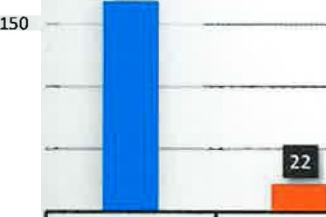
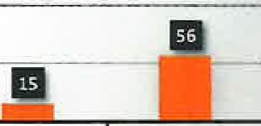
200
Ill

Destination Hospital Breakdown

100

II II a
so
0
rHM F.HM FHI) rH J.A NT

Destination Hospital | Abbr | #Trans | Total Transports | 196
Community Hospital Munster | CHM | 168 | Non-Transports | 75
Franciscan Health Munster | FHM | 22 | Grand Total | 271
Franciscan Health Dyer | FHD | 3 | M.A Citv | #RESP
St Catherine Hospital | SCH | 3 | Dver | 4
Fire Stand By | FS | 4 | Hi hland
Lift Assists | LA | 15 | Grand Total | 4
NO TRANSPORT | NT | 56
Grand Total |  | 271

Comment 1- Ambulance responding from base. Other ambulance and 2263 on another call
Comment 2- 2261 responding from having cleared prior call. Other ambulance and 2263 both on another call Comment 3- Chase car I 2263 out of service for maintenance. Ambulance responding from base
Comment 4- Chase car / 2263 out of service for maintenance. Responding from posted position but had distance delay Comment 5- Chase was originally enroute for this call but diverted to a more serious call. Ambulance responding from base
Comment 6- Chase car was originally enroute to above call but diverted to this one instead as it sounded more serious in nature.
Ambulance responding from base
Comment 7- Chase car / 2263 responding from previous call. Ambulance responding from base Comment 8- Chase car I 2263 on prior call. Ambulance responding from base
Comment 9- Call was toned out but tones were never received. Chase car was originally on a different call. Call was re-toned after 3 minutes.
Comment 10- Both chase car and ambulance responding from base due to time of chase car's shift change

Page 11 of 11

