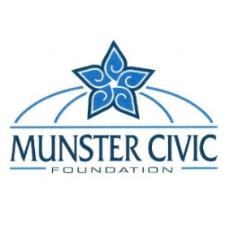

**ELECTRIFYING MUNSTER**

**Beauty & the Box Program**

**2025 Sponsorship Commitment Form**

**Sponsoring Entity Name**: Click or tap here to enter text.

**Contact**: Click or tap here to enter text.

**Full Address**: Click or tap here to enter text.

**Email**: Click or tap here to enter text. **Phone**: Click or tap here to enter text.

**__________________________________________________**

**Selected box:** *Please enter the number to your preferred box location. For details, refer to the location map & availability list. Be sure to note your top three (3) choices below. Your selection cannot be guaranteed until your deposit is received. If you wish to sponsor multiple boxes, please complete and return a separate form for each location.*

**1st Choice**: Click or tap here to enter text.

**2nd Choice**: Click or tap here to enter text.

**3rd Choice**: Click or tap here to enter text.

**Please select from one (1) of these options:**

**OPTION A:** $2,500.00 USD wrapping of box, installation, and $500 graphic artist stipend (to an artist from the MCF list).

**OPTION B**: $2,000.00 wrapping of box and installation (you will work with your own graphic artist to produce artwork within the outline parameters).

*\*The above noted sponsorship prices are guaranteed through 12/31/25*

A 50% deposit is due with the submission of this completed form. **Please make checks payable to** **Munster Civic Foundation**. Credit card payments will only be accepted in person in the Munster Clerk-Treasurer’s office. Deposits and completed forms can be mailed to: Munster Civic Foundation, 1005 Ridge Rd, Munster, IN 46321.

**__________________________________________________**

I agree with all terms outlined in the Sponsorship Details Section.  ***YES  NO***

**Signature**: ___________________________________________________ **Date**: Click or tap here to enter text.

**Printed Name**: Click or tap here to enter text.

**Company or Entity**: Click or tap here to enter text.