UCR /MONTHY ACTIVITY REPORT - MONTH | OF FEBRUARY | FEB, 2021 | FEB, 2020 | YEAR TO DATE | YEAR TO DATE
 |  | No Of | No Of | 2020 | 2021
HOMICIDE |  | 0 | 0 | 0 | 0
RAPE |  | 0 | 0 | 0 | 0
FORCIBLE FONDLING |  | 0 | - | - | 1
ASSAULT |  | 2 | 2 | 13 | 5
ROBBERY |  | 0 | 0 | 1 | 1
BURGLARY |  | 1 | 0 | 0 | 1
LARCENY |  | 6 | 16 | 30 | 18
MTR VEHICLE THEFT |  | 2 | 2 | 3 | 3
ADULT ARREST |  | 12 | 17 | 34 | 28
JUVENILE ARREST |  | 1 | 6 | 6 | 1
TOTAL ARREST |  | 13 | 23 | 40 | 29
ACCIDENTS |  | 38 | 66 | 119 | 86
INJURIES |  | 3 | 11 | 19 | 21
FATALITY |  | 0 | 0 | 0 | 0
TOTAL ACCIDENTS |  | 38 | 66 | 119 | 86
VANDALISM |  | 3 | 1 | 6 | 5
TRAFFIC VIOLATIONS
STATE VIOLATIONS |  | 42 | 137 | 217 | 112
LOCAL VIOLATIONS |  | 40 | 85 | 141 | 76
TOTAL TRAFFIC |  | 82 | 222 | 358 | 188
WARNINGS |  | 195 | 385 | 776 | 399
TOTAL ALARMS  NO MILES PATROLED |  | 45  22,425 | 57  17,291 | 116  42,880 | 78

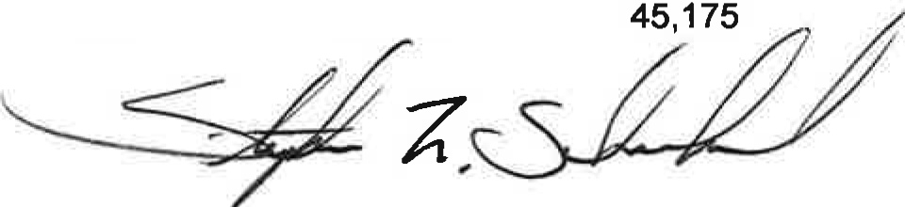
Stephen F. Scheckel Chief of Police

UCR/YEARLY ACTIVITY REPORT - 2021

 | JAN | FEB | MAR | APRIL | MAY | JUNE | JULY | AUG | SEPT | OCT | NOV | DEC | TOTAL
HOMICIDE | 0 | 0 |  |  |  |  |  |  |  |  |  |  | 0
RAPE | 0 | 0 |  |  |  |  |  |  |  |  |  |  | 0
FORCIBLE FONDLING | 1 | 0 |  |  |  |  |  |  |  |  |  |  | 1
ASSAULT | 3 | 2 |  |  |  |  |  |  |  |  |  |  | 5
ROBBERY | 1 | 0 |  |  |  |  |  |  |  |  |  |  | 1
BURGLARY | 0 | 1 |  |  |  |  |  |  |  |  |  |  | 1
LARCENY | 12 | 6 |  |  |  |  |  |  |  |  |  |  | 18
MTR VEHICLE THEFT | 1 | 2 |  |  |  |  |  |  |  |  |  |  | 3
ADULT ARREST | 16 | 12 |  |  |  |  |  |  |  |  |  |  | 28
JUVENILE ARREST | 0 | 1 |  |  |  |  |  |  |  |  |  |  | 1
TOTAL ARREST | 16 | 13 |  |  |  |  |  |  |  |  |  |  | 29
ACCIDENTS | 48 | 38 |  |  |  |  |  |  |  |  |  |  | 86
INJURIES | 18 | 3 |  |  |  |  |  |  |  |  |  |  | 21
FATALITIES | 0 | 0 |  |  |  |  |  |  |  |  |  |  | 0
TOTAL ACCIDENTS | 48 | 38 |  |  |  |  |  |  |  |  |  |  | 86
VANDALISM | 2 | 3 |  |  |  |  |  |  |  |  |  |  | 5
TRAFFIC
STATE VIOLATIONS | 70 | 42 |  |  |  |  |  |  |  |  |  |  | 112
LOCAL VIOLATIONS | 36 | 40 |  |  |  |  |  |  |  |  |  |  | 76
TOTAL TRAFFIC | 106 | 82 |  |  |  |  |  |  |  |  |  |  | 188
WARNINGS | 204 | 195 |  |  |  |  |  |  |  |  |  |  | 399
TOTAUALARMS | 33 | 45 |  |  |  |  |  |  |  |  |  |  | 78
FIELD CONTACTS | 0 | 0 |  |  |  |  |  |  |  |  |  |  | 0
NO. MILES PATROLED | 22,750 | 22,425 |  |  |  |  |  |  |  |  |  |  | 45, 175

