Administrative Special Order # 21-06

Date: July 1, 2021

Regarding: Restructure of Position

By order of the Chief of Police, effective immediately, the School Resource Officer will report directly to the Police Department's Administrative Lieutenant. This restructuring will allow for better unity of command and consolidate the D.A.R.E Officer and the School Resource Officer into a more cohesive unit. The organizational chart will be changed to reflect the reassignment.

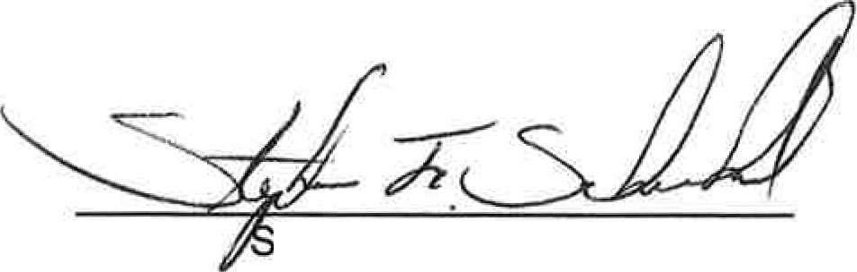

tephen F. Scheckel Chief of Police

cc: Dustin Anderson
Board of Safety Bulletin Board

1005 Ridge Road • Munster, IN 46321 • (219) 836-8810 • Fax (219) 836-6540 • Police I Fire Emergencies 911
Police Non-Emergency (219) 836-6600 • Fire Non-Emergency (219) 836-6960 www.munster.org

