POLICE DEPARTMENT DISBURSEMENTS

JANUARY 1-31, 2021

Date of Appropriation Number Vendor Services Amount Due
Invoice

12/8-22/20 | 249-21001-63105 | All City Management Services | Crossing Guard Services for: 11/22- 12/5/2020, 12/6-12/19/20 | $7,414.33
1/11/21 | 101-20101-62900 | American Express | Kitchen Supplies, Food for Officers | $233.59
 |  |  | Working Christmas, Donation for
 |  |  | Diane Hernandez
 | 217-20000-65150SWC |  | Shop With a Cop | $4,390 .26
 | 101-20101-63203 |  | Replenished I-Pass | $40.00
 | 101-20101-63908 |  | Amazon Prime Membership, Chiefs | $62.99
 |  |  | AMEX Membership Fee
 | 101-20401-62900 |  | Face Coverings for Officers, Snow | $261.41
 |  |  | Brushes for Squads
 | 101-20501-62900 |  | Batteries, USB's, Pens & Nameplates | $299.27
12/29/20- | 101-20401-62900 | Auto-Wares (Formerly Van | Battery on #5 & 26, Spark Plugs & | $360.41
1/16/21 |  | Senus) | Gaskets on 28
12/23/20 | 414-9152116-64775 | Axon Enterprises, Inc. | Portion of the Body Ca,mera/Taser | $5,875.00
 | 414-9152120-64775 |  | Contract | $85,775.00
12/29/20 | 217-20365-65150 | Bowman Displays | Display Board | $60.00
11/30-12/3/20 | 101-20401-62900 | Chicago Tire | 1 Tire on #33 , Repair Flat on #1 | $166.45
5/15/20 | 233-20109-63991 | Glock Professional, Inc. | Register Martin for Armorer Training | $250.00
 |  |  | 12/8 in Buffalo Grove
1/8-21/21 | 101-20401-62900 | Gus Back's Munster Ace | 4 Gallons of Windshield Wash & Sink | $10.75
 |  |  | Plunger
1/4/21 | 101-20101-63119 | Highland Police Department | July-December 2020 Animal Housing | $1,550.00
 |  |  | @ Highland Facility
1/22/21 | 101-20101-63908 | Indiana State Treasurer | Annual LESO Participation Fee | $200.00
12/22/20 | 101-20101-63908 | International Association of | Lohrentz's Annual Membership | $50.00
 |  | Law Enforcement Intelligence
 |  | Analysts
1/11/21 | 247-20101-63611 | Lake County Data Processing | Monthly Spillman Line Charges | $307.84
12/30/20 | 101-20401-62900 | Miner Electronics Corp. | Replace Antenna on #31 | $39.25
1/15/21 | 101-20401-63605 |  | Parts & Labor to Repair Cargo Box | $131.00
 |  |  | Rail in #31
12/19/20- | 217-20401-65150K9 | Munster Animal Hospital | Grooming Appointment for K9 Vader | $381.22
1/8/21 |  |  | & Office Visit Due to Illness
1/11/21 | 101-20401-63605 | Munster Car Wash | 4th Quarter Car Wash Club on | $1,907.50
 |  |  | Squads
1/7/21 | 217-20365-65150 | National Association of Town | Annual Membership | $35.00
 |  | Watch
12/20/20 | 101-20101-63908 | Northwest Indiana Major | Annual Membership | $200.00
 |  | Crimes Task Force

POLICE DEPARTMENT DISBURSEMENTS

JANUARY 1-31, 2021

Date of  Invoice  12/28/20 | Appropriation Number  217-20401-65150K9 | Vendor  Paw Palace, LLC. | Services  Dog Food for K9 Lucy | Amount Due  $625.00
12/29/20 | 101-20101-62900 | Pulse Technology | Desk Chair for Administrative | $447.00
 |  |  | Assistant
1/14/21 | 101-20401-63605 | Safety Training Services | Inspection of Fire Extinguishers & | $123.00
 |  |  | Recharge
12/17/20 | 414-9152117-64775 | Schneider Electric | Camera Work Done on Station & | $24,607.00
 |  |  | Hohman/Ridge
9/22-12/29/20 | 101-20403-62900 | Star Uniforms | Screen Screening VIPS Jackets & | $171.20
 |  |  | Belt, Hat for Chaplain
12/25/20 | 101-20101-63116 | Trans Union LLC | Professional Services Rendered | $100.00
1/1/21 | 101-20101-63903 | US Identification Manual | Annual Service Renewal Through | $82.50
 |  |  | 3/22
12/30/20- | 101-20401-63605 | Valvoline Express Care | Full Service Oil Change on #2, 5, 25, | $360.70
1/20/21 |  |  | 30, 35, 37, 39, 50
 |  |  | Grand Total | $136,517.67

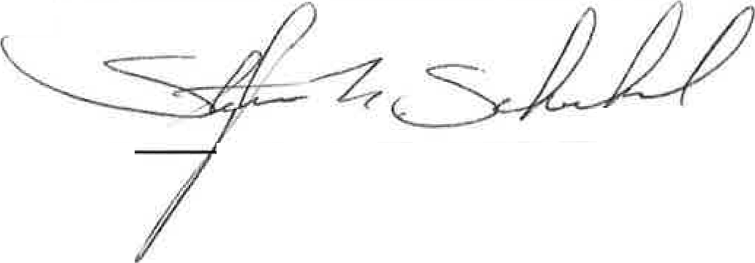
The above list of expenditures are within the Munster Police Department budget or are charged to other Town approved sources of funding. Claims for the above expenditures have been submitted to be approved by the Munster Town Council for payment.

Submitted by: ---.'---=---,=----=-=--=--=-
Stephen F. Scheckel

