UCR /MONTHY ACTIVITY REPORT - MONTH | OF JULY | JULY, 2021 | JULY, 2020 | Year to Date | Year to Date
 |  | No Of | No Of | 2020 | 2021
HOMICIDE |  | 0 | 0 | 0 | 0
RAPE |  | 1 | 0 | 0 | 3
FORCIBLE FONDLING |  | 1 | 0 | 1 | 5
ASSAULT |  | 9 | 6 | 46 | 28
ROBBERY |  | 0 | 1 | 4 | 4
BURGLARY |  | 3 | 1 | 7 | 10
LARCENY |  | 17 | 19 | 103 | 100
MTR VEHICLE THEFT |  | 0 | 5 | 11 | 7
ADULT ARREST |  | 18 | 29 | 117 | 112
JUVENILE ARREST |  | 0 | 2 | 21 | 12
TOTAL ARREST |  | 18 | 31 | 138 | 124
ACCIDENT/PUBLIC |  | 59 | 58 | 320 | 374
INJURIES/PUBLIC |  | 11 | 12 | 48 | 72
FATALITIES |  | 0 | 0 | 0 | 0
TOTAUACCIDENTS |  | 59 | 58 | 320 | 374
VANDALISM |  | 4 | 8 | 39 | 38

STATE VIOLATIONS | 69 | 80 | 440 | 505
LOCAL VIOLATIONS | 90 | 96 | 445 | 484
TOTAL TRAFFIC | 159 | 176 | 885 | 989
WARNINGS | 234 | 254 | 1649 | 1552
TOTAL ALARMS | 68 | 73 | 407 | 420
NO MILES PATROLED | 25,710 | 26,582 | 166,831

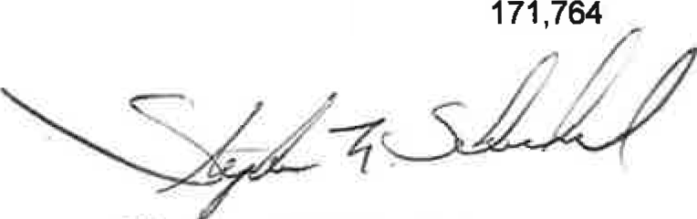
Stephen F. Scheckel Chief of Police

UCR/YEARLY ACTIVITY REPORT - 2021

JAN |  | FEB | MAR | APRIL | MAY | JUNE | JULY | AUG | SEPT | OCT | NOV | DEC | TOTAL
HOMICIDE | 0 | 0 | 0 | 0 | 0 | 0 | 0 |  |  |  |  |  | 0
RAPE | 0 | 0 | 0 | 1 | 1 | 0 | 1 |  |  |  |  |  | 3
FORCIBLE FONDLING | 1 | 0 | 0 | 1 | 2 | 0 | 1 |  |  |  |  |  | 5
ASSAULT | 3 | 2 | 4 | 3 | 2 | 5 | 9 |  |  |  |  |  | 28
ROBBERY | 1 | 0 | 1 | 0 | 0 | 2 | 0 |  |  |  |  |  | 4
BURGLARY | 0 | 1 | 0 | 2 | 0 | 4 | 3 |  |  |  |  |  | 10
LARCENY | 12 | 6 | 14 | 11 | 21 | 19 | 17 |  |  |  |  |  | 100
MTR VEHICLE THEFT | 1 | 2 | 2 | 0 | 1 | 1 | 0 |  |  |  |  |  | 7
ADULT ARREST | 16 | 12 | 14 | 16 | 14 | 22 | 18 |  |  |  |  |  | 112
JUVENILE ARREST | 0 | 1 | 4 | 3 | 2 | 2 | 0 |  |  |  |  |  | 12
TOTAL ARREST | 16 | 13 | 18 | 19 | 16 | 24 | 18 |  |  |  |  |  | 124
ACCIDENTS | 48 | 38 | 37 | 50 | 61 | 81 | 59 |  |  |  |  |  | 374
INJURIES | 18 | 3 | 6 | 11 | 8 | 15 | 11 |  |  |  |  |  | 72
FATALITIES | 0 | 0 | 0 | 0 | 0 | 0 | 0 |  |  |  |  |  | 0
TOTAL ACCIDENTS | 48 | 38 | 37 | 50 | 61 | 81 | 59 |  |  |  |  |  | 374
VANDALISM | 2 | 3 | 5 | 6 | 6 | 12 | 4 |  |  |  |  |  | 38
TRAFFIC
STATE VIOLATIONS | 70 | 42 | 78 | 70 | 87 | 89 | 69 |  |  |  |  |  | 505
LOCAL VIOLATIONS | 36 | 40 | 82 | 62 | 101 | 73 | 90 |  |  |  |  |  | 484
TOTAL TRAFFIC | 106 | 82 | 160 | 132 | 188 | 162 | 159 |  |  |  |  |  | 989
WARNINGS | 204 | 195 | 242 | 226 | 242 | 209 | 234 |  |  |  |  |  | 1552
TOTAUALARMS | 33 | 45 | 67 | 64 | 68 | 75 | 68 |  |  |  |  |  | 420
FIELD CONTACTS | 0 | 0 | 0 | 0 | 0 | 1 | 0 |  |  |  |  |  | 1
NO. MILES PATROLED | 22,750 | 22,425 | 25,030 | 24,557 | 27,632 | 23,660 | 25,710 |  |  |  |  |  | 171,764

