MUNSTER FIRE DEPARTMENT DISBURSEMENTS
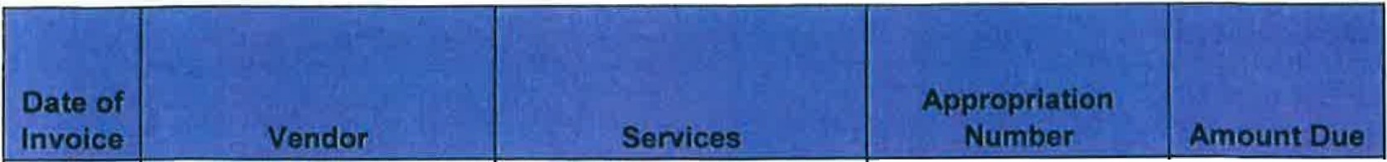
COVERING PERIOD FROM January 14 - February 17,2021

12/2/20 | Milne Supply | Piping for bathroom | 414-915-2117-64202 | $ | 59.95
12/31/20 | Mechanical Concepts | Heat Repair St. 1 | 101-12201-63609 | $ | 1,013.79
12/31/20 | Mechanical Concepts | Heat Repair St. 1 | 101-12201-63609 | $ | 1,117.08
1/14/21 | Valvoline Express Care | Oil Change #2202 | 101-23001-63602 | $ | 58.95
1/16/21 | Staples | Monitor for Radio Table | 402-23201-62900 | $ | 229 .99
1/16/21 | Staples | Wall Mount for monitor | 402-23201-62900 | $ | 39.49
 |  | Batteries, screws, wall
1/19/21 | Gus Bock | plates | 101-23001-62900 | $ | 31.88
1/13/21 | Gus Bock | Varnish/paintbrush | 101-23001-62900 | $ | 22.98
1/13/21 | Jose Serrano | BLS Instructor Renewal | 101-23201-63991 | $ | 50.00
1/25/21 | Active 911 | 2021 Renewal | 247-11402-63611 | $ | 762.50
1/17/21 | Pulse Technolgy | Furniture for Chiefs Office | 402-23201-R62900 | $ | 3,738.95
 |  | Fire Inspector Recert for
2/1/21 | NFPA | Andrew Giordano | 101-23201-63991 | $ | 150.00
1/22/21 | Gus Bock | Spray paint | 101-23001-62900 | $ | 21.54
1/15/21 | Fire Service | Drain valve on #2226 | 101-23001-62302 | $ | 526.10
1/21/21 | Grainger | Tool bag/sledgehammer | 101-23001-62303 | $ | 237.30
2/2/21 | The BlowHard Company | Ventilation Fan | 101-23001-62302 | $ | 600.00
12/9/20 | Milne Supply | Drinking Fountain | 41491521 17-64202 | $ | 1,026.00
 |  |  | 101-23001-
 |  | Bulletin boards, restroom | 62900, 10123201-
 |  | signs, squeeges, paper, | 62105, 4149152117-
1/27/21 | Pulse Technolgy | calculator, banker boxes | 64202 | $ | 546.81
2/2/21 | Pulse Technolgy | Desk Calendar | 101-23201-62105 | $ | 5.95
 | Fairmeadows Home | Hydrostatic Testing on
1/28/21 | Health Center | oxygen bottles | 101-23001-63602 | $ | 48.00
2/1/21 | Miner Electronics | Radio maintenance-March | 101-23202-63601 | $ | 65.00
GRAND TOTAL $ 10,352.26

