Administrative Special Order #21-09

Date: September 1, 2021 Regarding: Promotion

By order of the Chief of Police, the following personnel are promoted accordingly :

NAME | RANK | ASSIGNMENT | EFFECTIVE DATE
Vassar, Ryan | Sergeant | Patrol | September 1, 2021

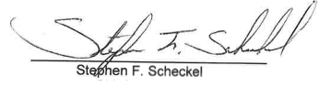
Chief of Police

cc: Dustin Anderson
Board of Safety Bulletin Board Sgt. Vassar Personnel File

1005 Ridge Road • Munster, IN 46321 • (219) 836-8810 • Fax (219) 836-6540 • Police I Fire Emergencies 911
Police Non-Emergency (219) 836-6600 • Fire Non-Emergency (219) 836-6960 www.munster.org
07/16/2021

