Town of Munster, Indiana Position Description

Title: Department: Date:
Civil ian Accreditation I Public Records Manager Police
May 2022

Purpose of Position

The purpose of this position is to perform administrative functions to support the Administrative Division and Records Department, as well as serve as the primary accreditation manager. This position provides support for and prepares all documents and media (including redaction of) related to the fulfillment of any records req uests. The incumbent will also assist in and retrieve, analyze and summarize information gathered from Law Enforcement and external sources to aid in the accreditation process and the direction and deployment of the department. The work is performed under the direction of the Police
Ad ministration.

Essential Duties and Responsibilities

The following duties are normal for this position. These are not to be construed as exclusive or all­ inclusive. Other duties may be required and assigned.

- Manage a daily review of accreditation standards files in the Department's Digital Management System to maintai n directives, policies, and documentation for accreditation.
- Updates and or develops agency policies and standard operating procedures that comply with state, federal, and accreditation standards.
- Uses the digital management system to track accreditation related time sensitive standards.
- Ensure that period reports, reviews, and other time sensitive materials are accomplished in the period prescri bed by the accreditation mandates.
- Uses the digital management system to generate required reports or issues written req uests to Administration for req uired information and or report.
- Immediately notifies Administration of any non-compliance issues and works with the Administrtaion to immediately remediate these issues.
- Provides mandated accreditation train ing for staff.
- Attends initial mandated accreditation manager's training and attends INPAC meetings and traini ng when possible.
- Meets regularly with Administration to provide status report on accreditation.
- Acts as a liaison to the assigned accreditation program manager and the Indiana Police Accreditation Coalition.
- Provides information to and makes public presentations concerning the accreditation process to community groups and the media as directed.
- Prepare various reports, such as monthly, quarterly, or yearly statistical reports and accreditation reports.
- Attends continuing education courses req uired for accreditation and release of public information.
- Com poses, edits and types correspondence, reports, memos, forms and other documents.
- Accepts and corresponds with persons req uesting records

Page l

- Prepares, redacts, and confers with Town Attorney and Administrtation when receiving requests for information.
- Delivers records to req uesters and ensures all fees are collected if applicable.

Non Essential Job Functions

- Assists training officer to be sure that mandated and required training standards for accreditation are met.
- Reviews crim inal reports to identify crime patterns to assist with resource allocation, including tactical and strategic planning.
- Assists records in da i ly activities.
- Performs other related duties as required.

Minimum Training and Experience Required to Perform Essential Job Functions

High school diploma or equivalent with additional degree or vocational or technical training preferred; Experience in law enforcement or records/dispatch preferred but not required; Must have a strong working knowledge of office equipment and software; Successful candidates will have an understanding of the structure and operation of town, county, state and/or federal government, as well as laws, codes, regulations, and ordinances pertaining to same; Additionally, applicants must respect confidentialty associated with sensitive records.

Physical and Mental Abilities Required to Perform Essential Job Functions

- Expert knowledge of law enforcement information systems and databases at local, state and federal levels.
- Ability to write clear and accurate policies to match the ph ilosophies of the Munster Pol ice Department.
- Ability to read, understand, and interpret standards and laws in order to translate that information into policy form.
- Possess excellent oral I interpersonal skills including but not limited to: diplomacy and professionalism when dealing with members of the Department or Town in order to obtain compliance with collecting needed proofs from staff. Also must be able to communicate effectively and efficiently whi le serv ing as liaison to accrediting authority.
- Ability to set and meet strict deadlines.
- Ability to collect, record, correlate, organize, and analyze data.
- Ability to focus on detai ls and maintain strict standards of accuracy.
- Abi lity to maintain confidentiality of highly sensitive information.
- Ability to operate a calculator, personal computer utilizing word processing, spreadsheet, database and other software applications necessary to perform job functions.
- Ability to work extended periods of time at a keyboard or workstation.

Physical Requirements

- Abi l ity to coordinate eyes, hands, feet and l imbs in performing skilled movements such as rapid keyboard use.
- Tasks involve the abi l ity to exert light physical effort in sedentary to l ight work, but which may involve some lifting, carrying, pushing and pulling of objects weighing five to ten pounds.
- Requires the ability to recognize and identify similarities or differences between characteristics of colors, shapes and sounds associated with job-related objects, materials and tasks.

Page 2

Environmental Adaptability

- Ability to work under safe and comfortable conditions where exposure to environmental factors is minimal and poses a very limited risk of injury.

The Town of Munster is an Equal Opportunity Employer. In compliance with the Americans with Disabilities Act, the Town will provide reasonable accommodations to qualified individuals with disabilities and encourages both prospective and current employees to discuss potential accommodations with the employer.

Page 3

Chief of Police
(1)

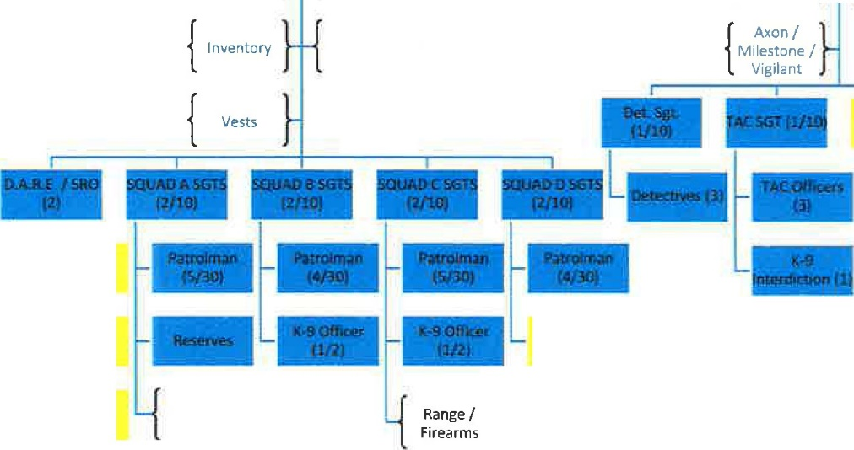
Chiefs Secretary (1)
Station 1 I r Station }
{Malnr enana;Jti Supplies
L Records (2)

PIO }

Patrol Division Commander (1/2)
Investigations Division Commander (1/2)
{ { !D's/Door Evidence }

Access
Techs &
Supplies

{ ODffetar ls
m "Patrols·)

Department }
{
CALEA IT &
Software

Employee
{Inspections Heath & }
Wellness

Special Events
}

{ Spillman COllSOlldued}
Dispatch

IT/Computer Forensics (1)

Accreditation Manager I Public Records
& Requests for Info (1)

CSO (l)

Explorers

Chap ains

Crossing
Guards

