EXHIBIT A

Design Standards

Centennial Village – A Planned Unit Development
A Mixed-Use Walkable Lifestyle Community

Town of Munster, Indiana

February 15, 2017
August 21, 2023
Revised August 07,2025
Presented October 14, 2025
Revised October 20, 2025
Revised December 17, 2025
Revised February 10, 2026

A Supplement to Chapter 26: Land Development Code

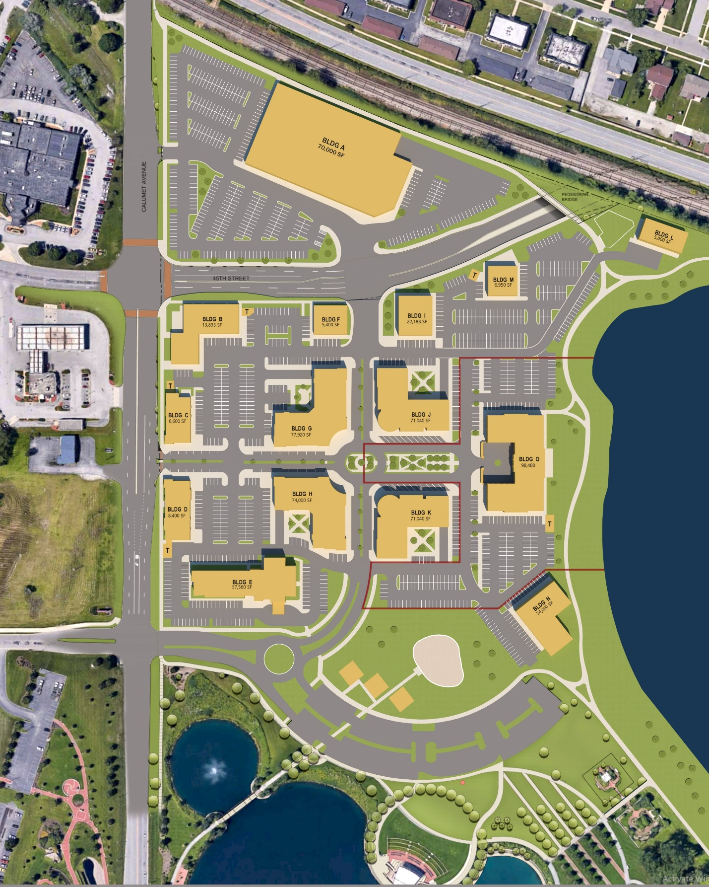
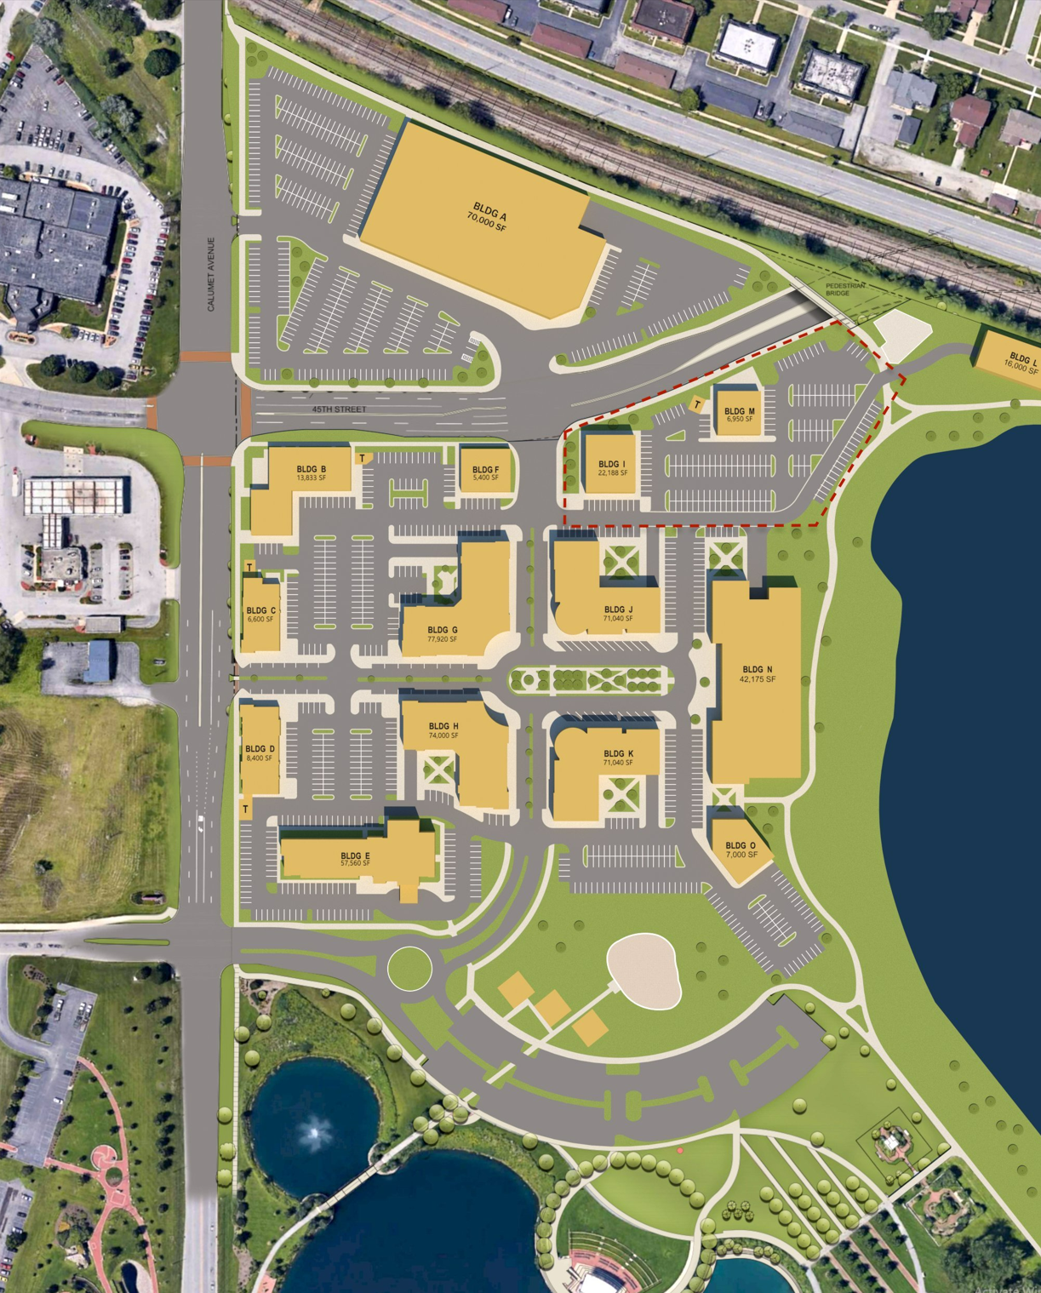

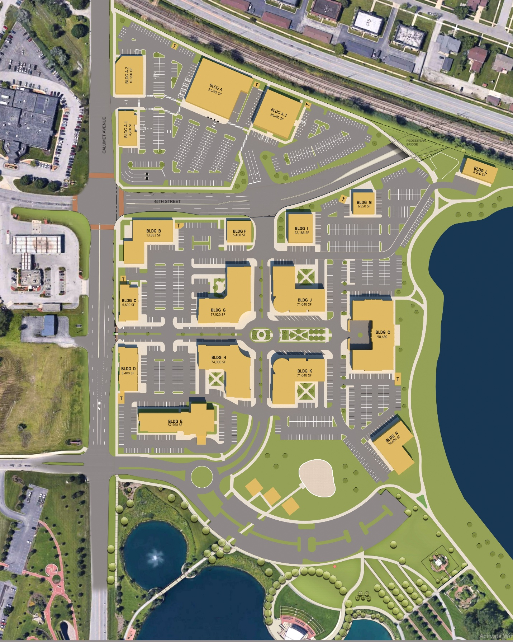

Design Standards
Centennial Village Planned Unit Development

Table of Contents

Section 1: Purpose & Intent
Section 2: Uses
Section 3: Setback & Height Requirements
Section 4: Building Materials and Architectural Design Standards
Section 5: Building Design Elements
Section 6: Site Circulation – Vehicular & Service
Section 7: Site Circulation – Pedestrian
Section 8: Parking – Site and Under Building
Section 9: Site Lighting
Section 10: Site Landscaping & Common Areas
Section 11: Signage
Section 12: Refuse & Recycling Management
Section 13: Screening of Loading & Service Areas
Section 14: Site Furniture, Fixtures & Equipment
Section 15: Utility Service
Section 16: Storm Water Management
Section 17: Subdivision of Land and Site Development Approval

Appendices:

1: Centennial Village PUD Final Subdivision Plat
2: Plan of Development
3: Infrastructure Development Plan Set
4: Sign Regulations for Centennial Village

Section 1: Purpose & Intent

The purpose of the Centennial Village Development is to provide the Town of Munster with a sustainable, mixed use, Walkable Lifestyle Community adjacent to the key regional thoroughfares of Calumet Avenue and 45th Street. The Centennial Village PUD is a partnership with the Town of Munster to combine the former Munster Steel redevelopment site with certain land areas of the Town owned Centennial Park (including Clayhole Lake) to create a landmark development neighborhood. Additionally, the Centennial Village PUD will provide the Town of Munster the necessary land area to facilitate design and construction of the Calumet Avenue and 45th Street public infrastructure realignment improvements and underpass crossings of the CN Railroad line.

Centennial Village will include commercial, office, residential, recreational and entertainment land uses. The Centennial Village PUD is intended to support high quality development with the flexibility to adapt to the unique conditions of the site, the proposed Town public roadway infrastructure improvements, market demands and phasing of development implementation plan. The Centennial Village Development Plan has been created to meet the development goals of Town of Munster’s 2010 Comprehensive Master Plan which calls for redeveloping the former Munster Steel site, improving Clay Hole Lake as a major public open space and to integrate the Centennial Village development with the existing Centennial Park and Pennsy Greenway Trail.

The mixed land uses and development density proposed within the Centennial Village PUD is essential to meet the development goals of the Town of Munster as outlined in the Development Agreement between the Town and the Centennial Village developer. The mixed use development plan is required to establish the level of commercial vitality and economic return to the Town of Munster in Tax Increment to support the approved TIF Bonds that have been granted to the project. The treatment of building design, parking, landscaping, site improvements and pedestrian spaces as outlined in the Centennial Village PUD Design Standards is essential to creating the pedestrian oriented environment for the Centennial Village walkable lifestyle community.

The Centennial Village PUD Design Standards are intended to insure the proper development of the project site to achieve the economic return goals of the Town of Munster, to improve the quality of life for existing Munster residents, to add significant architectural buildings and development areas to the Munster business landscape and to attract new businesses and residents to the Munster Community.



Section 2: Uses

The Centennial Village PUD shall permit the following uses within the development plan area:

2.1 Permitted Uses

- Those permitted uses contained within the Town of Munster C-2 Zoning District excepting those further defined as Prohibited Uses in this Section.
- Retail & Service Uses
  - Art Galleries & Supplies
  - Bakeries
  - Banks & Financial Institutions
  - Barber & Beauty Shops
  - Beer, Wine & Spirits Shops – 1 Allowed within Development
  - Book Stores
  - Computer Sales & Service
  - Communication Equipment Sales & Service
  - Custom Clothing and Apparel Stores
  - Decorating Shops
  - Department Stores
  - Electrical and Household Appliance stores
  - Financial Services
  - Fitness Spas and Clubs
  - Florist Shops
  - Garden Supply Stores
  - General Retail Stores
  - Grocery Stores
  - Hardware Stores
  - Optical Shops
  - Personal Care Shops
  - Household Furniture, Furnishings & Appliances
  - Jewelry Stores
  - Music Shops
  - Photography Studios
  - Paint & Wallpaper Stores
  - Pet Supply & Care Establishments
  - Shoe Sales and Service Shops
  - Sporting Goods Stores
  - Tailor Shops
  - Travel Service Stores
  - Toy Stores

- Recreation & Entertainment
  - Theaters
  - Community Centers
  - Public Outdoor Recreation

- Hospitality
  - Hotels
  - Restaurants
- Education
  - Schools such as those for teaching performance art and business vocations
  - K-12 academic enhancement schools
- Offices
  - Business
  - Medical
  - Professional & Personal Services
- Residential
  - Multi-family Dwellings
  - Multi-family Senior Living Facilities
- Accessory Uses
  - Drive Thru Service to Customers of a Business will be permitted only by review and action by the Town of Munster Board of Zoning Appeals.

2.2 Prohibited Uses

The Centennial Village PUD shall prohibit the following uses within the development plan area:

- Any use which emits an obnoxious odor, fumes or sound which can be heard or smelled outside of any building in the Centennial Village Area.
- Any operation primarily used as a warehouse operation, manufacturing refining, smelting, agricultural, industrial, or mining operation.
- Food Catering Establishments operating as the Primary Business
- Pawn Shop, Flea Market, Salvage Store or Auction House
- Manufactured Home Park, Trailer Court, labor Camp, Junk Yard or Stockyard
- Mortuary or Funeral Home
- Adult Use Establishments as defined and regulated in the Town Municipal Code
- Tattoo Parlor & Piercings operating as the Primary Business
- Any Unlawful or Illegal Purpose
- Any Use that is a Public or Private Nuisance
- Automotive Vehicle Sales
- Automotive Retail
- Storage Facilities where storage is the Primary Business
- Tobacco Stores
- Any Business dealing with Guns and Ammunition
- All “Prohibited Uses” defined and listed in the Defined Terms, pages 8, 9 & 10 of the Centennial Park Development, Development Agreement dated September 5, 2013

Section 3 – Setback & Height Requirements

The Architectural Style proposed for the Centennial Village Lifestyle Community is modeled after a Neo-Traditional Urban Design promoting buildings placed near the street in mixed use, multi-story buildings. The public roadway right of ways serving the Centennial Village PUD include Calumet Avenue adjacent to the west side of the site and 45th Street adjacent to the north side of the southerly PUD parcel and adjacent to the south side of the northerly PUD parcel.

The Centennial Village PUD may be platted and subdivided into individual lots for each proposed building pad identified in the Development Plan. All pedestrian and vehicular circulation routes within the development parcel boundary shall serve all the subdivision lots and shall be privately owned and maintained. All subdivided lots shall be provided with pedestrian and vehicular circulation routes platted with access easements, cross access easements and cross parking easements to achieve the urban Neo-Traditional design objective.

The following is a listing of the proposed Development Plan lots with the associated Setback and Building Height Requirements:

Building  Lot | Building Use Description | No. of Floors  (Stories) | Maximum Building Height  (ft) | Front Yard Building Setback @ Main Entry  (ft) | Side Yard Building Setback  (ft) | Rear Yard Building Setback  (ft)
A | –Grocery - Anchor | 1 | 35 | 5 | 5 | 5
A.1 | Bank | 1 | 25 | 5 | 5 | 5
A.2 | Retail/Offices – Single Story | 1 | 25 | 5 | 5 | 5
A.3 | Office – 2 Story or 3 Story | 2 or 3 | 55 | 5 | 5 | 5
B | Retail – Multi Tenant | 1 | 25 | 5 | 5 | 5
C | Retail – Multi Tenant | 1 | 25 | 5 | 5 | 5
D | Retail – Multi Tenant | 1 | 25 | 5 | 5 | 5
E | Hotel | 4 | 50 | 5 | 5 | 5
F | Retail – Multi Tenant | 1 | 25 | 5 | 5 | 5
G | Retail – Multi Tenant 1st Floor, Residential 2nd to 4th Floor | 4 | 65 | 5 | 5 | 5
H | Retail – Multi Tenant 1st Floor, Residential 2nd to 4th Floor | 4-5 | 70 | 5 | 5 | 5
I | Retail – Multi Tenant | 3 | 55 | 5 | 5 | 5
J | Retail – Multi Tenant 1st Floor, Residential 2nd to 4th Floor | 4-5 | 70 | 5 | 5 | 5
K | Retail – Multi Tenant 1st Floor, Residential 2nd to 4th Floor | 4-5 | 70 | 5 | 5 | 5
L | Residential - Multifamily | 3 | 55 | 5 | 5 | 5
M | Retail – Single Tenant | 2 | 55 | 5 | 5 | 5
N | Retail - Anchor | 3 | 50 | 5 | 5 | 5
O | Hotel | 5 | 80 | 5 | 5 | 5

Building Lot A, A.1, A.2 and A.3 are located on the northeast corner of Calumet Avenue and 45th Street. Its main entry is proposed to front either 45th Street or Calumet Avenue and therefore has 2 Front Yards.

Buildings on Lot B, C, D, and E are adjacent to Calumet Avenue and Buildings B, F, I and M are adjacent to 45th Street. The main entries to Buildings B, C, D, E, F & I all are proposed to face inward to the development as depicted on the Development Plan and as such their front yard is considered with respect to the lot line closest and across from the main entry to each respective building. The lot line adjacent to the Calumet Avenue and 45th Street is the rear yard or side yard lot line as depicted on the Development Plan.

Building Height is defined as the vertical distance from the average elevation of the adjoining ground level or the established finish floor elevation, whichever is lower to:

- The highest point of the cornice or parapet wall of a flat roof;
- The deck line of a mansard roof;
- A point directly above the highest wall of a shed roof ;
- The uppermost point of a round or other arch type roof;
- The mean distance from the eave line to the ridge or peak of the highest point on a pitched or gabled, hipped and gambrel styled roof

The Pensey Greenway Pedestrian Path, Sidewalks and Parking areas are permitted to be located within the designated building setbacks. The Pensey Greenway Pedestrian Path and Sidewalks shall be permitted to be placed running longitudinally over property lines so part of the path or sidewalk is located partially on public right of way and within the setback area of the development.

Section 4: Building Materials and Architectural Design Standards

Building Materials and Architectural Design for all buildings within the Centennial Village PUD for both the Commercial and Residential development areas will follow a Neo Traditional Architectural Design Style. The Neo Traditional Architectural Design Style is a contemporary architecture that borrows historical building design elements designed and constructed using modern materials. Neo Traditional Architectural Design Style is contemporary architecture that is inspired by historic styles. Neo Traditional Buildings suggest the past, using decorative details to add a nostalgic aura to a modern-day contemporary structure design style.

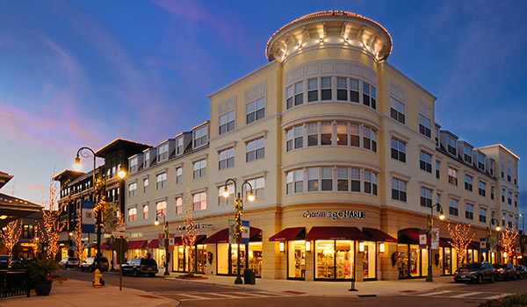
Neo Traditional Architecture Design Style to be developed in the Centennial Village PUD shall utilize a variety of building materials and architectural elements. The variety of building materials will be distributed throughout the development based on a class of material as listed below:

Class 1 – Primary Exterior Building Materials / Building – 1st Floor

Allowable building materials on Class 1 Exterior Building Walls shall comprise of one or more of the following materials:

  - Brick
  - Structural Brick: permitted only on Lot 11
  - Natural Masonry and Architectural Cast Stone
  - Architectural Metal Panels
  - Glass & Store Front Aluminum Window & Door Frames
  - Conventional Windows and Frames

Class 1 Primary Building Materials as a total sum will comprise of a minimum of 75% of the total exterior wall surface area on Class 1 building walls. Architectural Pre-cast Wall Panels will be considered as a primary material provided that a Brick or similar Architectural Stone is precast into the panel meeting the minimum of 75% of the building wall surface area. Class 1 Building Materials as defined in this Section shall only be allowed on 1st Floor Level Exterior Walls. The First Floor Level is defined from the line created at the building wall by finish exterior ground elevation grade to the top of the wall for single story buildings and to the 2nd Level Floor line for multi-story buildings.

Class 2 – Accent Materials – 1st Floor

Allowable building materials on Class 2 Exterior Building Walls shall comprise of one or more of the following materials:

- Architectural Masonry
- Spandrel Glass and Opaque Panels
- Exterior Insulation Finishing System (EIFS)
- Architectural Metal Panels Accents
- Natural Wood Panels & Siding
- Manufactured Wood Panels & Siding
- Structural Steel

Class 2 Accent Exterior Building Materials as a total sum will comprise of a maximum of 25% of the wall surface area on Class 2 building walls. Class 2 Buildings Materials as defined in this Section shall only be allowed on 1st Floor Level Exterior Walls. The First Floor Level is defined from the line created at the building wall by finish exterior ground elevation grade to the top of the wall for single story buildings and to the 2nd Level Floor line for multi-story buildings.

Class 3 – Primary Exterior Building Materials – 2nd to 5th Floors

Allowable building materials on Class 3 Exterior Building Walls shall comprise of one or more of the following materials:

  - Brick
  - Natural Masonry and Architectural Cast Stone
  - Architectural Metal Panels
  - Glass & Store Front Aluminum Window & Door Frames
  - Conventional Windows and Frames including Operable Aluminum or Vinyl Clad Windows

Class 3 Primary Building Materials as a total sum will comprise of a minimum of 25% of the total exterior wall surface area on Class 3 building walls. Architectural Pre-cast Wall Panels will be considered as a primary material provided that a Brick or similar Architectural Stone is precast into the panel meeting the minimum of 25% of the building wall surface area. Class 3 Materials as defined in this Section shall only be allowed on 2nd to 5th Floor Level Exterior Walls. The 2nd to 5th Level exterior wall surface is defined from the 2nd Level Floor line to the top of the upper most floor exterior wall , excluding parapet walls and decorative trim and cornices, for buildings with flat roofs or to the uppermost level soffit or fascia line for buildings with sloped roofs.

Class 4 – Accent Materials – 2nd to 5th Floors

Allowable building materials on Class 4 Exterior Building Walls shall comprise of one or more of the following materials:

- Architectural Masonry
- Spandrel Glass and Opaque Panels
- Exterior Insulation Finishing System (EIFS)
- Architectural Metal Panels Accents
- Natural Wood Panels & Siding
- Manufactured Wood Panels & Siding
- Aluminum Fascia and Soffit Material
- Structural Steel

Class 4 Accent Building Materials as a total sum will comprise of a maximum of 75% of the wall surface area on Class 4 building walls. Architectural Pre-cast Wall Panels will be considered as a primary material provided that a Brick or similar Architectural Stone is precast into the panel meeting the minimum of 70% of the building wall surface area. Class 4 Materials as defined in this Section shall only be allowed on 2nd to 4th Floor Level Exterior Walls. The 2nd to 5^{h} Level exterior wall surface is defined from the 2nd Level Floor line to the top of the upper most floor wall for buildings with flat roofs or to the uppermost level soffit or fascia line for buildings with sloped roofs.


General Building Design Requirements

- The color and material of Service Doors shall be coordinate with the color tones and materials of the Primary Materials and match the design of the buildings they serve. Service doors shall be permitted on Class 1 and Class 2 wall surfaces and be counted as a Class 1 Primary Material.

- Doors, Door Frames, Window surfaces and Window Frames shall be permitted on all classes of materials and be counted in the quantity of Primary Materials.

- Bright accent colors such as bright orange, bright yellow or fluorescent colors shall be minimized and in no case shall such coloring exceed 5% of any exterior wall area.

- Brick or stone exteriors shall not be painted without the prior approval of the Town of Munster Plan Commission.

- Equipment used for mechanical, processing, bulk storage tanks or equipment used for suppressing noise and odor that protrudes from a side of a building or is located on the ground adjacent to a building shall be screened from public view as much as practical with Class 1 & 3 Primary Building Materials matching the design of the building and landscaping treatments.

- Equipment used for mechanical, processing and bulk storage tanks placed on roofs of buildings shall be screened from public view as much as practical with Class 2 & 4 Accent Building Materials matching the design of the building.

- Pre-engineered metal and wood pole buildings are prohibited.

- The general architectural design for all buildings in the PUD shall reflect a unique architectural style. The design form, materials and colors for each building may have an architectural relationship only to other buildings within the Centennial Village PUD. Architectural design used as a branding marketing technique to identify a particular business identity is not permitted within the development.

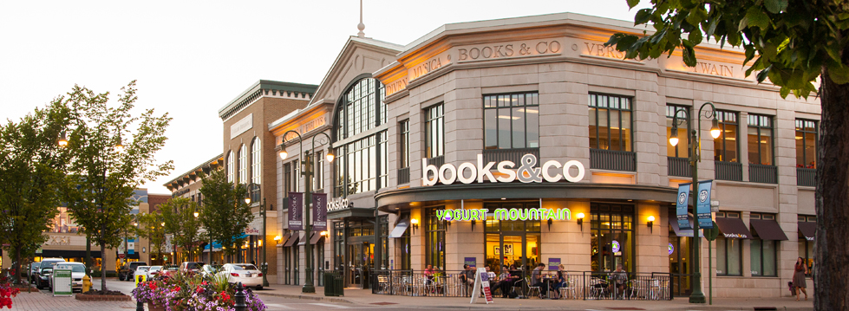

The distribution of Architectural Class Materials on all buildings throughout the project site is summarized in the table below:

Building  Lot | Building Use Description | No. of Floors  (Stories) | Building Materials on Exterior of First Floor | Building Materials on Exterior of 2nd thru 4th Floor
A | Grocery-Anchor | 1 | Class 1 & 2 | N/A
A.1 | Bank | 1 | Class 1 & 2 | N/A
A.2 | Retail/Offices – Single Story | 1 | Class 1 & 2 | N/A
A.3 | Office – 2 or 3 Story | 2 or 3 | Class 1 & 2 | Class 3 & 4
B | Retail – Multi Tenant | 1 | Class 1 & 2 | N/A
C | Retail – Multi Tenant | 1 | Class 1 & 2 | N/A
D | Retail – Multi Tenant | 1 | Class 1 & 2 | N/A
E | Hotel | 4 | Class 1 & 2 | Class 3 & 4
F | Retail – Multi Tenant | 1 | Class 1 & 2 | N/A
G | Retail – Multi Tenant 1st Floor, Residential 2nd to 4th Floor | 4 | Class 1 & 2 | Class 3 & 4
H | Retail – Multi Tenant 1st Floor, Residential 2nd to 4th Floor | 4 or 5 | Class 1 & 2 | Class 3 & 4
I | Retaill – Multi Tenant | 3 | Class 1 & 2 | Class 3 & 4
J | Retail – Multi Tenant 1st Floor, Residential 2nd to 4th Floor | 4 or 5 | Class 1 & 2 | Class 3 & 4
K | Retail – Multi Tenant 1st Floor, Residential 2nd to 4th Floor | 4 or 5 | Class 1 & 2 | Class 3 & 4
L | Residential – Multifamily | 3 | Class 1 & 2 | Class 3 & 4
M | Retail – Single Tenant | 2 | Class 1 & 2 | Class 3 & 4
N | Retail – Anchor | 3 | Class 1 & 2 | Class 3 & 4
O | Hotel | 5 | Class 1 & 2 | Class 3 & 4

Section 5: Building Design Elements

In addition to Exterior Building Material Standards, all buildings within the Centennial Village PUD shall comply with the following Building Design Elements requirements.

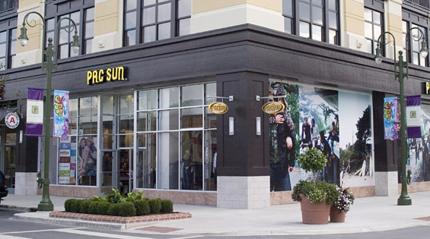
- Building facades shall provide architectural detail and character that contain windows at the ground level in areas oriented to the pedestrian activities of the development to create views into buildings with focus to building main entries. The building and pedestrian interface is a crucial part of the urban design and the design shall provide visual interest, create opportunities for pedestrian socialization and overall pedestrian safety and comfort.

- The use and appearance of all exterior building materials within the development shall be compatible with adjacent and surrounding buildings.

- The use and appearance of all exterior building materials used on side and rear building walls of any building shall be similar to and compatible with its front building wall.

- All buildings shall be located such that the front doors of the building front a public street or parking areas. Any building with a building wall adjacent to a public street that does not provide for the front door to front the public street shall design the building wall adjacent to the public street with Primary Building Materials and with design features to make the adjacent wall to the public street look as if it is a main entry wall.

- Parking Garages shall be located to the rear or interior of the site. Entrance ramps to underground parking areas shall be located near service areas of buildings and screened from public view with landscaping or other structural screening walls.

- Main entries to buildings shall be emphasized through the use of architectural features such as covered roof overhangs, increased building heights with columns, featured roof elements, and recession or extension of the building façade or other architectural details that highlight the importance of the entrances.

- The rear entrance to a building can be utilized as an additional primary entrance when parking areas are located in the interior of a block as is typical for a traditional urban development plan. When rear building entrances are used as an additional primary entrance, the entries should be improved to include signs, lighting, canopies, windows, landscaping and other complementary elements to create a safe and inviting access to the additional building entry.

- All building fronts shall include a minimum of 6 architectural details following the items listed below:

  - Cornice Architectural Details
  - Architectural Awning including Structural Steel or Canvas Awning
  - Parapet Wall Detailing
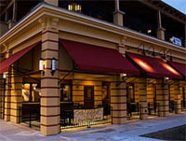
  - Brick Coursing changes such as soldier coursing, row lock coursing and stack bond coursing
  - Masonry Stone Accenting around windows, doors and roof lines
  - Entry Feature Columns
  - A visually pleasing, clearly articulated entry which presents the obvious entry location from the street, sidewalk and parking area.
  - A combination of horizontal and vertical design features
  - Contrasting but complimentary materials and colors
  - Irregular building shapes
  - Horizontal offsets in the entry door wall relative to the primary front façade wall
  - Vertical offsets in the roof line of the entry door wall relative to the primary front façade wall
  - Varying roof lines and accents

- Multi-story buildings shall have the ground floor distinguished from the upper floors by having one or more of the following:

  - Awnings
  - Trellis
  - Window Lintels
  - Cornice Line delineating the change between the First Floor level and the 2nd Floor level
  - Brick detailing such as quoins or corbels delineating the change between the First Floor level and the 2nd Floor level
  - A change in Primary Building materials between the First Floor level and the 2nd Floor level

- All buildings within the development will utilize a variety of complimentary architectural materials, design elements, colors and the use of vertical and horizontal design features in such a way so that no one building is identical or monotonous with any other building. The Neo Traditional Design Style defined for the Centennial Village project encourages the architectural, color and building material differences between buildings on all lots within the development.

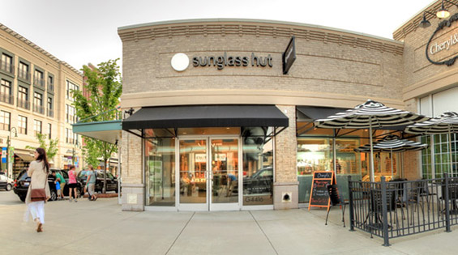

Section 6: Site Circulation – Vehicular & Service

The Centennial Village Site will be provided vehicular access from public right of ways depicted in the Development Plan and specifically defined below:

- Development Area North of 45th Street:

  - Full Access Entry Driveway on the north side of 45th Street approximately 500 feet west of the Calumet Avenue center line. The Full Access Entry Driveway will be controlled by a traffic control signal and designed in coordination with the Town of Munster’s 45th Street public infrastructure project.

  - Right in – Right out entry drive on the east side of Calumet Avenue approximately 200-feet north of the 45th Street center line.

- Development Area South of 45th Street:

  - Full Access Entry Driveway on the south side of 45th Street approximately 500 feet east of the Calumet Avenue center line. The Full Access Entry Driveway will be controlled by a traffic control signal designed in coordination with the Town of Munster’s 45th Street public infrastructure project.

  - Right in – Right out entry drive on the east side of Calumet Avenue approximately 400-feet south of the 45th Street center line.

  - Full Access Entry Driveway at the Centennial Drive and Calumet Avenue intersection. The Centennial Drive Entry Driveway shall be shared by the Centennial Village PUD area and the Town of Munster Centennial Park. The existing Centennial Drive Traffic Signal and intersection at Calumet Avenue will be modified by the Centennial Village PUD to accommodate the additional traffic generated by the development project.

- The Development Plan for the development area south of 45th Street is divided into 4 development quadrants by the location of 2 main access roadways. The site is divided by a main north-south roadway and an east-west roadway. All vehicular roadways within the Centennial Village PUD shall be privately constructed, owned and maintained.

- The main north-south thoroughfare named “Centennial Drive” will be developed to intersect with Calumet Avenue at the southwest corner of the site, extend easterly to connect with the existing Centennial Park parking lot, then extend northerly to a proposed Centennial Drive Town Center Green round about, and then further extend north to intersect with 45th Street.

- The main east-west thorough fare named “Village Parkway” extends easterly from Calumet Avenue at the west central edge of the site into the Centennial Drive Town Center Green round about.

- All parking areas located within each of the 4 quadrants shall be connected to both Centennial Drive and Village Parkway.

- Centennial Drive and Village Parkway shall have 12-foot minimum vehicular travel lane widths. The minimum lane width of Centennial Drive at the Calumet Avenue and 45th Street intersections shall be 11-feet wide. Lane widths shall be measured from the center line of any lane striping to the face of curb. For conditions where there is not lane striping, the lane width shall be measured between face of curb to face of the opposite curb.

- Minimum cross slopes perpendicular to the direction of travel shall be 2%. Minimum longitudinal slope of the curb gutter flow line shall be 0.50%.

- The minimum pavement cross section for roadways and parking lots shall consist of 10-inches of No. 53 aggregate placed on a stable subgrade with 3-inches of H.A.C. Binder Course and 1 ½-inches of H.A.C. Surface Course. The final pavement cross section specification will be developed to accommodate the specific subgrade conditions where roadways and parking lots are placed.

- Minimum combination curb and gutter sections widths shall be a combination of a 6-inch wide curb with a 12-inch wide gutter flag.

- Boulevards located in the center of Centennial Drive and Village Parkway shall be bordered at the street with a 6-inch wide stand up curb.

- Cross Access Easements and shared Public Common Space Agreements will be developed during the subdivision platting process to provide for the sharing of parking, vehicular circulation and pedestrian access among all property owners, business tenants and residents within the development.

Section 7: Site Circulation – Pedestrian

The Centennial Village PUD is located adjacent to the recreational activities within Centennial Park including the regional Pensey Greenway Trail. The Centennial Village PUD site design shall emphasize pedestrian connections with Centennial Park walkways, the Pensey Greenway Trail and future sidewalks proposed by the Town of Munster in the 45th Street and Calumet Avenue public infrastructure improvement plans.

- The Pensey Greenway Trail will be extended from the south boundary of the Centennial Village PUD and extend along the west shore line of Clay Hole Lake to the south right of way line of the new 45th Street right of way. This trail extension will be completed by the Centennial Village PUD and will be constructed to standards matching the existing trail south of the Centennial Village PUD.

- Pedestrian walkways adjacent to and within the Centennial Drive corridor connecting Calumet Avenue to 45th Street shall be a minimum of 10-feet wide, except the sidewalk adjacent to 45th Avenue, southernmost of Lot 10, Lot 11 and Lot 13 is not required. Pedestrian walkways adjacent to buildings within the Village Parkway corridor shall be a minimum of 10-feet wide. Pedestrian walkways adjacent to buildings in all other areas of the development shall be a minimum of 8-feet wide, except Western most Lot 11, Southern most Lot 12 & Northern most Lot 13 shall be minimum 6-feet wide

- Where sidewalks are integral with parking area curbs within parking areas of the development, the minimum sidewalk width shall be 5-feet.

- All sidewalks shall be constructed of Portland Cement Concrete and shall be a minimum of 4-inches in thickness for pedestrian use only areas and a minimum of 6-inches in thickness for vehicular service loadings areas and shall be placed on a minimum of 4-inches of base sand or No. 53 aggregate.

- Pedestrian routes crossing streets and driveways within the development shall be constructed with a material contrasting with the pavement material of the street or driveway. Acceptable materials for pedestrian route street and driveway crossings shall include colored concrete, paver bricks and paver blocks.

- All pedestrian routes crossing streets and driveways within the development will be provided with ADA Accessible Ramps meeting the design requirements of all State and Federal Accessibility Requirements.

- Sidewalks within the development and the Calumet Avenue and 45th Street right of ways will be maintained by the Centennial Village PUD. Snow removal of sidewalks within the development and the will Calumet Avenue & 45th Street right of ways will be the responsibility of the Centennial Village PUD.

- The Centennial Village PUD shall plat the appropriate pedestrian access easements during the site development and subdivision platting process through the Town of Munster Plan Commission.

Section 8: Parking – Site and Under Building Parking Areas

The Centennial Village PUD is an urban development plan designed to provide for shared parking for all lots within the development. All building lots within the development will be platted with Cross Access Easements and all parking lots shall be designed to be interconnected for both pedestrian and vehicular access. Off-street and on-street parking shall be provided within the development on common parking lots, along circulation roadways and in parking structures.

- The total minimum number of parking spaces required for the Centennial Village PUD shall be calculated on the following basis:

Land Use | Minimum Required Parking
Retail – Single Tenant | 3.25 parking spaces per 1,000 sf of Gross Building Floor Area
Retail – Multi-tenant | 3.25 parking spaces per 1,000 sf of Gross Building Floor Area
Restaurant | - space per 4 customer seats
Office Uses | 4.0 parking spaces per 1,000 sf of Gross Building Floor Area
Hotel | 1.05 parking spaces per number of Hotel Room Units
Residential – Multi-family | 1.25 spaces per Residential Unit

Off-street parking for commercial uses shall be sufficient to provide parking for employees of all proposed uses as well as customer parking. Spaces reserved for employees may be designated by means of striping and signage. The location, quantity, signage and design standards for parking spaces for the disabled shall be designed to meet the requirements of all State and Federal Accessibility Requirements.

- Parking Areas shall be designed to conform to the following standards:

  - Parking space dimensions (other than those designed for the disabled) perpendicular to the parking area drive aisles shall be a minimum of 18-feet long and 9-feet wide. Angle parking shall maintain a full 18-foot x 9-foot block within the angled parking space. Parking spaces shall be dimensioned in relation to face of curbs and walks and to the centerline of parking space striping lines.
  - Parking space dimensions parallel to roadways within the development shall be a minimum of 20-feet long by 8-feet wide.
  - Parking spaces in under building parking garages may be a minimum of 17-foot x 9-foot with 20-foot drive aisles.
  - Where feasible, tandem parking spaces may be provided in under building parking garages.
  - Parking space dimensions for the disabled shall meet the design requirements of the Federal Americans with Disabilities Act.
  - Parking lots shall be constructed of Hot Asphaltic Concrete, Portland Cement Concrete or other acceptable hard surface material approved by the Town of Munster Plan Commission and meeting Town Standards.
  - All parking areas shall be edged with Portland Cement Concrete vertical curbs, curb and gutters and mono-thically formed curb sidewalks.
  - Parking areas shall be landscaped in Planting Areas as defined in the Centennial Village PUD Development Plan. The parking area Planting Areas shall be landscaped with Trees and/orshrubs and/or perennial flowers.
  - Parking area landscaping shall conform to an approved Landscaping Plan and to the design standards defined in the Site Landscaping – Section 10.

- Parking Areas shall be owned, operated and maintained by the Centennial Village PUD land and building owners. The parking areas shall be kept clean and well maintained and shall conform to the following operations standards:

  - Striping defining parking areas, loading and service zones, stop bars, directional arrows, lane division and other pavement markings shall be clearly visible at all times. Parking area striping shall be re-painted when the parking area markings are faded and compromises safety to patrons of the development.
  - Failed pavement shall be properly repaired to assure safe and convenient travels within the development.
  - Snow removal of sidewalk, parking areas and driveways within the Centennial Village PUD shall be the responsibility of the Centennial Village PUD owners. Snow removal shall be completed during any snow event on all building lots within the development on a unified basis. Snow shall be placed on the perimeter and islands of parking areas and driveways. During heavier snow events, snow will be removed from the site and deposited at designated locations into Clay Hole Lake. The Development Plan shall identify the specific designated snow deposit areas. The design of the snow deposit areas shall be detailed and designed to accommodate the needed grading and structural loading of the snow removal equipment.
  - Parking areas shall be regularly cleaned of debris.

Section 9 – Site Lighting

Site lighting shall be decorative in nature and consistent with the architectural design of buildings within the development. All site lighting within the Centennial Village PUD shall adhere to the following requirements for illumination of parking areas, pedestrian walkways and roadways.

- All exterior lighting shall be designed and constructed to direct light away from adjacent properties.

- All exterior lighting shall be arranged and designed with a common light fixture type and with a variety of heights based on lighting system use. Vehicular and pedestrian level lights shall illuminate directly below or inboard of the property lines of the property such that the point source of light is not directly viewed by pedestrian or vehicular traffic in adjacent public right of ways.

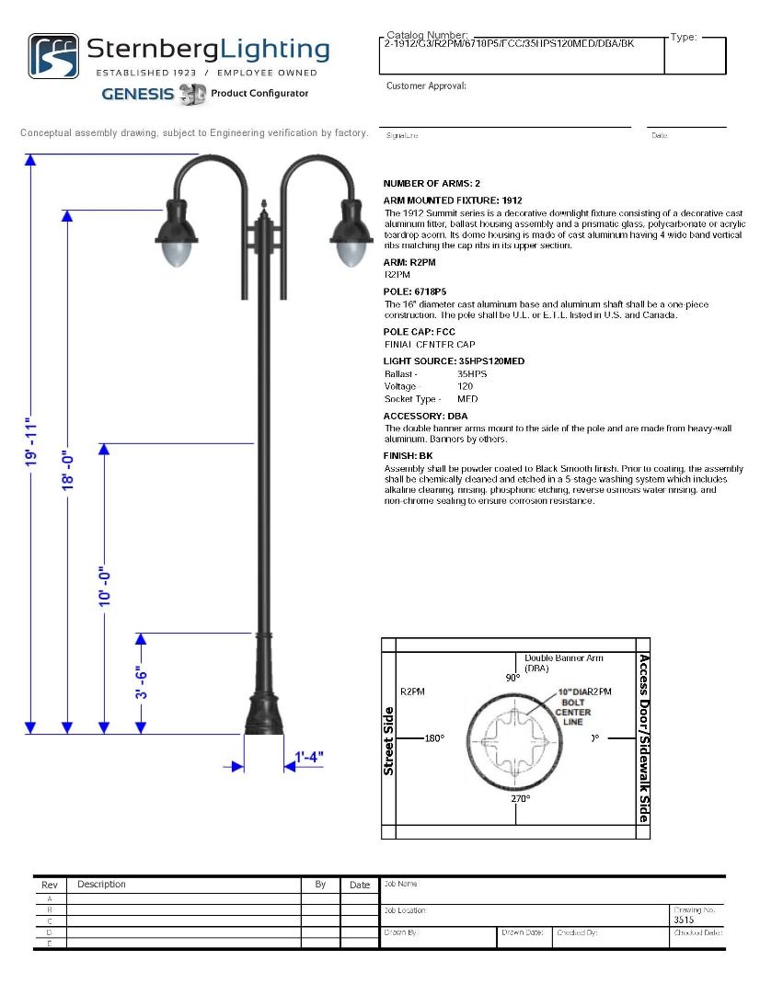
- Lighting shall be designed such that there is a minimum of 0.5 foot-candles at any property line. A photometric plan inclusive of all site and building sconce lighting for each fixture shall be submitted for review by the Town of Munster at each site plan review application. Photometric lighting levels within parking, roadway and pedestrian areas shall be illuminated to a range of 3 to 10 foot candles.

- Lighting which is flashing or revolving in nature or that otherwise resembles a traffic control signal shall not be permitted in any development area where it could cause a hazard for pedestrian or vehicular traffic.

- Parking areas shall be adequately lighted for the safety of pedestrian and vehicular movements using decorative style lighting with a design style equal to the “Genesis Series” model manufactured by Sternberg Lighting. No “shoe box” style lighting shall be permitted. Parking Lot lighting shall have a maximum height to the top of the fixture of 26-feet.

- Roadway areas shall be adequately lighted for the safety of pedestrian and vehicular movements using decorative style lighting with a design style equal to the “Genesis Series” model manufactured by Sternberg Lighting. No “shoe box” style lighting shall be permitted. Roadway area lighting shall have a maximum height to the top of the fixture of 22-feet.

- Pedestrian walkways not lighted by parking or roadway lighting shall be adequately lighted for the safety of pedestrians using decorative style lighting with a design style equal to the “Genesis Series” model manufactured by Sternberg Lighting. Pedestrian area lighting shall have a maximum height to the top of the fixture of 14-feet. Pedestrian walkways can also be illuminated using decorative wall sconce lighting matching the style of parking and roadway lighting mounted on buildings adjacent to pedestrian walkways. No “shoe box” wall mounted fixture lighting shall be permitted.

- Decorative wall mounted or ground mounted lighting may be used on building fronts visible from streets and parking areas to illuminate building entries and highlight building architectural features.

- Lighting Pole and Fixture locations shall be out of the way of service and pedestrian access to buildings throughout the development site.

Section 10 – Site Landscaping

Landscaping for the Centennial Village PUD shall be required in accordance with a final detailed Landscaping Plan approved by the Town of Munster Plan Commission for each building and development phase at the Site Development Plan submittal. All areas of the site not occupied by buildings, parking areas and other site improvements or paving shall be planted with trees, shrubs, hedges, perennials, annual flowers, ground cover and or grasses unless such plantings shall cause a public safety or safe sight line condition for vehicles and pedestrians. Site Landscaping within the Centennial Village PUD shall adhere to the following requirements:

- Landscaping Design Standards and Specifications shall generally follow the requirements of Article X of Chapter 26 of the Munster Land Development Code.

- Landscaping shall be integrated with other functional and ornamental site design elements such as pedestrian paths and walkways, site furniture, fountains, trellises, gazebos, screen walls and public art.

- Plant suitability, maintenance and compatibility with site and construction features shall be considered in the final landscape design plans for each building lot. Plantings should be designed with repetition, structured patterns and complimentary textures and colors and should reinforce the overall character of the development. After construction, maintenance of plants and landscaping will be completed to a high standard, keeping lawns, grasses and plants regularly groomed, planted areas free from weeds and debris, and plants that have died replaced.

- All stumps and other tree parts, litter, brush, weeds and vegetation debris shall be removed from the development and lawfully disposed. If trees and limbs are reduced to chips, they may be used as mulch in landscaped areas. Areas which are to remain as undeveloped open space shall be cleaned of all vegetation debris.

- Landscaping of cut and fill areas for the creation of proper drainage shall be constructed with grading slopes and plant materials to prevent soil erosion.

- Planted landscaping shall meet the following specification at the time of planting unless otherwise specified in the Landscape Plan.

  - Deciduous trees shall be at least a 2 ½-inch caliper and have an average 8-foot height
  - Evergreen trees shall be a minimum of 6-feet in height
  - Shrubs shall be 3-feet in height

- Material and installation specifications for all trees, shrubs, bushes, annuals and perennials shall be specified to meet local horticultural standards and meet the local growing and climatic conditions. The materials and installation shall be appropriate for an Urban Development environment. Shrub plant selection shall be made using drought tolerant vegetation to the extent possible. Plant materials shall be nursery stock grown conforming to ANSI Z60.1. No trees planted in the development shall be topped, tipped or deformed in any way at the time of planting.

- Within one year from the time of installation, all dead or dying plants and lawns shall be replaced in kind in the locations and specifications in accordance with the Landscape Plan.

- Tree spacing shall be determined and identified in the Landscape Plan based on the tree species type. As a general guide to the Landscape Plan basis of design, larger maturing trees shall be planted a minimum of 30-feet on center. Smaller maturing trees shall be planted at a minimum of 20-feet on center. Larger maturing trees will generally be planted along street frontages, right of ways and on the perimeter edges of the development.

- Refuse and recycling collection areas and other building utility service areas shall be screened with a combination of structural screen walls and landscaping designed to match the building architecture it services. The screen walls shall be a minimum of 5-feet in height with a corresponding landscaping buffer against the wall designed to grow in height to match the height of the screen wall. A mixture of hardy flowering and/or decorative evergreen and deciduous trees will be planted with bushes and shrubs in the screen wall buffer against the screen wall and with a decorative stone ground cover.

- Larger landscape areas will be provided with irrigation systems. The following areas may be serviced with irrigation systems:

  - Center Green Boulevard Area between Buildings J & K
  - Main Sign Location at the Southeast Corner of 45th Street & Calumet Avenue
  - Boulevard Islands on Village Parkway
  - Boulevard Islands on Centennial Drive
  - Outdoor Plazas in the rear of Buildings G, H, J & K
  - Outdoor Plazas on the sides of Buildings N

- Maintenance of all Landscaping within the Centennial Village PUD shall be completed by the Centennial Village development.

- Acceptable for tree plantings within planting islands and parkways are set out in Table 10-13-1 and Table 10-13-2:

Table 10-13-1
Trees for Parking Lot Islands and General Landscaping
Common Name | Scientific Name | Mature Height
Chinquapin Oak | Quercus Muehlenbergii | 80-feet
Hackberry | Celtis Occidentalis | 60-feet
Kentucky Coffee Tree | Gymnocladus | 60-feet
Skyline Honey Locust | Gleditsia Triacanthos | 60-feet
Shingle Oak | Quercus Imbarcaria | 50-feet
Swamp White Oak | Quercus Bicolor | 50-feet
Sour Gum | Nyssa Sylvatica | 40-feet
Ironwood | Ostrya Virginiana | 30-feet
Japanese Tree Lilac | Syringa Reticulata | 30-feet
Blue Beech American Hornbeam | Carpinus Caroliniana | 20-feet

Table 10-13-2
Trees for Parkway Planting
Common Name | Scientific Name | Mature Height
Chinquapin Oak | Quercus Muehlenbergii | 80-feet
Burr Oak | Quercus Macrocarpa | 80-feet
American Elm | Ulmus Americana | 70-feet
Hackberry | Celtis Occidentalis | 60-feet
Kentucky Coffee Tree | Gymnocladus | 60-feet
American Linden | Tilia Americana | 60-feet
Skyline Honey Locust | Gleditsia Triacanthos | 60-feet
Shingle Oak | Quercus Imbarcaria | 50-feet
Hills Oak | Quercus Ellipsoidallis | 50-feet
Scarlet Oak | Quercus Coccinea | 50-feet
Sugar Maple | Acer Saccharum | 50-feet
Swamp White Oak | Quercus Bicolor | 50-feet
Sour Gum | Nyssa Sylvatica | 40-feet
Littleleaf Linden | Tilia Cordata | 40-feet
Ironwood | Ostrya Virginiana | 30-feet
Japanese Tree Lilac | Syringa Retuculate | 20-feet
Blue Beech American Hornbeam | Carpinus Caroliniana | 20-feet
Serviceberry | Amelanchier Sp. | 20-feet
Nannyberry Viburnum | Viburnum Lentago | 18-feet

- Acceptable for shrub plantings within planting islands and general landscape areas are set out in Table 10-14-1 and Table 10-14-2:

Table 10-14-1
Shrubs for Parking Lot Islands and General Landscaping – Spring Flowering
Common Name | Scientific Name
Spicebush | Lindera Benzoin
Downy Serviceberry | Amerlanchier Arborea
Dommon Chokecherry | Prunus Viriniana
Forsythia | Forsythia Spp.
Lilac | Syringa Spp.
Viburnums | Viburnum Spp.
Currant Gooseberry | Ribes Spp.
Weigla | Weigela Spp.
Smoketree | Cotinus Coggyria
Beautybush | Kolkwitzia Amabilis
Red Twig Dogwood | Cornus Alba Sibirica

Table 10-14-2
Shrubs for Parking Lot Islands and General Landscaping – Summer Flowering
Common Name | Scientific Name
Buttonbush | Cephalanthus Occidentalis
American Elderberry | Sambucus Canadensis
Common Ninebark | Physocarpus Opulifolius
Black Chokeberry | Aronia Melanocarpa
Winterberry | Ilex Verticillata
Wild Hydrangea | Hydrangea Aborescens
Virginia Sweetspire | Itea Virginica
Butterfly Bush | Buddleia Davidii
Sumac | Rhus Spp.
Coralberry, Snowberry | Symphoricarpos Spp.

- Trees and plants identified as “Invasive Species” as defined by the Indiana Department of Natural Resources shall not be planted within the Centennial Village PUD.
- Parking Areas and Parking Lots shall contain at least one landscape island for every twenty-six (26) parking spaces. Parking Lots with more than one landscape island shall have such islands distributed throughout the Parking Lot.
- Interior parking rows shall be terminated with a landscape island or striping at the end.
- Each parking island landscape width shall be of a minimum 7 feet wide to accommodate any landscape and light poles.
- Parking islands shall contain a minimum of landscape with shrubs.
- Rows of parking fronting on drive aisles, including alleys, shall be provided with a minimum of three feet (3’) (excluding curbs) landscape buffer.
- The Parking Area or Parking Lot shall be screened from the public right-of-way with any landscape or ornamental fence, a minimum of 0.5 feet from the public right-of-way.
- All lots, except Lot 13. For every 3,000 square feet of Parking Area or Parking Lot, at least one tree shall be installed or preserved within the Parking Area or Parking Lot, except to the extent that Trees outside of the Lot containing the Parking Area or Parking Lot area are allowed to satisfy this requirement as set forth in the Article X of Chapter 26 of the Munster Land Development Code.
  - Lot 13. For every 6,000 square feet of Parking Area or Parking Lot, at least one tree shall be installed or preserved within the Parking Area or Parking Lot , except to the extent that Trees outside of the Lot containing the Parking Area or Parking Lot area are allowed to satisfy this requirement as set forth in the Article X of Chapter 26 of the Munster Land Development Code.
- No parking space shall be more than 200 ft, a Tree within the Lot, as measured from the center of the Tree to the nearest line demarcating the space.

Section 11 – Signage

All signs located within the development shall be regulated and conform to the current Sign Regulations for Centennial Village as included in Appendix 4.



Section 12 – Refuse & Recycling Management

The handling of refuse and recycling materials generated by the development is an important function for businesses within the Centennial Village PUD. Pick up and removal of these materials from the site shall be scheduled during times that do not conflict with normal hours of operation for the majority of businesses within the development.

All trash, recycling and related material handling equipment shall be stored within the principal structure, within an attached structure accessible from the principal structure or within an un-attached refuse enclosure structure nearby the building it serves. Trash, recycling and related material handling equipment and structures shall be totally screened from view from public streets, residential areas and main vehicular and pedestrian routes within the development. Trash and recycling structures and enclosures shall be constructed of the same materials and design style of the principal structure it serves. The structures and enclosures shall be constructed with these materials on 3 sides and provided with an opaque easily operated access door or gate. The door or gate shall remain closed at all times other than when the material is being picked up and removed.

The location of trash and recycling structure enclosures will be positioned so that the removal equipment can readily access the storage containers and not conflict with service requirements of the site improvements and buildings within the development.

Section 13 – Screening of Loading & Service Areas

The screening requirements to visually enhance loading and service areas to buildings within the development shall utilize architectural screen walls, landscape hedging and architectural fencing.

- The perimeter views of all external loading and service areas must be screened from public right of ways, residential areas and main vehicular and pedestrian routes with the development except at the points of access.

- Architectural screen walls and architectural fencing shall be constructed of the same materials and design style of the principal structure it serves. Such walls shall be a minimum of 5-feet in height measured from the finish grade at the base of the wall.

- Landscape hedges and shrubs used to screen loading and service areas shall maintain a minimum opaqueness of 80% throughout the entire year and shall be a minimum of 5-feet in height at full maturity. Landscaping shall be maintained and any dead plantings shall be promptly replaced.

- The screening of loading and service areas shall maintain a collective minimum opaqueness of 80% throughout the entire year.

- Loading and service areas are not permitted to be screen where equipment is required to access the buildings and utility service areas.

- No outdoor storage of materials shall be permitted.

Section 14 – Site Furniture, Fixtures & Equipment
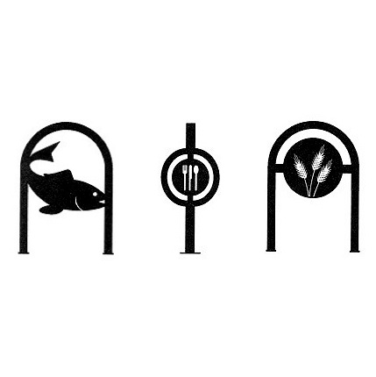
Site Furniture & Equipment will be incorporated into the final site design of all Buildings. Clear internal pedestrian circulation routes and connections to the Pennsey Greenway Trail will be provided as defined in the Development Plan. Featured locations within development such as key circulation corners shall be highlighted with enhanced design of pedestrian crossings and be provided with other pedestrian amenities as defined in this section.

- The individual site development plans for all buildings will where applicable include detail design of the listed site amenities:

  - Bicycle Racks
  - Decorative Trash Receptacles
  - Pedestrian Benches
  - Decorative Plant Containers
  - Fountains
  - Public Art

- Traffic Control Signs including Stop Signs, Traffic Directional Signs and Street Signs will be designed to match the design style of the Site Lighting System Fixtures.

- The design of Bike Racks, Refuse Dispensers and Pedestrian Benches will be designed to match the design style of the Lighting System Fixtures.

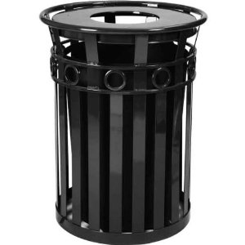
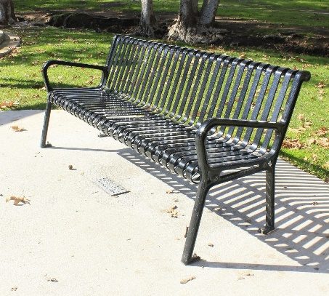

Section 15 – Utility Service

All buildings within the Centennial Village Development shall be serviced with public utilities from the Town of Munster Municipal Utilities and Public Utilities with Franchise service agreements within the Town of Munster. Specifically, the development will be provided with the following utilities and associated utility service providers:

Utility Type | Utility Service Company
Sanitary Sewer | Town of Munster Sanitary Sewer Utility
Storm Water | Centennial Village PUD
Water | Town of Munster Water Utility
Electric | NISPCO
Gas | NISPCO
Communication | AT&T
Communication | Comcast

- Sanitary Sewer Service for the development areas on the south side of 45th Street will be provided by connecting to an existing 10-inch PVC sanitary sewer line located on the south side of Centennial Drive between Calumet Avenue and the Centennial Park parking lot. A new 10-inch sanitary sewer will connect into the existing manhole located on the west side of the Centennial Park parking lot and extend north into the new Centennial Drive.

Sanitary Sewer Service for the development area on the north side of 45th Street will be provided by connecting to an existing gravity sewer located at the southeast corner of Calumet Avenue and the CN Railroad. A new 8-inch sanitary sewer will connect into the existing manhole located on the east side of Calumet Avenue and extend east parallel with the north property line of Lot A.

All Sanitary Sewer Main Lines shall be platted in public utility easements and be dedicated to the Town of Munster Sanitary Sewer Utility for ownership and maintenance. All public utility easements shall be a minimum of 20-feet in width and will be in locations that provide the Utility immediate access for maintenance. All sanitary sewer mains shall be constructed of SDR 26 PVC piping and constructed in accordance with the Munster Sanitary Sewer Utility standard specifications. Restoration repairs of the ground surface conditions including asphalt pavement, concrete pavement, landscaping and hardscaping shall be made by and paid for by the Centennial Village PUD within 7 days of any repair by the Town of Munster to the utility infrastructure.

Sanitary Sewer Service lines connecting buildings to the Sanitary Sewer Main Lines shall be the owned and maintained by the ownership entity of the building it serves. The sanitary sewer service lines shall be constructed of SDR 26 PVC piping with fittings, manholes and gasket materials meeting the specifications defined in the Munster Sanitary Sewer Utility Use Ordinance.

- Water Service for domestic and fire service for the development areas on the south side of 45th Street will be provided by connecting to an existing 12-inch water main located on the west side of Calumet Avenue. The development’s water distribution system design will provide a water supply loop that connects to the existing 12-inch Calumet Avenue water main with a proposed 12-inch water main at Centennial Drive. The new 12-inch water main will extend along the route of Centennial Drive to 45th Street and extend north under the Grand Trunk Canadian National Railroad and connect to an existing 16-inch water main on 45th Street north of the Grand Trunk Canadian National Railroad. All proposed water main crossings of Calumet Avenue will be bored under Calumet Avenue and the Grand Trunk Canadian National Railroad. No open cuts of Calumet Avenue will be permitted.

There will be two 8-inch water main inner loops that will extend through the areas west and east of the proposed 12-inch Centennial Drive water main to service the buildings along Calumet Avenue and adjacent to Clay Hole Lake and all buildings located in the 4 quadrants of the development.

All Water Main Lines shall be platted in public utility easements and be dedicated to the Town of Munster Water Utility for ownership and maintenance. All public utility easements shall be a minimum of 20-feet in width and will be in locations that provide the Utility immediate access for maintenance. All water mains shall be constructed of Class 52 ductile iron piping and constructed in accordance with the Munster Water Utility standard specifications. Fire hydrants shall be spaced and located in accordance with Town Ordinance and with the approval of the Munster Fire Department. Restoration repairs of the ground surface conditions including asphalt pavement, concrete pavement, landscaping and hardscaping shall be made by and paid for by the Centennial Village PUD within 7 days of any repair by the Town of Munster to the utility infrastructure.

Water Service lines connecting buildings to the Water Main Lines shall be the owned and maintained by the ownership entity of the building it serves. The water service lines shall be constructed of Type K copper or Class 52 ductile iron piping with valves, fittings, hydrants and gasket materials meeting the specifications defined in the Munster Water Utility Use Ordinance.

- Electric and Gas service shall be provided by NIPSCO. Existing Electric Service overhead transmission lines are located on the east and west sides of Calumet Avenue. The specific electric service plan for the development will route electric lines underground to building pad mount transformers. The underground electric route plan will to the extent possible parallel the water and sanitary sewer utility routes. The specific electric service design shall be completed by NIPSCO.

Existing Gas Service mains are located on the east side of Calumet Avenue. The specific gas service plan for the development will route lines underground in a joint trench with the proposed electric lines to building meters. The underground gas route plan will to the extent possible parallel the water and sanitary sewer utility routes. The specific gas service design shall be completed by NIPSCO.

All Electric and Gas Lines shall be platted in public utility easements and be dedicated to the NIPSCO for ownership and maintenance. All NIPSCO utility easements shall be a minimum of 10-feet in width and will be in locations that provide the Utility immediate access for maintenance. Restoration repairs of the ground surface conditions including asphalt pavement, concrete pavement, landscaping and hardscaping shall be made by the Centennial Village PUD within 7 days of any repair by the NIPSCO to the utility infrastructure.

- Communication service shall be provided by AT&T and Comcast. Existing Communication Service overhead transmission lines are located on the east and west sides of Calumet Avenue. The specific communication service plan for the development will route communication copper and potentially fiber lines underground to building service entry points. The underground communication route plan will to the extent possible parallel the water and sanitary sewer utility routes. The specific communication service design shall be completed by the respective communication utility company.

All Communication Lines shall be platted in public utility easements and be dedicated to the specific utility for ownership and maintenance. All communication utility easements shall be a minimum of 10-feet in width and will be in locations that provide the Utility immediate access for maintenance. Restoration repairs of the ground surface conditions including asphalt pavement, concrete pavement, landscaping and hardscaping shall be made by the Centennial Village PUD within 7 days of any repair by the AT&T and Comcast to the utility infrastructure.

Section 16 – Storm Water Management

Storm Water Runoff from the site shall meet the quantity and quality requirements of the Storm Water Ordinance of the Town of Munster. All storm water shall be permitted to discharge directly into Clay Hole Lake. Clay Hole Lake shall provide the storm water quantity management for all of the Centennial Village PUD development area.

- The storm water collection system shall be designed following the Munster Storm Water Ordinance and sized to convey the 10-year, 24-hour storm event.

- The on-site storm water collection system shall be designed to respect the natural drainage patterns of the site and adjacent properties. Inlets, catch basin and manholes shall generally be located to collect storm water along the outer edges of the development so that the development grading plan can match existing adjacent grades.

- Locations of Inlets, Catch Basins and Manholes will be positioned to avoid main pedestrian walking routes, trash enclosures, parking spaces and main building entries.

- Storm Sewer collection system piping shall meet the specifications of INDOT Type 2 pipe and shall include Reinforced Concrete Pipe (RCP), Poly Vinyl Chloride (PVC), and High Density Ribbed Polypropylene pipe material.

- Building roof drains and footing drains may be connected directly to underground storm sewer system piping to minimize overland runoff to inlets.

- Clay Hole Lake shall provide the storm water quantity storage requirement of the development. The water’s edge of Clay Hole Lake shall be treated and landscaped to provide safe usage of the lake for pedestrians. The storm water management plan for Clay Hole Lake will incorporate the lake as a visual and recreational amenity of the development.

- The storm water collection system shall be designed with storm water quality structural BMPs to remove suspended solids, oil and gas residuals, snow removal salts, and other pollutants from storm water runoff. The storm water quality system shall be incorporated into the pre and post construction Storm Water Pollution Prevention Plan for the development (SWPPP). The SWPPP construction and post construction period activity shall be strictly adhered and be submitted to the Town of Munster for Storm Water Permitting.

- A storm water management plan shall be submitted with final site engineering design plans for each building phase of the development. The plan shall include storm water collection system sizing, quantity and quality calculations following the Town of Munster Storm Water Ordinance.

- An IDEM Rule 5 NOI shall be submitted to the Indiana Department of Environmental Management for all construction related soil disturbing activities.

- The Centennial Village PUD shall be permitted to modify the positions and locations of building, parking, curbing and other site improvements to accommodate the storm sewer routing for the 45th Street Town of Munster public improvement project. It is anticipated that storm water from the north side of the CN railroad will be routed through the Building A site and extend to 45th Street near the proposed 45th traffic signal. From the signal area, storm sewer routing is anticipated to extend to the south side of 45th Street along Buildings I, M & L to eventually discharge into Clay Hole Lake. Additionally, a storm water pumping station is proposed adjacent to 45th Street between buildings M & L. Any modifications to the Centennial Village PUD due to the 45th Street storm water system shall be permitted to be completed administratively with the Town of Munster’s administrative staff.

- Maintenance of the Centennial Village storm sewer collection system and conveyance piping shall be the responsibility of the Centennial Village PUD excepting the 60-inch storm sewer and collection system designed and constructed by the Town of Munster to drain areas north of the Grand Trunk Canadian National Railroad and the 45th Street realignment project. The 60-inch storm sewer and collection system generally runs through the east half of the Centennial Village parcel north of 45th Street and the northeast quadrant of the Centennial Village parcel south of 45th Street.

- Overland Flow Paths resulting from the 100-year Storm Event shall be determined, clearly shown as hatched areas on the plans and clearly situated within drainage easements. The drainage easements shall be clearly marked as Overland Flow Paths on the Final Plats. No improvements that can impeded the flow of stormwater shall be constructed within these easements.

Section 17 – Subdivision of Land and Site Development Approvals

The Centennial Village PUD consists of 18 building sites. Construction to be completed on all building sites shall submit to the Town of Munster Plan Commission an application for Site Development Plan Approval following Article IX of Chapter 26 of the Town of Munster Land Development Code. The development will complete the appropriate application documentation at the time of each building site development and process the Development Plan Approval through the Munster Plan Commission as outlined in Town Ordinance.

Certain building sites within the Centennial Village PUD may have benefit to execute the subdivision of land in accordance with Article V of Chapter 26 of the Town of Munster Land Development Code. The development will determine on a building site basis how best to hold land ownership interest. The Munster Plan Commission will review and approve all petitions and plats for the subdivision of lots within the Centennial Village PUD.

Appendix 1 – Centennial Village Planned Unit Development Final Subdivision Plat

Appendix 2 – Centennial Village Planned Unit Development Plan of Development

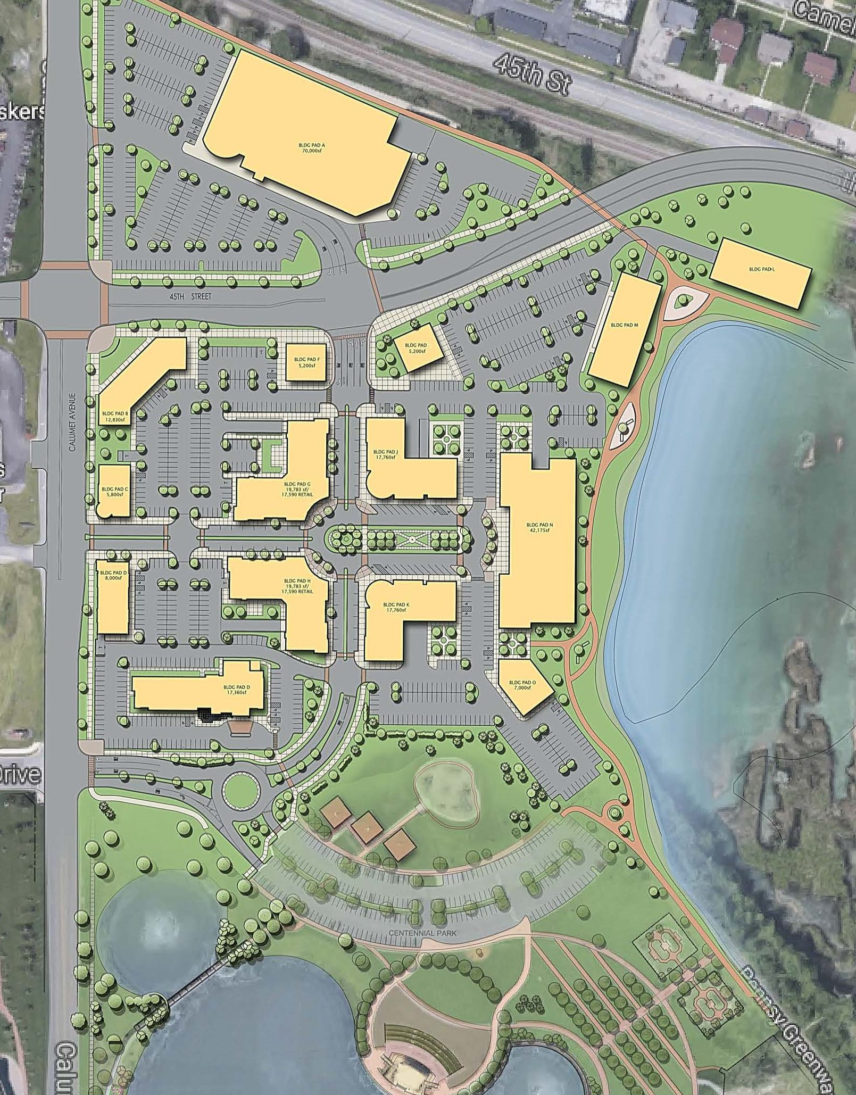

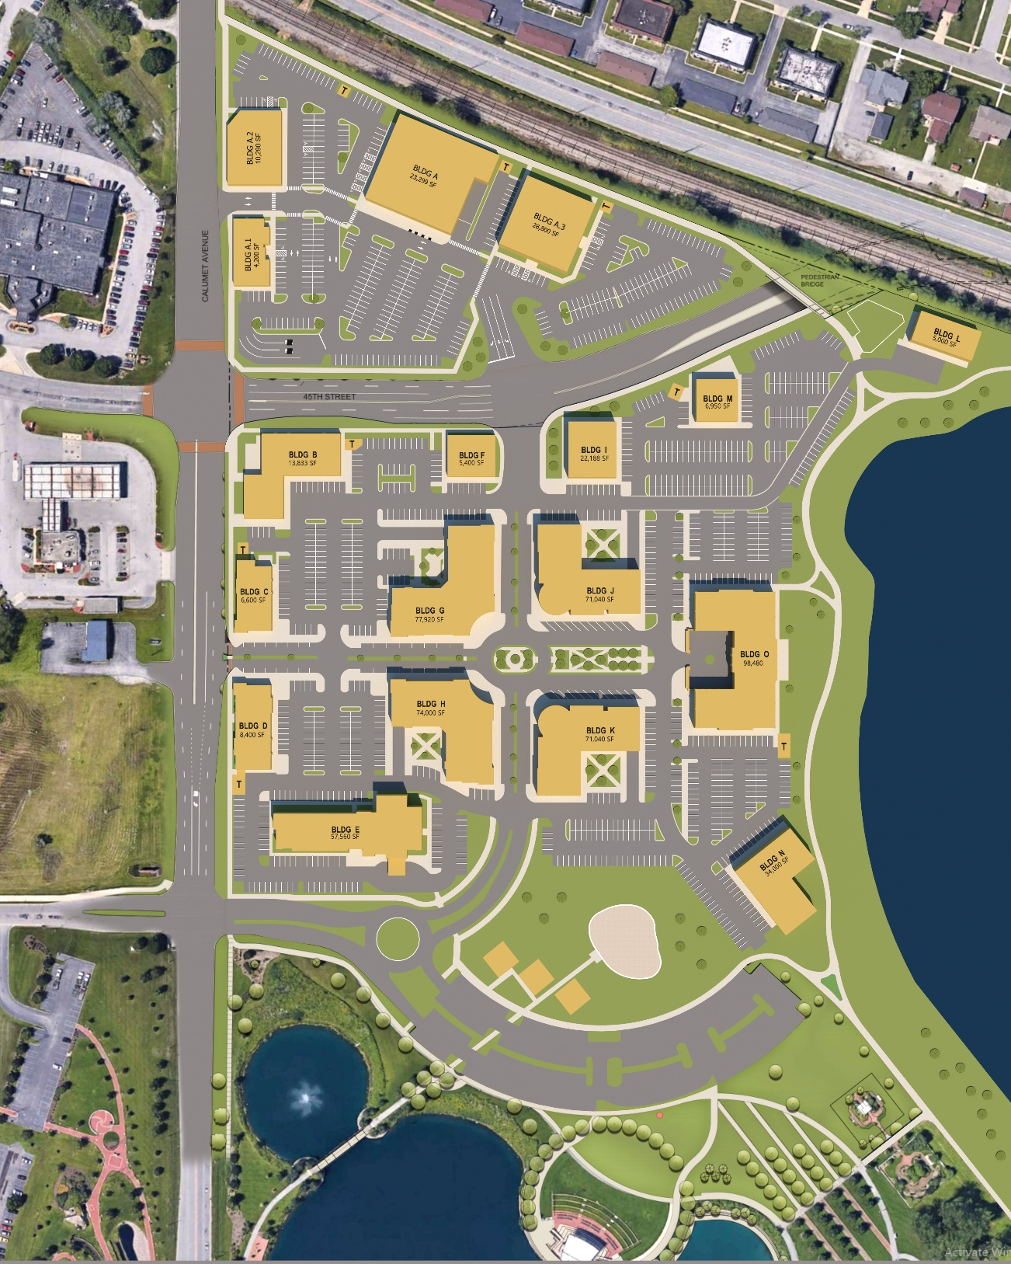
Modified and approved within the red hashed line –
January xx, 2026 Conceptual Plan
Modified and approved within the red hashed line –
August 21, 2023
Modified and approved within the red line –
November 20, 2023

Appendix 3 – Infrastructure Development Plan Set

by reference:

DVG Engineering Plans Title “Centennial Village - Phase 1A” and “Centennial Village - Phase 1B”

Appendix 4 – Signage

by reference:

Sign Regulations for Centennial Village

Sign Regulations for Centennial Village
Town of Munster
Purpose
The sign regulations set forth are made in accordance with an overall plan and program for the public safety, area development, preservation of property values, and the general welfare of the Town of Munster and Centennial Village. The intent is to safeguard the general welfare of the property owner, to maintain the beauty and aesthetic atmosphere of the community while balancing this with the growth and development of the area. All signs located within the development shall conform to the following standards:

General Standards:
- Signs necessary to inform the public, such as traffic control, street name, directional and special parking restrictions that are used to implement public safety and wayfinding within the development, that do not exceed four (4) square feet in area, are permitted.
- Obstruction of vision of drivers. No sign higher than 3 ½ ft shall be placed in such a manner that it would block or obscure the vision of the driver of a motor vehicle stopped at a stop sign, traffic light, or entrance to a public or private street of record for a sight triangle distance of 30 feet in which there is oncoming traffic.
- Wind resistance shall withstand a wind pressure of not less than 20 pounds per square foot of surface area.
- Elimination, signs shall be removed within six (6) months for: inoperable signs, damaged signs, signs of vacated business.

Definitions
In this code, the definitions contained in this section shall be observed and applied, except when the context herein clearly indicates otherwise.
- Address Sign: A sign that identifies the numerical and street address of a property or building shall be a series of 10” black individual numbers mounted on the cast stone corner of the building, similar to the existing address signs. There is a separate ordinance for address numbers because fire code has specific requirements, unless you want all yours to look uniform, then you need to create standards.
- Attention-getting-device: Any pennant, flag, valance, banner, propeller, spinner, streamer, search light, balloon and similar device or ornamentation designed for purposes of promotion or advertising or attracting attention.
- Attraction Panels with changeable letters: Panels on which individual letters may be temporarily affixed to advertise tenants, special sales, products, or other facts non-essential to the identity of the basic business conducted on the premises.
- Awning: A structure, typically made from a canvas or metal material, attached to a building, and intended to provide shelter or decoration over a walkway, window or building entrance.
- Awning or Canopy Sign: A sign that includes letters, numbers, logos and graphics affixed to or imprinted on an Awning or Canopy.
- Back-Lit Sign: An externally illuminated sign made of individual, opaque characters that is illuminated by lighting located behind each individual character and wherein the light is not visible except as a silhouette or halo around each individual character.
- Blade Sign: A sign attached perpendicular to the façade of a store for the primary purpose of identifying the storefront from an adjacent sidewalk.
- Billboard: A single or double-faced ground sign including changeable copy signs, used for the display of commercial information not associated with the conduct of a business or enterprise located on the same premises of such sign. Also referred to as an off-premise advertising sign.
- Building Frontage: The distance between side building lines (building width) measured at the front building line.
- Canopy: see Awning.
- Commercial Poster Board Sign: a large temporary sign or display used for advertising made of foam board or similar rigid substrate.
- Construction or Development Sign: A temporary sign that is installed on a construction or development site during construction and shall include development information.
- Directory Wall Sign: A small sign, placed on the wall by the public entrance(s) to an internally accessed multi-tenant building. It identifies the tenant's names and locations.
- Door Sign: A sign or symbol on a door that identifies the occupant.
- Electronic or Digital Sign: a display screen used to display information using a LED or LCD to display content.
- Externally Illuminated Sign: A sign illuminated by a source of light which is cast upon or falls upon the surface of the sign to illuminate by reflection only.
- Façade: Any face of a building with architectural treatment.
- Façade Measurement: The overall measurement of one side of a building (corner to corner) horizontal and linear measurement in feet.
- Flag: A sign bearing any non-commercial emblem, design or insignia, including but not limited to countries, states, cities, or other civic institution, or other ideological perspective.
- Flashing Sign: Any illuminated sign which exhibits changing natural or artificial light or color effects by any means whatsoever.
- Freestanding Sign: A sign that has its own structural support and stands on the ground independently of any building. Includes: ground signs, monument signs, pillar signs, roundabout signs, and entry/ arched drive under signs.
- Ground Sign: A sign completely or principally self-supported by posts or other supports independent of any building or other structure, anchored in or upon the ground.
- Internally Illuminated Sign: A sign, all or any part of the letter or design of which is made of incandescent, neon or other types of lamps; or a sign with painted, flush or raised letters lighted by an electric lamp or lamps attached thereto; or a sign having a border of LED, incandescent or fluorescent lamps thereto attached and reflecting light thereon; or a transparent glass sign whether lighted by electricity or other illuminant.
- Light Pole Banners: A banner hung on light poles between two horizontal sign posts.
- Neon Sign: A sign consisting of glass tubes and various neon gases that emit different color light, or that is made of LED lights to look similar to the glass tube lights.
- Memorial, Tablet or Cornerstone Sign: A sign that is a marker to commemorate an event, building or person.
- Monument Sign: A sign that is generally placed perpendicular to the road so that it is visible to both directions of traffic. Monument signs are freestanding signs supported by a concrete foundation with a solid base and are typically constructed of durable materials of a permanent nature that are like the type, color, and scale as the building(s) that it identifies.
- Mural: painting or other work of art executed directly on a wall.
- Parcel Frontage: The distance between side lot lines (lot width) measured at the front lot line or along the setback line, whichever is less.
- Pennant: A long, narrow, relatively small flag, often triangular, used for signaling or identification.
- Pillar Sign: A masonry or stone pillar that is at a minimum 2 times in height compared to its width or depth with lettering or logo attached, typically located near or in the medium of a road, street or drive aisle.
- Plaque sign: A small wall sign that identifies a building or its builder, or the name and occupation or profession of the occupant of the premises on which the sign is located. May also be referred to as an architectural sign or nameplate sign.
- Portable Sign: Any sign that is not permanently affixed to a building, structure or the ground; a sign designed to be moved from place to place. These signs include, but are not limited to, signs attached to wood or metal frames designed to be self-supporting and moveable; paper, cardboard or canvas signs wrapped around supporting poles. Also included are those signs commonly trailer mounted, which are designed to be moved from place to place.
- Portable Sidewalk Sign: A sign made of a rigid material (i.e. not a banner, placard or pennant), not attached to the ground or a building, and designed to be carried and moved daily.
- Projecting Sign: A sign supported by a building or other structure and which projects over any street, sidewalk, alley or other public way or public easement, or which projects more than twelve inches from the face of any building, structure, or supporting wall.
- Property Sale, Lease, or Rental Sign: A sign indicating the sale, rental or lease of Real Estate.
- Roof Sign: A sign erected, constructed upon, supported, extending above, or maintained in whole or in part upon, above, or over the roof of a building or structure.
- Sign: The term "Sign" shall mean and include every sign, billboard, ground sign, wall sign, roof sign, illuminated sign, projecting sign, temporary sign, marquee, awning, canopy, and street clock, and shall include any announcement, declaration, demonstration, display, illustration, insignia, or logo used to direct attention to, advertise or promote the interests of any person when the same is in view of the general public.
- Storefront: The façade of a business space that contains a public entrance.
- Streamer: A long, narrow flag, banner or pennant.
- Box Sign: A sign that is an enclosed box shaped structure (typically square or rectangular) with or without internal lighting which can be single or double sided.
- Roundabout Sign: A sign located within the center of a roundabout.
- Entry/ Arched Drive Under Sign: A permanent sign mounted over a road, or street and supported by structural and decorative posts.
- Traffic Directional Sign: A sign that identifies and provides directions for the circulation of traffic on or through private property.
- Wall Sign: A sign mounted or attached to the outside surface of a wall in a plane parallel to that of the supporting wall.
- Window Sign: A sign painted on, attached or affixed to or placed against any window, or hung within 4 feet behind the window.
Measurement of Sign Area: All signs shall be measured as per the following Sign calculation standards:
  - Sign area:
    - The area of a sign as regulated herein shall be the product of the total width and the total height of the smallest rectangle that encompasses all such lettering, devices or graphics.
    - Where said display area is on a background, the background is included in the computation.
    - For signs having two (2) sides, the maximum display area shall be permitted on both sides and the total area of one side shall be deemed to be the total sign area.
    - The supporting structures and mounting hardware shall not be included in the sign area computation.
  - Freestanding sign height:
    - The vertical distance measures from the highest point of the sign to the finished grade of the ground immediately beneath the sign.
    - Any artificial berm is not to exceed 12 inches.
Permitted Signs: If materials are not specified below, they may be wood, metal, acrylic or glass, copy may also be directly printed, painted, or applied vinyl, for each type of sign.
  - Ground Sign(s): One ground sign shall be permitted for each lot or parcel provided the lot or parcel has at least 100 feet of frontage on a public or private street of record, that the height of such sign does not exceed 8 feet, that the sign is located a minimum of 10 feet from all property lines, and that the square footage shall not exceed 80 square feet. These signs can be illuminated.
  - Entryway/ Arched Drive Under Sign(s): A maximum of one sign per entryway to Centennial Village from a public street may be allowed provided each sign shall not exceed 90 square feet in area and mounting height shall not exceed24 feet in height. These signs can be illuminated.
  - Roundabout Sign(s): One sign may be allowed for each Roundabout provided it does not exceed 90 square feet in area, is located 10 feet from all street curb lines and does not exceed 8 feet in height. These signs can be illuminated.
4. Monument Sign(s): One monument sign is allowed at each entrance to a public street or road to/from Centennial Village. The maximum area is 100 sf and height is 10 ft located a minimum of 10 feet from any street curb line. Sign base to be same material(s) and scale as nearest building wall, sign face to be brick, stone, wood, metal, or glass and copy to be channel letters, acrylic, or metal. The letters and logos can be internally illuminated.
5. Wall Sign(s):
- Businesses, except grocery stores. Each business is permitted one wall sign per business façade, with a maximum of two signs total per business, except that no wall signage is permitted on the façade facing the public plaza/residential entrances on buildings G, H, J and K. Sign area shall not exceed 1.5 sf of sign area per linear feet of business façade on which the signage is affixed. For single story buildings the overall sign height may not exceed 3 ft. For buildings two story or greater the sign height shall not exceed 4 ft in height, unless the business facade is setback >100 ft from the street curbline, then the sign height may not exceed 5 ft in height. Permitted wall signs shall not be mounted covering architectural features and shall be mounted no higher than the height of the building parapet wall and no lower than five feet (5') above average surrounding grade.
- Grocery stores. Each grocery business is permitted multiple signs on the primary/front façade, with a combined sign area not to exceed 3.7 sf of sign area per linear feet of business façade on which the signage is affixed and the overall sign heights shall not to exceed 8.5 ft in height. An additional wall sign is permitted on another façade not to exceed 1.8 sf of sign area per linear feet of business façade on which the signage is affixed and the overall sign height shall not to exceed 8.5 ft in height.
  - Door Sign(s): Shall be permitted on public entrance doors subject to the standards listed below.
    - The size shall not exceed more than 8 SF and shall be cut vinyl letters or logos.
  - Window Sign(s): Shall be permitted subject to the standards listed below.
    - The sum total of all window signs shall not exceed:
      - 40 percent of the total glass area of the windows on which they are located for opaque or perforated window decals or
      - 30 percent of the total glass area of the windows on which they are located for cut vinyl signs with individual letters, logos, and insignia.
    - Window signs shall not have any moving parts.
    - A series of windows that are separated by frames and supporting material of less than six inches in width may be considered as a single window for the purpose of computation.
    - No wood or acrylic sign to be hung inside of the windows and no illumination.
  - Projecting Sign(s): A sign which is typically used in pedestrian friendly areas and may project outward from a building at a 90-degree angle. Copy may be placed on both sides of the sign. One projecting sign per business and must be spaced at a minimum of 15 feet from other projecting or blade signs. Projecting signs are only permitted where the business does not have a blade sign.
    - Small Projecting Sign(s): May only be installed on the first story of a building. Must be 8 ft above the sidewalk elevation. Sign area may not exceed 10 sf with a maximum height of 3 ft and must not project more than 4 ft from the face of the building including frame or hardware. Materials may include wood, metal, glass or acrylic and may be externally illuminated.
    - Large Projecting Sign(s): May only be installed on buildings with multiple stories and may not be installed on the first story. Sign shall be vertically oriented with the height greater than the projection of the sign. Must be 12 ft above the sidewalk elevation. Sign area may not exceed 50 sf, may not extend above the roof line and must not project more than 5 ft from the face of the building including frame or hardware, depth shall not exceed 18 inches. Materials may include wood, metal, glass or acrylic and may be externally illuminated.
  - Directory Wall Sign(s): One sign per ground floor entrance to an internally accessed multi-tenant building, with a maximum of 10 sf and a minimum of 3 ft above grade. Materials may include wood, metal, glass or acrylic. It shall be located within 6 ft of the entrance of the building. These signs can be illuminated.
  - Plaque Sign(s): One sign per building and must be no larger than 3 sf and must be mounted more than 3 ft above grade and no higher than 7 ft above grade. Should be within 5 ft of the entrance of the building. Sign material may include wood, stone, metal, acrylic or glass. Shall not be illuminated.
  - “Open” Sign(s): Open signs may be illuminated and may not exceed more than 2 sf and one per public entrance located anywhere in the business space.
  - Light Pole Banners: A banner affixed to each private light pole may be allowed for a limited time not to exceed 90 days total in any one calendar year.
  - Memorial, Tablets or Cornerstone Sign(s): One sign per building that names, dates or provides history of the building is allowed and must not be larger than 6 sf. The material must be the general material sign standard compatible and consistent with the materials used to construct the building.
  - Awning or Canopy Sign(s): Letters, numbers or logo graphics on one vertical side of the awning or canopy and no more than two signs per business. The letter height may not exceed 10”. The sign area must not exceed 75% of the canopy or awning vertical façade area. Copy shall be metal, acrylic, professionally painted, vinyl, or screen-printed. No illumination is allowed.
  - Portable Sidewalk Sign(s): The sign structure shall not exceed 4 feet in height and 9 square feet in area. The sign face shall not exceed 6 square feet in area. One sign per storefront, per façade, is permitted. Signs shall only be displayed during business hours and shall be removed at any time the business is not open. The sign shall be located a maximum of 12 feet from the entrance. The sign shall not interfere with any pedestrian area or block necessary sight lines for pedestrians or vehicles. Under no circumstances shall a sign cause the sidewalk to be less than 4 feet in usable width. A sign shall be of sufficient weight or design to prevent its movement in the wind. Changeable copy on the sign shall be permitted provided the sign is designed to accommodate changeable copy (for example, chalk board signs). Changeable copy signs using individual plastic letters are generally discouraged (but still permitted). The sign shall be plastic, metal, wood, chalkboard, dry-erase board, or paper with weatherproof protector.
  - Blade Sign(s): One circular blade sign is allowed per tenant storefront for any type of building and must be spaced at a minimum of 15 feet from other projecting or blade signs. Formed plastic and injection molded plastic, are prohibited. A minimum clearance of 7’-8” is required between the sidewalk and the bottom of the sign. The maximum allowed horizontal projection is 3’-11” from the storefront. The maximum allowed area is 9 square feet. The maximum allowed depth of the sign panel shall be 8”. Blade signs may be illuminated. May only be installed on the first story of a building. Blade signs are only permitted where the business does not have a projecting sign.
  - Murals: Artistic wall murals are permitted on walls that face the Pennsy Greenway local/regional trail system on portions of the wall that do not have windows. The mural must not be distracting to automobile drivers and requires Plan Commission approval as part of development plan review for each building.
  - Pillar Sign(s): Vertical pillar signs must be a minimum of 6 ft in height and not exceed 12 ft in height and must be square in plan not smaller than 3 ft in depth or width and not greater than 5 ft in depth or width. The pillar may have a maximum of 6 sf of sign area on each side and the materials can be metal, wood or acrylic. These shall not be illuminated except for landscape lighting.
  - Construction or Development Signs: A site under construction or development shall be allowed one sign with a maximum area of 64 sf and height of 10 ft and be located a minimum of 15 ft from the lot line. Material may be wood, metal, vinyl or canvas and properly secured to the ground. The sign must be removed upon obtaining a certificate of occupancy.
  - Property Sale, Lease, or Rental Signs: For Commercial property, signs shall be inside glass windows or mounted on posts not to exceed 32 sf. For new residential property, the signs must be inside glass windows or mounted on balcony railings and shall not exceed 20 sf. Not to exceed more than one sign per unit for both commercial and new residential units. For sales or rental of previously occupied residential property, no signs are allowed.
Prohibited Signs
The following signs are hereby expressly prohibited for erection, construction, repair, alteration or relocation within Centennial Village, except as otherwise hereinafter specifically provided:
- Billboards, except as otherwise provided for by law.
- Roof Signs
- Signs on fences
- Signs in the shape of products sold.
- Pennants
- Streamers
- Signs on vehicles, boats, or trailers, except for vehicles that are parked within 50 ft of the public entrance of a business storefront for a maximum of 4 hours per day.
- Signs which move or have moving parts, which movement is caused either by the wind or mechanically.
- Signs using reflective paints or tape.
- Neon Signs
- Flashing Signs
- Commercial Signs not advertising bona fide businesses conducted, or a product sold or service provided on the same premises where the sign is to be located.
- Portable Signs: including but not limited to portable signs carried by a person for the purpose of advertising a retail business or commercial sales event, except as otherwise permitted herein.
- Signs hung across any street, alley, or public right-of-way, except as otherwise permitted herein.
- Signs which contain statement, words, pictures or other depictions of an obscene, indecent or immoral character and which offend public morals or decency.
- Ground and wall signs advertising or displaying interest rates or the price of merchandise, commodities, goods or services for sale or lease except as may otherwise be specifically allowed by other provisions of this Ordinance.
- Internally illuminated signs with a transparent or translucent background that transmits light.
- Miscellaneous attention-getting devices, other than signs which conform to the provisions contained herein.
- Signs in conflict with traffic signals, vehicular or pedestrian travel, or which impede access to fire hydrants and fire lanes and exits, and other signs which impede or impair the public health, safety and welfare.
- Signs painted on the walls or windows of any building, except as otherwise permitted herein.
- Signs on microwave, radio, transmission or receiving towers and satellite dishes.
Permits Required
It shall be unlawful for any person to erect, construct, alter, change any lettering or graphics on or relocate any sign, except as otherwise permitted herein, within Centennial Village without first obtaining a permit from the Community Development Department and paying the fee required.

Application For Permit
Application for a permit shall be made upon forms provided by the Community Development Department and shall include the required information.
Issuance Of Permits
It shall be the duty of the Community Development Department, who shall be the enforcing officer, upon the filing of an application for a permit, to examine such plans and specifications and other data and the premises upon which it is proposed to erect, construct, alter or relocate the sign and issue a permit if all requirements of these regulations are satisfied. Prior to final issuance of a permit, the Community Development Department must receive approval from the Centennial Village developer or Managing Member of Centennial Village LLC.
Building Code
All signs shall comply with the requirements of the Indiana Building Code and any amendments thereto as adopted by the Town from time to time.
Electrical Code
All signs in which any electrical wiring and/or connections are to be used shall comply with the Indiana Electrical Code and any amendments thereto as adopted by the Town from time to time.
Painting And/Or Maintenance
The owner of any sign shall paint and otherwise maintain all parts and supports thereof as necessary to maintain the sign in a clean and attractive condition comparable to its original condition and to prevent rusting, rotting or deterioration.
Externally Illuminated Signs
Externally illuminated signs shall be allowed subject to the type and manner of illumination being specifically restricted by the following:
- Color temperature of lighting shall not exceed 3000K.
- Light fixtures are to be full cut off or fully shielded and directed down.
- Lighting shall be uniformly distributed over the area of the sign or portion thereof and not extend beyond the edges of the sign except that lighting for back-lit signs may extend beyond the edges of the sign text but not beyond the edges of the sign structure or building wall upon which the sign is located.
- The lighting shall not shine into dwellings or create a traffic hazard.
- The light reflectance when measured perpendicular one foot from the surface of the sign shall not exceed 70 foot candles at its brightest area when measured with a standard light meter.
- Illumination shall be what is known as white and not colored light and shall not be blinking, fluctuating or moving.
- Light rays shall shine only upon the sign or upon the property within the premises and shall not spill over the property lines in any direction.
Variances
Variances from the requirements of these Regulations may be requested by the filing of a BZA Application with the Community Development Department Planning Director and shall follow the procedure set forth in the Town of Munster Zoning Ordinance.

