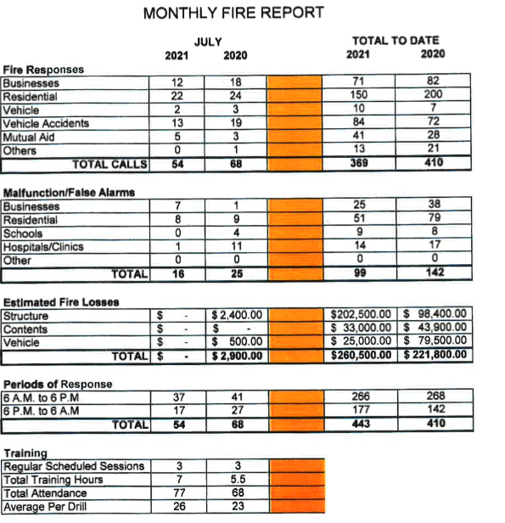

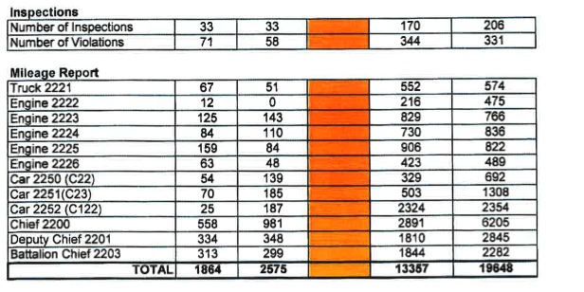
July Fire Calls 2021
Date | People | Run# | NIFRS | Type & Location |  | # | Time
7/1 | 10 | 358 | 746 | CO Alarm/9540 Northcote/te | .sting detectors | 1 | 10:05
7/1 | 14 | 361 | 611 | Pl Accident/Broad moor & Calumet/cancelled by dispatch |  | 2 | 14:24
7/2 | 11 | 362 | 324 | Pl Accident/Calumet & Fisher/no injuries/covered fluids with oil dry |  | 3 | 8:15
7/2 | 14 | 363 | 412 | Gas eak/316 Miiford Haven/Soaring company hit gas llne/Nipsco on scene |  | 4 | 12:08
7/3 | 17 | 365 | 322 | Pl Accldent/7890 Calumet/returned upon arrival |  | 5 | 15:29
7/3 | 24 | 366 | 111 | Applh1nce fire/Homewo od Suites/checked with TIC, ventilated room |  | 6 | 17:52
7/4 | 13 | 367 | 463 | Pl Accident/Calumet & Evergreen/used oil dry on fluids |  | 7 | 17:06
7/4 | 14 | 368 | 412 | Gas Leak/233 Mayfair Way/stove left on, checked levels In home |  | 8 | 17:42
7/4 | 19 | 369 | 154 | Outside Fire/Dumpster fire St. Pauls/extinguished fire |  | 9 | 22:01
7/5 | 16 | 370 | 412 | Odor/8748 Madison/odor due to remodeling in basement |  | 10 | 12:21
7/5 | 16 | 371 | 143 | Outside grass flre/1910 Robin Drive/put out by neighbor |  | 11 | 14:17
7/7 | 5 | 372 | 463 | Pl Accident/Main & Calumet/pole down/advised Midwest Electric |  | 12 | 1:16
7/7 | 12 | 373 | 611 | Open fire hydrant/1815 Magnolia/WO flushing water main for new hydrant |  | 13 | 17:01
7/8 | 15 | 374 | 653 | Smoke Alarm/9404 Main/food burnt In toaster oven |  | 14 | 14:37
7/9 | 8 | 375 | 424 | CO Alarm/8940 White Oak Apt. 5/replaced battery |  | 15 | 4:58
7/9 | 11 | 376 | 463 | Pl Accident/Calumet & Rldge/1injury/cleaned up debris and used oil drv |  | 16 | 5:44
7/11 | 24 | 377 | 736 | CO Alarm/1845 Tulip/vent holes covered by pan/ventilated home |  | 17 | 20:05
7/11 | 12 | 378 | 611 | Fire Alarm/1111Cornwallis/cancelled by alarm company |  | 18 | 23:03
7/12 | 11 | 379 | 463 | Pl Accident/Ridge & White Oak/cleaned up debris |  | 19 | 15:54
7/12 | 11 |  | 611 | Auto A id to Lansing/held up by Lansing |  | 20 | 17:55
7/13 | 10 | 380 | 463 | Pl Accident/Beverl y & Forest/1 injury/cleaned up debris |  | 21 | 15:15
7/13 | 24 | 381 | 651 | Smoke Odor/Baring & River/caused by burnout from vehicle |  | 22 | 20:54
7/13 | 24 | 382 | 651 | Wires Down/7940 Linden/noise was fireworks not wires down |  | 23 | 21:10
7/15 | 16 | 383 | 611 | Mutual aid to Lansing/returned upon arrival |  | 24 | 13:55
7/15 | 15 | 384 | 442 | Smoke Odor/325 Milford Haven Way/freezer in basement/unplugged & reset breaker |  | 25 | 22:09
7/15 | 15 | 385 | 111 | Mutual Aid to Lansing/assisted with building fire |  | 26 | 22:59
7/16 | 13 | 386 | 111 | Fire Alarm/Hampton Inn/pool pump on fire/extinguished and ventilated |  | 27 | 9:01
7/17 | 18 | 387 | 571 | Station Coverage/2150 Hart St. Dyer Station 18 |  | 28 | 10:43
7/17 | 11 | 388 | 463 | Pl Accident/Calumet & Ridge/1 injury/cleaned up debris and used oil dry |  | 29 | 16:47
7/20 | 8 | 389 | 743 | Fire Alarm/47S Superlor·GE Warehouse/Set off by burnt popcorn |  | 30 | 1:16
7/20 | 10 | 390 | 463 | Pl Accident/Cobblestone & Main/car on top of Junction box/Nlpsco called |  | 31 | 10:05
7/20 | 24 | 391 | 463 | Pl Accident/Fran Lin & Columbla/1lnJurv/traffic control & cleaned up debris |  | 32 | 18:38
7/21 | 9 | 392 | 424 | CO Alarm/938 Boxwood/no readings found |  | 33 | 17:45
7/22 | 21 | 393 | 424 | CO Alarm/9740 Wiidwood Circle Apt. B/lssue with stove, ventilated home |  | 34 | 20:54
7/23 | 12 | 394 | 162 | Outside fire/299 Exeter/grill on fire/disconnected and removed/checked home |  | 35 | 16:48
7/24 | 11 | 395 | 743 | Smoke Alarm/1630 45th/dust from construction |  | 36 | 8:10
7/24 | 10 | 396 | 743 | Smoke Alarm/1630 45th/dust from construction |  | 37 | 9:17
7/24 | 10 | 397 | 412 | Asslst/8718 Greenwood/proparie tank/cooled down and removed from home |  | 38 | 14:20
7/25 | 5 | 399 | 733 | Smoke Alarm/7843 Madison/helium balloon near detector/advised to update detectors |  | 39 | 4:01
7/25 | 12 | 400 | 555 | Elevator Alarm/Munster Med Inn/nothing found on arrival |  | 40 | 22:53
7/26 | 11 | 401 | 742 | Fire Alarm/1014Sth/ Paving Company using hydrant which set off alarm |  | 41 | 8:25
7/26 | 14 | 402 | 736 | CO Alarm/8713 Crestwood/bad detector |  | 42 | 17:20
7/26 | 14 | 403 | 611 | Mutual Ald/17640 Rosewood-Lansing/cancelled en route |  | 43 | 17:35
7/27 | 10 | 404 | 352 | Pl Accldent/1040 Ridge Road/extricated driver/cleaned up debris/contacted Midwest |  | 44 | 5:05
7/27 | 7 | 405 | 743 | Fire Alarm/Applebees 330 Ridge Road/testing system |  | 45 | 7:14
7/27 | 8 | 406 | 412 | Gas Odor/7951 Calumet/nothing found |  | 46 | 7:49
7/28 | 10 | 407 | 441 | Wires in tree/8623 Baring/notified Nlpsco |  | 47 | 9:18
7/28 | 12 | 408 | 736 | CO Alarm/9128 White Oak/bad detector |  | 48 | 11:47
7/28 | 11 | 409 | 463 | Pl Accident/Calumet & River Dr/011 Ory on spills, cleaned up debris |  | 49 | 12:43
7/28 | 17 | 410 | 743 | Smoke Alarm/936 Boxwood/set off from cooking |  | 50 | 17:15
7/28 | 23 | 411 | 131 | Vehicle fire/R idge & Columbia/engine overheated |  | 51 | 20:37
7/29 | 12 | 412 | 622 | Vehicle Fire/801 Main/nothing found at address |  | 52 | 10:53
7/30 | 1 | 413 | 611 | Fire Alarm/1630 45th/cancelled en route |  | 53 | 9:47
7/31 | 12 | 414 | 142 | Brush Fire/9418 Larch Dr/bush caught on fire while burning weeds/extinguished |  | 54 | 12:01

