UCR /MONTHY ACTIVITY REPORT - MONTH | OF MAY | MAY, 2021 | MAY, 2020 | Year to Date | Year to Date
 |  | No Of | No Of | 2020 | 2021
HOMICIDE |  | 0 | 0 | 0 | 0
RAPE |  | 1 | 0 | 0 | 2
FORCIBLE FONDLING |  | 2 | 0 | 1 | 4
ASSAULT |  | 2 | 5 | 32 | 14
ROBBERY |  | 0 | 0 | 3 | 2
BURGLARY |  | 0 | 1 | 3 | 3
LARCENY |  | 21 | 14 | 65 | 64
MTR VEHICLE THEFT |  | 1 | 0 | 5 | 6
ADULT ARREST |  | 14 | 11 | 70 | 72
JUVENILE ARREST |  | 2 | 1 | 13 | 10
TOTAL ARREST |  | 16 | 12 | 83 | 82
ACCIDENT/PUBLIC |  | 61 | 33 | 209 | 234
INJURIES/PUBLIC |  | 8 | 9 | 35 | 46
FATALITIES |  | 0 | 0 | 0 | 0
TOTAUACCIDENTS |  | 61 | 33 | 209 | 234
VANDALISM |  | 6 | 3 | 26 | 22
TRAFFIC ARREST
STATE VIOLATIONS |  | 87 | 16 | 318 | 347
LOCAL VIOLATIONS |  | 101 | 40 | 263 | 321
TOTAL TRAFFIC ARREST |  | 188 | 56 | 581 | 668
WARNINGS |  | 242 | 86 | 1200 | 1109
TOTAL ALARMS |  | 68 | 54 | 263 | 277
NO MILES PATROLED |  | 27,632 | 22,477 | 111,044 | 122,394
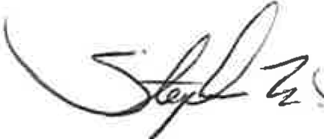

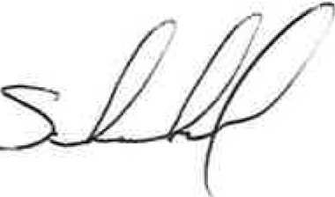
Stephen F. Scheckel Chief of Police

UCR/YEARLY ACTIVITY REPORT - 2021

 | JAN | FEB | MAR | APRIL | MAY | JUNE | JULY | AUG | SEPT | OCT | NOV | DEC | TOTAL
HOMICIDE | 0 | 0 | 0 | 0 | 0 |  |  |  |  |  |  |  | 0
RAPE | 0 | 0 | 0 | 1 | 1 |  |  |  |  |  |  |  | 2
FORCIBLE FONDLING | 1 | 0 | 0 | 1 | 2 |  |  |  |  |  |  |  | 4
ASSAULT | 3 | 2 | 4 | 3 | 2 |  |  |  |  |  |  |  | 14
ROBBERY | 1 | 0 | 1 | 0 | 0 |  |  |  |  |  |  |  | 2
BURGLARY | 0 | 1 | 0 | 2 | 0 |  |  |  |  |  |  |  | 3
LARCENY | 12 | 6 | 14 | 11 | 21 |  |  |  |  |  |  |  | 64
MTR VEHICLE THEFT | 1 | 2 | 2 | 0 | 1 |  |  |  |  |  |  |  | 6
ADULT ARREST | 16 | 12 | 14 | 16 | 14 |  |  |  |  |  |  |  | 72
JUVENILE ARREST | 0 | 1 | 4 | 3 | 2 |  |  |  |  |  |  |  | 10
TOTAL ARREST | 16 | 13 | 18 | 19 | 16 |  |  |  |  |  |  |  | 82
ACCIDENTS | 48 | 38 | 37 | 50 | 61 |  |  |  |  |  |  |  | 234
INJURIES | 18 | 3 | 6 | 11 | 8 |  |  |  |  |  |  |  | 46
FATALITIES | 0 | 0 | 0 | 0 | 0 |  |  |  |  |  |  |  | 0
TOTAL ACCIDENTS | 48 | 38 | 37 | 50 | 61 |  |  |  |  |  |  |  | 234
VANDALISM | 2 | 3 | 5 | 6 | 6 |  |  |  |  |  |  |  | 22
TRAFFIC
STATE VIOLATIONS | 70 | 42 | 78 | 70 | 87 |  |  |  |  |  |  |  | 347
LOCAL VIOLATIONS | 36 | 40 | 82 | 62 | 101 |  |  |  |  |  |  |  | 321
TOTAL TRAFFIC | 106 | 82 | 160 | 132 | 188 |  |  |  |  |  |  |  | 668
WARNINGS | 204 | 195 | 242 | 226 | 242 |  |  |  |  |  |  |  | 1109
TOTAL/ALARMS | 33 | 45 | 67 | 64 | 68 |  |  |  |  |  |  |  | 277
FIELD CONTACTS | 0 | 0 | 0 | 0 | 0 |  |  |  |  |  |  |  | 0
NO. MILES PATROLED | 22,750 | 22,425 | 25,030 | 24,557 | 27,632 |  |  |  |  |  |  |  | 122,394

